CE100 Algorithms and Programming II
Huffman Coding
Author: Asst. Prof. Dr. Uğur CORUH

CE100 Algorithms and Programming II

Week-9 (Huffman Coding)

Spring Semester, 2021-2022
Download DOC, SLIDE, PPTX

Huffman Coding

Outline
- Heap Data Structure (Review Week-4)
- Heap Sort (Review Week-4)
- Huffman Coding

Huffman Codes

Huffman Codes for Compression
- Widely used and very effective for data compression
- Savings of 20% - 90% typical
  - (depending on the characteristics of the data)
- In summary: Huffman’s greedy algorithm uses a table of frequencies of character occurrences to build up an optimal way of representing each character as a binary string.

Binary String Representation - Example
- Consider a data file with:
  - 100K characters
  - Each character is one of $\{a,b,c,d,e,f\}$
- Frequency of each character in the file:
  - frequency: $\overset{45K}{\overbrace{a}},\overset{13K}{\overbrace{b}},\overset{12K}{\overbrace{c}},\overset{16K}{\overbrace{d}},\overset{9K}{\overbrace{e}},\overset{5K}{\overbrace{f}}$
- Binary character code: Each character is represented by a unique binary string.
- Intuition:
  - Frequent characters $⇔$ shorter codewords
  - Infrequent characters $⇔$ longer codewords

Binary String Representation - Example
$$\begin{matrix}\text{characters} & a & b & c & d & e & f \\ \text{frequency} & 45K & 13K & 12K & 16K & 9K & 5K \\ \text{fixed-length} & 000 & 001 & 010 & 011 & 100 & 101 \\ \text{variable-length(1)} & 0 & 101 & 100 & 111 & 1101 & 1100 \\ \text{variable-length(2)} & 0 & 10 & 110 & 1110 & 11110 & 11111\end{matrix}$$
- How many total bits needed for fixed-length codewords? $100K×3=300K bits$
- How many total bits needed for variable-length(1) codewords? $45K×1+13K×3+12K×3+16K×3+9K×4+5K×4=224K$
- How many total bits needed for variable-length(2) codewords? $45K×1+13K×2+12K×3+16K×4+9K×5+5K×5=241K$

Prefix Codes
- Prefix codes: No codeword is also a prefix of some other codeword
- Example:
$$\begin{matrix}\text{characters} & a & b & c & d & e & f \\ \text{codeword} & 0 & 101 & 100 & 111 & 1101 & 1100\end{matrix}$$
- It can be shown that:
  - Optimal data compression is achievable with a prefix code
- In other words, optimality is not lost due to prefix-code restriction.

Prefix Codes: Encoding
$$\begin{matrix}\text{characters} & a & b & c & d & e & f \\ \text{codeword} & 0 & 101 & 100 & 111 & 1101 & 1100\end{matrix}$$
- Encoding: Concatenate the codewords representing each character of the file
- Example: Encode file “abc” using the codewords above
  - $abc⇒0.101.100⇒0101100$
- Note: “.” denotes the concatenation operation. It is just for illustration purposes, and does not exist in the encoded string.

Prefix Codes: Decoding
- Decoding is quite simple with a prefix code
- The first codeword in an encoded file is unambiguous
  - because no codeword is a prefix of any other
- Decoding algorithm:
  - Identify the initial codeword
  - Translate it back to the original character
  - Remove it from the encoded file
  - Repeat the decoding process on the remainder of the encoded file.

Prefix Codes: Decoding - Example
$$\begin{matrix}\text{characters} & a & b & c & d & e & f \\ \text{codeword} & 0 & 101 & 100 & 111 & 1101 & 1100\end{matrix}$$
- Example: Decode encoded file $001011101$
  - $001011101$
  - $0.01011101$
  - $0.0.1011101$
  - $0.0.101.1101$
  - $0.0.101.1101$
  - $aabe$

Prefix Codes
- Convenient representation for the prefix code:
  - a binary tree whose leaves are the given characters
- Binary codeword for a character is the path from the root to that character in the binary tree
- “$0$” means “go to the left child”
- “$1$” means “go to the right child”

Binary Tree Representation of Prefix Codes
- Weight of an internal node: sum of weights of the leaves in its subtree
- The binary tree corresponding to the fixed-length code
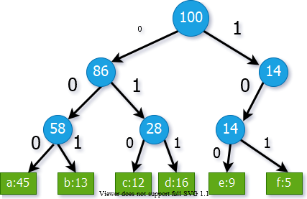
center h:450px

Binary Tree Representation of Prefix Codes
- Weight of an internal node: sum of weights of the leaves in its subtree
- The binary tree corresponding to the optimal variable-length code
- An optimal code for a file is always represented by a full binary tree
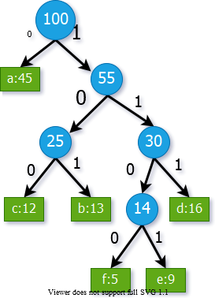
bg right:40% h:600px

Full Binary Tree Representation of Prefix Codes
- Consider an FBT corresponding to an optimal prefix code
- It has $\left|C\right|$ leaves (external nodes)
- One for each letter of the alphabet where $C$ is the alphabet from which the characters are drawn
- Lemma: An FBT with $\left|C\right|$ external nodes has exactly $\left|C\right|−1$ internal nodes

Full Binary Tree Representation of Prefix Codes
- Consider an $FBT$ $T$, corresponding to a prefix code.
- Notation:
  - $f\left(c\right)$: frequency of character c in the file
  - $d_{T}\left(c\right)$: depth of $c$’s leaf in the $FBT$ $T$
  - $B\left(T\right)$: the number of bits required to encode the file
- What is the length of the codeword for $c$?
  - $d_{T}\left(c\right)$, same as the depth of $c$ in $T$
- How to compute $B\left(T\right)$, cost of tree $T$?
  - BT=c∈C​fcdTc

Cost Computation - Example
BT=c∈C​fcdTc
$$\begin{matrix}B\left(T\right)= & \left(45×1\right)+\left(12×3\right)+ \\ & \left(13×3\right)+\left(16×3\right)+ \\ & \left(5×4\right)+\left(9×4\right) \\ = & 224\end{matrix}$$
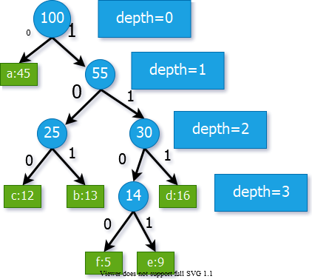
bg right:50% h:500px

Prefix Codes
- Lemma: Let each internal node i is labeled with the sum of the weight $w\left(i\right)$ of the leaves in its subtree
- Then
BT=c∈C​fcdTc=i∈IT​wi
- where $I_{T}$ is the set of internal nodes of $T$
- Proof: Consider a leaf node $c$ with $f\left(c\right)$ & $d_{T}\left(c\right)$
  - Then, $f\left(c\right)$ appears in the weights of $d_{T}\left(c\right)$ internal node
  - along the path from $c$ to the root
  - Hence, $f\left(c\right)$ appears $d_{T}\left(c\right)$ times in the above summation

Cost Computation - Example
BT=i∈IT​wi
$$\begin{matrix}B\left(T\right)= & 100+55+ \\ & 25+30+14 \\ = & 224\end{matrix}$$
bg right:50% h:500px

Constructing a Huffman Code
- Problem Formulation: For a given character set C, construct an optimal prefix code with the minimum total cost
- Huffman invented a greedy algorithm that constructs an optimal prefix code called a Huffman code
- The greedy algorithm
  - builds the FBT corresponding to the optimal code in a bottom-up manner
  - begins with a set of $\left|C\right|$ leaves
  - performs a sequence of $\left|C\right|−1$ “merges” to create the final tree

Constructing a Huffman Code
- A priority queue $Q$, keyed on $f$, is used to identify the two least-frequent objects to merge
- The result of the merger of two objects is a new object
  - inserted into the priority queue according to its frequency
  - which is the sum of the frequencies of the two objects merged

Constructing a Huffman Code
- Priority queue is implemented as a binary heap
- Initiation of $Q$ ($\text{BUILD-HEAP}$): $O\left(n\right)$ time
- $\text{EXTRACT-MIN}$ & $\text{INSERT}$ take $O\left(lgn\right)$ time on $Q$ with $n$ objects

Constructing a Huffman Code
$$\begin{matrix} & \text{HUFFMAN}\left(c\right) \\ & n←\left|C\right| \\ & Q←\text{BUILD-HEAP}\left(c\right) \\ & for i←1 to n−1 do \\ & z←\text{ALLOCATE-NODE}\left(\right) \\ & x←left\left[z\right]←\text{EXTRACT-MIN}\left(Q\right) \\ & y←right\left[z\right]←\text{EXTRACT-MIN}\left(Q\right) \\ & f\left[z\right]←f\left[x\right]←f\left[y\right] \\ & \text{INSERT}\left(Q,z\right) \\ & return \text{EXTRACT-MIN}\left(Q\right)⊲\text{one object left in} Q\end{matrix}$$

Constructing a Huffman Code - Example
- Start with one leaf node for each character
- The $2$ nodes with the least frequencies: $f\&e$
- Merge $f\&e$ and create an internal node
- Set the internal node frequency to $5+9=14$
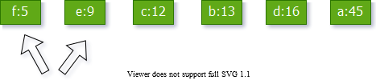
center h:300px

Constructing a Huffman Code - Example
- The 2 nodes with least frequencies: $b\&c$
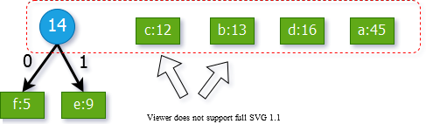
center h:400px

Constructing a Huffman Code - Example
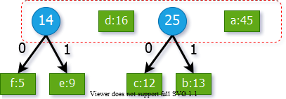
center h:350px

Constructing a Huffman Code - Example
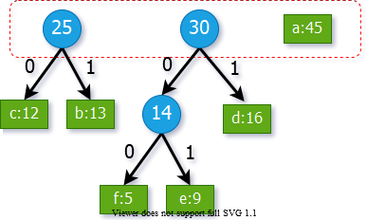
bg right:50% h:350px

Constructing a Huffman Code - Example
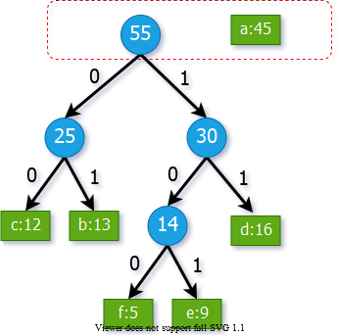
bg right:50% h:600px

Constructing a Huffman Code - Example
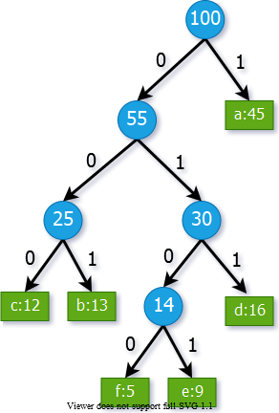
bg right:50% h:600px

Correctness Proof of Huffman’s Algorithm
- We need to prove:
  - The greedy choice property
  - The optimal substructure property
- What is the greedy step in Huffman’s algorithm?
  - Merging the two characters with the lowest frequencies
- We will first prove the greedy choice property

Greedy Choice Property
- Lemma 1: Let $x\&y$ be two characters in $C$ having the lowest frequencies.
- Then, $∃$ an optimal prefix code for $C$ in which the codewords for $x\&y$ have the same length and differ only in the last bit
- Note: If $x\&y$ are merged in Huffman’s algorithm, their codewords are guaranteed to have the same length and they will differ only in the last bit.
  - Lemma 1 states that there exists an optimal solution where this is the case.

Greedy Choice Property - Proof
- Outline of the proof:
  - Start with an arbitrary optimal solution
  - Convert it to an optimal solution that satisfies the greedy choice property.
- Proof: Let $T$ be an arbitrary optimal solution where:
  - $b\&c$ are the sibling leaves with the max depth
  - $x\&y$ are the characters with the lowest frequencies

Greedy Choice Property - Proof
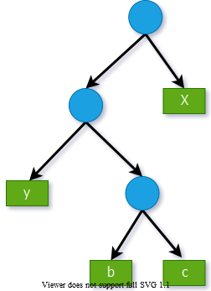
bg right:50% h:600px
- Reminder:
  - $b\&c$ are the nodes with max depth
  - $x\&y$ are the nodes with min freq.
- Without loss of generality, assume:
  - $f\left(x\right)≤f\left(y\right)$
  - $f\left(b\right)≤f\left(c\right)$
- Then, it must be the case that:
  - $f\left(x\right)≤f\left(b\right)$
  - $f\left(y\right)≤f\left(c\right)$

Greedy Choice Property - Proof
- $T⇒T′$: exchange the positions of the leaves $b\&x$
- $T′⇒T″$: exchange the positions of the leaves $c\&y$
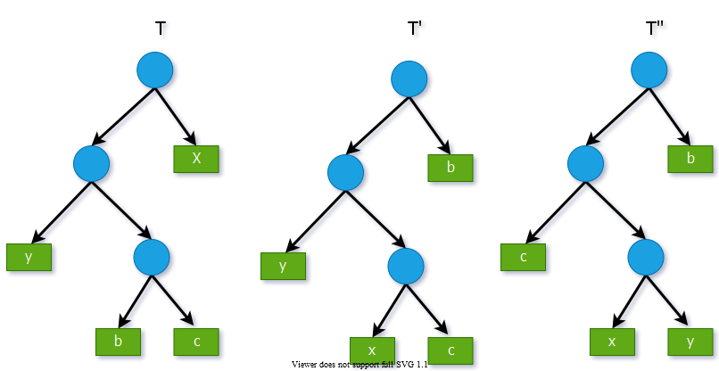
center h:400px

Greedy Choice Property - Proof
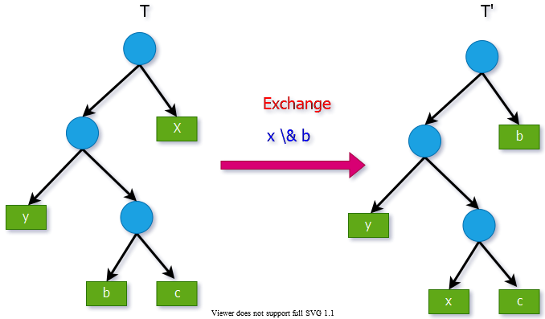
center h:500px

Greedy Choice Property - Proof
- Reminder: Cost of tree $T′$
BT=c∈C​fcdT′c
- How does $B\left(T′\right)$ compare to $B\left(T\right)$?
- Reminder: $f\left(x\right)≤f\left(b\right)$
  - $d_{T′}\left(x\right)=d_{T}\left(b\right)$ and $d_{T′}\left(b\right)=d_{T}\left(x\right)$
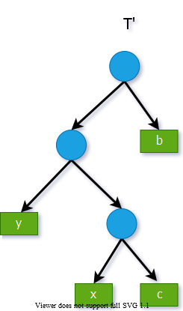
bg right:50% h:500px

Greedy Choice Property - Proof
- Reminder: $f\left(x\right)≤f\left(b\right)$
  - $d_{T′}\left(x\right)=d_{T}\left(b\right)$ and $d_{T′}\left(b\right)=d_{T}\left(x\right)$
- The difference in cost between $T$ and $T′$:
BT−BT′=c∈C​fcdTc−c∈C​fcdT′c=fxdTx+fbdTb−fxdT′x−fbdT′b=fxdTx+fbdTb−fxdTx−fbdTb=fbdTb+dTx−fxdTb−dTx=fb−fxdTb+dTx

Greedy Choice Property - Proof
$$\begin{matrix}B\left(T\right)−B\left(T′\right)=\left(f\left[b\right]−f\left[x\right]\right)\left(d_{T}\left(b\right)+d_{T}\left(x\right)\right)\end{matrix}$$
- Since $f\left[b\right]−f\left[x\right]≥0$ and $d_{T}\left(b\right)≥d_{T}\left(x\right)$
  - therefore $B\left(T′\right)≤B\left(T\right)$
- In other words, $T′$ is also optimal

Greedy Choice Property - Proof
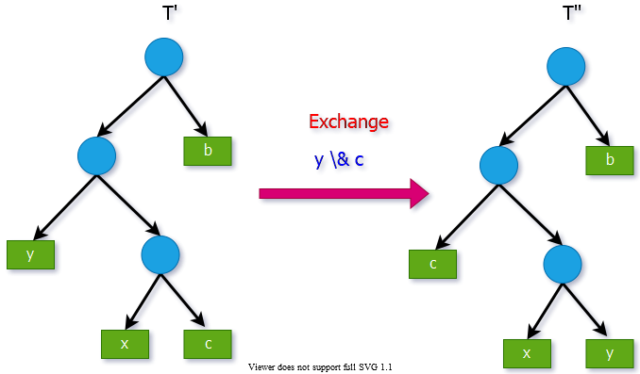
center h:450px

Greedy Choice Property - Proof
- We can similarly show that
- $B\left(T′\right)−B\left(T″\right)≥0⇒B\left(T″\right)≤B\left(T′\right)$
  - which implies $B\left(T″\right)≤B\left(T\right)$
- Since $T$ is optimal $⇒B\left(T″\right)=B\left(T\right)⇒T″$ is also optimal
- Note: $T″$ contains our greedy choice:
  - Characters $x\&y$ appear as sibling leaves of max-depth in $T″$
- Hence, the proof for the greedy choice property is complete

Greedy-Choice Property of Determining an Optimal Code
- Lemma 1 implies that
  - process of building an optimal tree
  - by mergers can begin with the greedy choice of merging
  - those two characters with the lowest frequency
- We have already proved that BT=i∈IT​wi , that is,
  - the total cost of the tree constructed
  - is the sum of the costs of its mergers (internal nodes) of all possible mergers
- At each step Huffman chooses the merger that incurs the least cost

Optimal Substructure Property
- Consider an optimal solution $T$ for alphabet $C$. Let $x$ and $y$ be any two sibling leaf nodes in $T$. Let $z$ be the parent node of $x$ and $y$ in $T$.
- Consider the subtree $T′$ where $T′=T–\{x,y\}$.
  - Here, consider z as a new character, where
    - $f\left[z\right]=f\left[x\right]+f\left[y\right]$
- Optimal substructure property: $T′$ must be optimal for the alphabet $C′$, where $C′=C–\{x,y\}∪\{z\}$
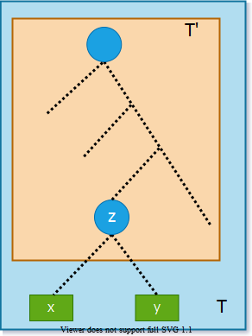
bg right:30% h:500px

Optimal Substructure Property - Proof
Reminder:
BT=c∈C​fcdTc
Try to express $B\left(T\right)$ in terms of $B\left(T′\right)$.
Note: All characters in $C′$ have the same depth in $T$ and $T′$.
$$B\left(T\right)=B\left(T′\right)–cost\left(z\right)+cost\left(x\right)+cost\left(y\right)$$
bg right:30% h:500px

Optimal Substructure Property - Proof
Reminder:
BT=c∈C​fcdTc
$$\begin{matrix}B\left(T\right) & =B\left(T′\right)–cost\left(z\right)+cost\left(x\right)+cost\left(y\right) \\ & =B\left(T′\right)−f\left[z\right].d_{T}\left(z\right)+f\left[x\right].d_{T}\left(x\right)+f\left[y\right].d_{T}\left(y\right) \\ & =B\left(T′\right)−f\left[z\right].d_{T}\left(z\right)+\left(f\left[x\right]+f\left[y\right]\right)\left(d_{T}\left(z\right)+1\right) \\ & =B\left(T′\right)−f\left[z\right].d_{T}\left(z\right)+f\left[z\right]\left(d_{T}\left(z\right)+1\right) \\ & =B\left(T′\right)−f\left[z\right]\end{matrix}$$
$$\begin{matrix}d_{T}\left(x\right)=d_{T}\left(z\right)+1 \\ d_{T}\left(y\right)=d_{T}\left(z\right)+1\end{matrix}$$
$$\begin{matrix}B\left(T\right)=B\left(T′\right)+f\left[x\right]+f\left[y\right]\end{matrix}$$
bg right:30% h:500px

Optimal Substructure Property - Proof
- We want to prove that $T′$ is optimal for
  - $C′=C–\{x,y\}∪\{z\}$
- Assume by contradiction that that there exists another solution for $C′$ with smaller cost than $T′$. Call this solution $R′$:
- $B\left(R′\right)<B\left(T′\right)$
- Let us construct another prefix tree $R$ by adding $x\&y$ as children of $z$ in $R′$
$$\begin{matrix}B\left(T\right)=B\left(T′\right)+f\left[x\right]+f\left[y\right]\end{matrix}$$
bg right:30% h:500px

Optimal Substructure Property - Proof
- Let us construct another prefix tree $R$ by adding $x\&y$ as children of $z$ in $R′$.
- We have:
  - $B\left(R\right)=B\left(R′\right)+f\left[x\right]+f\left[y\right]$
- In the beginning, we assumed that:
  - $B\left(Rʹ\right)<B\left(T′\right)$
- So, we have:
  - $B\left(R\right)<B\left(T′\right)+f\left[x\right]+f\left[y\right]=B\left(T\right)$
Contradiction! Proof complete
bg right:30% h:500px

Greedy Algorithm for Huffman Coding - Summary
- For the greedy algorithm, we have proven that:
  - The greedy choice property holds.
  - The optimal substructure property holds.
- So, the greedy algorithm is optimal.

References
- Introduction to Algorithms, Third Edition | The MIT Press
- Bilkent CS473 Course Notes (new)
- Bilkent CS473 Course Notes (old)

$−End−Of−Week−9−Course−Module−$

