CE100 Algorithms and Programming II
Greedy Algorithms, Knapsack
Author: Asst. Prof. Dr. Uğur CORUH

CE100 Algorithms and Programming II

Week-7 (Greedy Algorithms, Knapsack)

Spring Semester, 2021-2022
Download DOC, SLIDE, PPTX

Greedy Algorithms, Knapsack

Outline
- Greedy Algorithms and Dynamic Programming Differences
- Greedy Algorithms
  - Activity Selection Problem
  - Knapsack Problems
    - The 0-1 knapsack problem
    - The fractional knapsack problem

Activity Selection Problem

Activity Selection Problem
- We have:
  - A set of activities with fixed start and finish times
  - One shared resource (only one activity can use at any time)
- Objective: Choose the max number of compatible activities
- Note: Objective is to maximize the number of activities, not the total time of activities.
- Example:
  - Activities: Meetings with fixed start and finish times
  - Shared resource: A meeting room
    - Objective: Schedule the max number of meetings

Activity Selection Problem
- Input: a set $S=\{a_{1},a_{2},…,a_{n}\}$ of n activities
- $s_{i}$ : Start time of activity $a_{i}$,
- $f_{i}$ : Finish time of activity $a_{i}$ Activity $i$ takes place in $[s_{i},f_{i})$
- Aim: Find max-size subset $A$ of mutually compatible activities
  - Max number of activities, not max time spent in activities
  - Activities $i$ and $j$ are compatible if intervals $[s_{i},f_{i})$ and $[s_{j},f_{j})$ do not overlap, i.e., either $s_{i}≥f_{j}$ or $s_{j}≥f_{i}$

Activity Selection Problem An Example
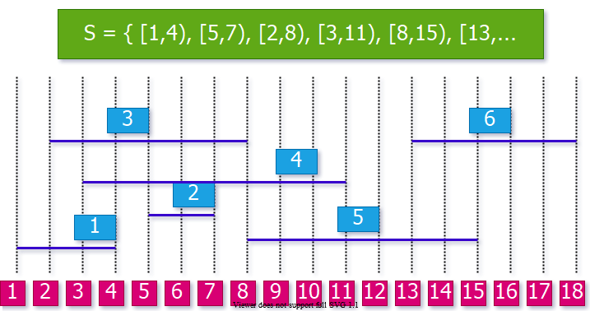
center h:400px

Optimal Substructure Property
- Consider an optimal solution $A$ for activity set $S$.
- Let $k$ be the activity in $A$ with the earliest finish time
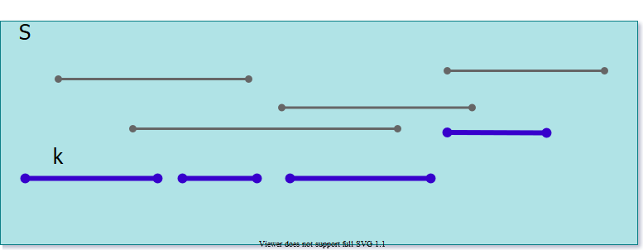
center h:400px

Optimal Substructure Property
- Consider an optimal solution $A$ for activity set $S$.
- Let $k$ be the activity in $A$ with the earliest finish time
- Now, consider the subproblem $S_{k}′$ that has the activities that start after $k$ finishes, i.e. $S_{k}′=\{a_{i}∈S:s_{i}≥f_{k}\}$
- What can we say about the optimal solution to $S_{k}′$ ?
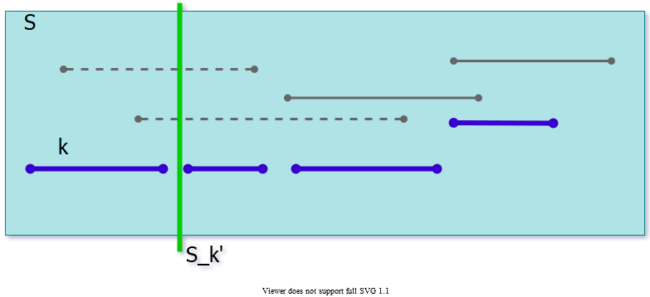
center h:300px

Optimal Substructure Property
- Consider an optimal solution $A$ for activity set $S$.
- Let $k$ be the activity in $A$ with the earliest finish time
- Now, consider the subproblem $S_{k}′$ that has the activities that start after $k$ finishes, i.e. $S_{k}′=\{a_{i}∈S:s_{i}≥f_{k}\}$
- $A−\{k\}$ is an optimal solution for $S_{k}′$. Why?
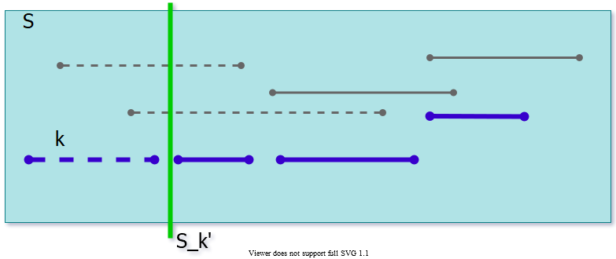
center h:300px

Optimal Substructure
- Theorem: Let $k$ be the activity with the earliest finish time in an optimal soln $A⊆S$ then
  - $A−\{k\}$ is an optimal solution to subproblem
  - $S_{k}′=\{a_{i}∈S:s_{i}≥f_{k}\}$
- Proof (by contradiction):
  - $⊳$ Let $B′$ be an optimal solution to $S_{k}′$ and
    - $\left|B′\right|>\left|A−\{k\}\right|=\left|A\right|−1$
  - Then, $B=B′∪\{k\}$ is compatible and
    - $\left|B\right|=\left|B′\right|+1>\left|A\right|$
  - Contradiction to the optimality of $A$
$Q.E.D.$

Optimal Substructure
- Recursive formulation: Choose the first activity $k$, and then solve the remaining subproblem $S_{k}′$
- How to choose the first activity $k$?
  - DP, memoized recursion?
    - i.e. choose the $k$ value that will have the max size for $S_{k}′$
- DP would work,
  - but is it necessary to try all possible values for $k$?

Greedy Choice Property
- Assume (without loss of generality) $f_{1}≤f_{2}≤…≤f_{n}$
  - If not, sort activities according to their finish times in non-decreasing order
- Greedy choice property: a sequence of locally optimal (greedy) choices $⇒$ an optimal solution
- How to choose the first activity greedily without losing optimality?

Greedy Choice Property - Theorem
- Let activity set $S=\{a_{1},a_{2},…a_{n}\}$, where $f_{1}≤f_{2}≤…≤f_{n}$
- Theorem: There exists an optimal solution $A⊆S$ such that $a_{1}∈A$
In other words, the activity with the earliest finish time is guaranteed to be in an optimal solution.

Greedy Choice Property - Proof
- Theorem: There exists an optimal solution $A⊆S$ such that $a_{1}∈A$
- Proof: Consider an arbitrary optimal solution $B=\{a_{k},a_{ℓ},a_{m},…\}$, where $f_{k}<f_{ℓ}<f_{m}<…$
  - If $k=1$, then $B$ starts with $a_{1}$, and the proof is complete
  - If $k>1$, then create another solution $B′$ by replacing $a_{k}$ with $a_{1}$. Since $f_{1}≤f_{k}$, $B′$ is guaranteed to be valid, and $\left|B′\right|=\left|B\right|$, hence also optimal
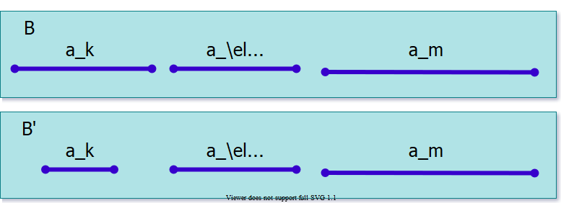
center h:250px

Greedy Algorithm
- So far, we have:
  - Optimal substructure property: If $A=\{a_{k},…\}$ is an optimal solution, then $A−\{a_{k}\}$ must be optimal for subproblem $S_{k}′$, where $Sk′=\{a_{i}∈S:s_{i}≥f_{k}\}$
    - Note: $a_{k}$ is the activity with the earliest finish time in $A$
  - Greedy choice property: There is an optimal solution $A$ that contains $a_{1}$
    - Note: $a_{1}$ is the activity with the earliest finish time in $S$

Greedy Algorithm
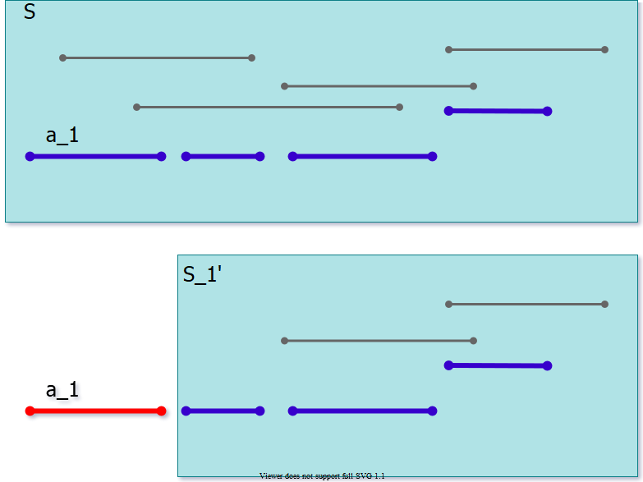
center h:450px
explained in the next slide..

Greedy Algorithm
- Theorem: There exists an optimal solution $A⊆S$ such that $a_{1}∈A$
- Basic idea of the greedy algorithm:
  - Add $a_{1}$ to $A$
  - Solve the remaining subproblem $S_{1}′$, and then append the result to $A$
- Remember arbitary optimal solution explaination from previous sections (finish time order is important for $a_{1}$ selection with star time and overlapping checking)
  - $B=\{a_{k},a_{ℓ},a_{m},…\}$,
  - where $f_{k}<f_{ℓ}<f_{m}<…$

Greedy Algorithm for Activity Selection

Definitions in Greedy Algorithm:
- $j$: specifies the index of most recent activity added to $A$
- $f_{j}=Max\{f_{k}:k∈A\}$, max finish time of any activity in $A$;
  - because activities are processed in non-decreasing order of finish times
- Thus, $s_{i}≥f_{j}$ checks the compatibility of $i$ to current $A$
- Running time: $Θ\left(n\right)$ assuming that the activities were already sorted.

Greedy Algorithm for Activity Selection

Pseudocode for Greedy Algorithm:
$$ $$

Greedy Algorithm for Activity Selection, An Example (Step-1)
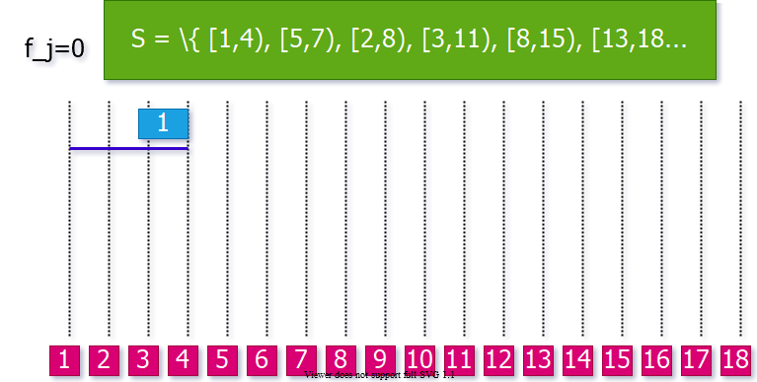
center h:450px

Greedy Algorithm for Activity Selection, An Example (Step-2)
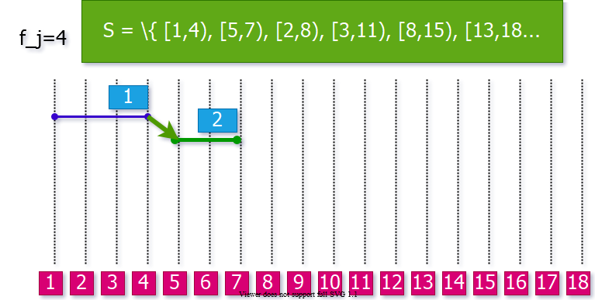
center h:450px

Greedy Algorithm for Activity Selection, An Example (Step-3)
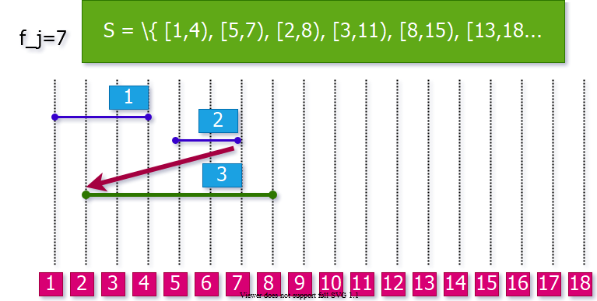
center h:450px

Greedy Algorithm for Activity Selection, An Example (Step-4)
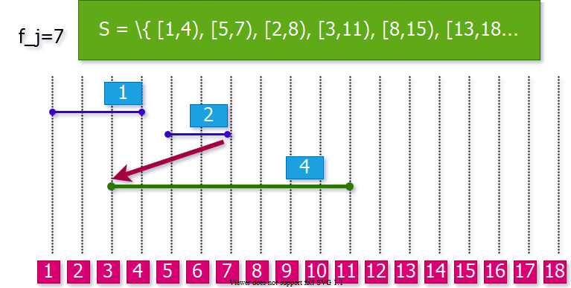
center h:450px

Greedy Algorithm for Activity Selection, An Example (Step-5)
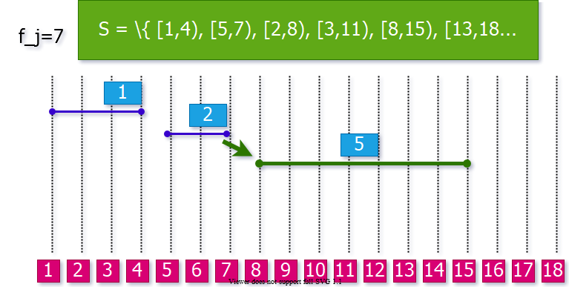
center h:450px

Greedy Algorithm for Activity Selection, An Example (Step-6)
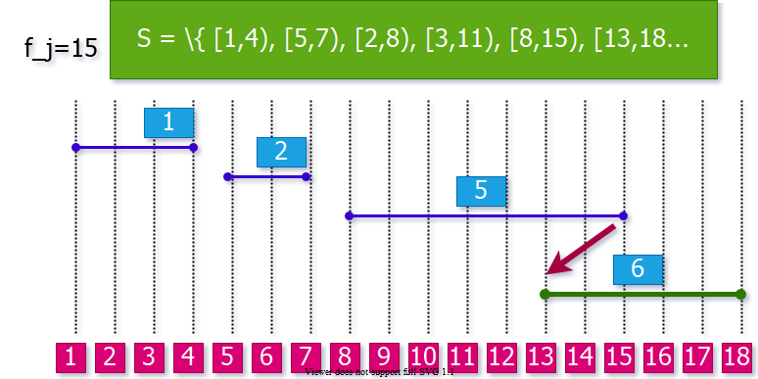
center h:450px

Greedy Algorithm for Activity Selection, An Example (Step-7)

Final Solution
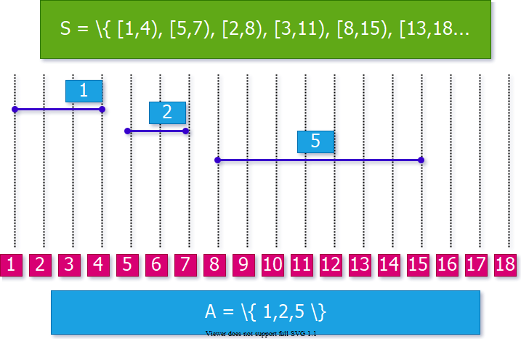
center h:450px

Comparison of DP and Greedy Algorithms

Reminder: DP-Based Matrix Chain Order
$$m_{ij}=\underset{i≤k<j}{MIN}\{m_{ik}+m_{k+1,j}+p_{i−1}p_{k}p_{j}\}$$
- We don’t know ahead of time which $k$ value to choose.
- We first need to compute the results of subproblems $m_{ik}$ and $m_{k+1,j}$ before computing $m_{ij}$
- The selection of $k$ is done based on the results of the subproblems.

Greedy Algorithm for Activity Selection
center h:450px
explained in the next slide..

Greedy Algorithm for Activity Selection
- Make a greedy selection in the beginning:
  - Choose $a_{1}$ (the activity with the earliest finish time)
- Solve the remaining subproblem $S_{1}′$ (all activities that start after a1)

Greedy vs Dynamic Programming
- Optimal substructure property exploited by both Greedy and DP strategies
- Greedy Choice Property: A sequence of locally optimal choices $⇒$ an optimal solution
  - We make the choice that seems best at the moment
  - Then solve the subproblem arising after the choice is made
- DP: We also make a choice/decision at each step, but the choice may depend on the optimal solutions to subproblems
- Greedy: The choice may depend on the choices made so far, but it cannot depend on any future choices or on the solutions to subproblems

Greedy vs Dynamic Programming
- DP is a bottom-up strategy (use memory to store the results of subproblems)
- Greedy is a top-down strategy (make choices at each step)
  - each greedy choice in the sequence iteratively reduces each problem to a similar but smaller problem

Proof of Correctness of Greedy Algorithms
- Examine a globally optimal solution
- Show that this soln can be modified so that

    - A greedy choice is made as the first step

    - This choice reduces the problem to a similar but smaller problem
- Apply induction to show that a greedy choice can be used at every step
- Showing (2) reduces the proof of correctness to proving that the problem exhibits optimal substructure property

Greedy Choice Property - Proof
- Theorem: There exists an optimal solution $A⊆S$ such that $a_{1}∈A$
- Proof: Consider an arbitrary optimal solution $B=\{a_{k},a_{ℓ},a_{m},…\}$, where $f_{k}<f_{ℓ}<f_{m}<…$
  - If $k=1$, then $B$ starts with $a_{1}$, and the proof is complete
  - If $k>1$, then create another solution $B′$ by replacing $a_{k}$ with $a_{1}$. Since $f_{1}≤f_{k}$, $B′$ is guaranteed to be valid, and $\left|B′\right|=\left|B\right|$, hence also optimal
center h:250px

Elements of Greedy Strategy
- How can you judge whether
- A greedy algorithm will solve a particular optimization problem?
- Two key ingredients
  - Greedy choice property
  - Optimal substructure property

Key Ingredients of Greedy Strategy
- Greedy Choice Property: A globally optimal solution can be arrived at by making locally optimal (greedy) choices
- In DP,we make a choice at each step but the choice may depend on the solutions to subproblems
- In Greedy Algorithms, we make the choice that seems best at that moment then solve the subproblems arising after the choice is made
  - The choice may depend on choices so far, but it cannot depend on any future choice or on the solutions to subproblems
- DP solves the problem bottom-up
- Greedy usually progresses in a top-down fashion by making one greedy choice after another reducing each given problem instance to a smaller one

Key Ingredients: Greedy Choice Property
- We must prove that a greedy choice at each step yields a globally optimal solution
- The proof examines a globally optimal solution
- Shows that the soln can be modified so that a greedy choice made as the first step reduces the problem to a similar but smaller subproblem
- Then induction is applied to show that a greedy choice can be used at each step
- Hence, this induction proof reduces the proof of correctness to demonstrating that an optimal solution must exhibit optimal substructure property

Key Ingredients: Greedy Choice Property
- How to prove the greedy choice property?
  - Consider the greedy choice $c$
  - Assume that there is an optimal solution $B$ that doesn’t contain $c$.
  - Show that it is possible to convert $B$ to another optimal solution $B′$, where $B′$ contains $c$.
- Example: Activity selection algorithm
  - Greedy choice: $a_{1}$ (the activity with the earliest finish time)
  - Consider an optimal solution $B$ without $a_{1}$
  - Replace the first activity in $B$ with $a_{1}$ to construct $B′$
  - Prove that $B′$ must be an optimal solution

Key Ingredients: Optimal Substructure
- A problem exhibits optimal substructure if an optimal solution to the problem contains within it optimal solutions to subproblems
- Example: Activity selection problem $S$
  - If an optimal solution A to S begins with activity a1 then the set of activities
$$A′=A−\{a_{1}\}$$
  - is an optimal solution to the activity selection problem
$$S′=\{a_{i}∈S:s_{i}≥f_{1}\}$$
  - where $s_{i}$ is the start time of activity $a_{i}$ and $f_{i}$ is the finish time of activity $a_{i}$

Key Ingredients: Optimal Substructure
- Optimal substructure property is exploited by both Greedy and dynamic programming strategies
- Hence one may
  - Try to generate a dynamic programming soln to a problem when a greedy strategy suffices → inefficient
  - Or, may mistakenly think that a greedy soln works when in fact a DP soln is required → incorrect
- Example: Knapsack Problems(S, w)

Knapsack Problems

Knapsack Problem
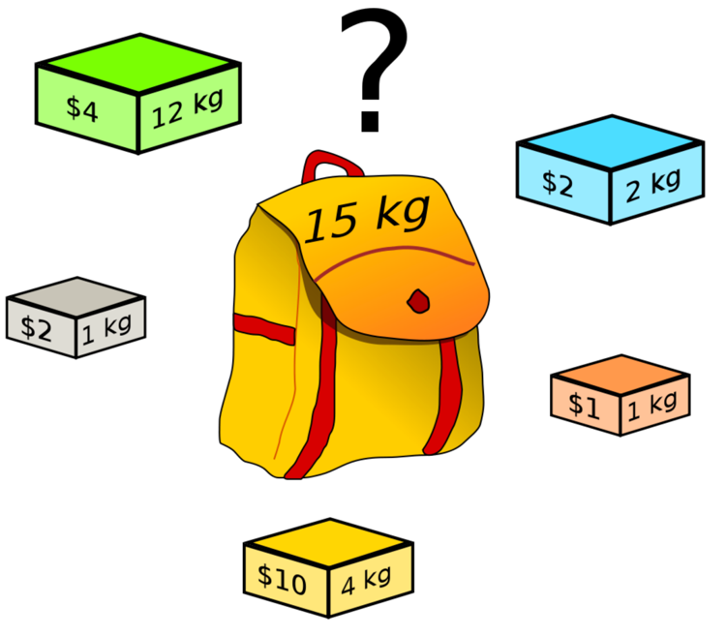
bg right:40% h:400px
- Each item $i$ has:
  - weight $w_{i}$
  - value $v_{i}$
- A thief has a knapsack of weight capacity $w$
- Which items to choose to maximize the value of the items in the knapsack?

Knapsack Problem: Two Versions
- The 0-1 knapsack problem:
  - Each item is discrete.
  - Each item either chosen as a whole or not chosen.
  - Examples: TV, laptop, gold bricks, etc.
- The fractional knapsack problem:
  - Can choose fractional part of each item.
  - If item i has weight wi, we can choose any amount ≤ wi
  - Examples: Gold dust, silver dust, rice, etc.

Knapsack Problems
- The 0-1 Knapsack Problem($S,W$)
  - A thief robbing a store finds $n$ items $S=\{I_{1},I_{2},…,I_{n}\}$, the ith item is worth $v_{i}$ dollars and weighs $w_{i}$ pounds, where vi and wi are integers
  - He wants to take as valuable a load as possible, but he can carry at most $W$ pounds in his knapsack, where $W$ is an integer
  - The thief cannot take a fractional amount of an item
- The Fractional Knapsack Problem ($S,W$)
  - The scenario is the same
  - But, the thief can take fractions of items rather than having to make binary ($0−1$) choice for each item

Optimal Substructure Property for the 0-1 Knapsack Problem (S, W)
- Consider an optimal load L for the problem (S, W).
- Let Ij be an item chosen in L with weight wj
- Assume we remove Ij from L, and let:
$$\begin{matrix} & L_{j}′=L–\{I_{j}\} \\ & S_{j}′=S–\{I_{j}\} \\ & W_{j}′=W–w_{j}\end{matrix}$$
- Q: What can we say about the optimal substructure property?
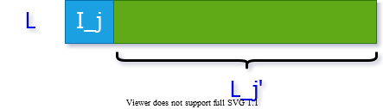
center h:150px

Optimal Substructure Property for the 0-1 Knapsack Problem (S, W)
$$\begin{matrix} & L_{j}′=L–\{I_{j}\} \\ & S_{j}′=S–\{I_{j}\} \\ & W_{j}′=W–w_{j}\end{matrix}$$
- Optimal substructure property:
  - $L_{j}′$ must be an optimal solution for $\left(S_{j}′,W_{j}′\right)$
- Why?
  - If we remove item $j$ from $L$, we can construct a new optimal solution $L_{j}′$ for $\left(S_{j}′,W_{j}′\right)$
  - If $L_{j}′$ is optimal, then $L$ must be optimal
center h:150px

Optimal Substructure Property for the 0-1 Knapsack Problem (S, W)
$$\begin{matrix} & L_{j}′=L–\{I_{j}\} \\ & S_{j}′=S–\{I_{j}\} \\ & W_{j}′=W–w_{j}\end{matrix}$$
- Optimal substructure: $L_{j}′$ must be an optimal solution for $\left(S_{j}′,W_{j}′\right)$
- Proof: By contradiction, assume there is a solution $B_{j}′$ for $\left(S_{j}′,W_{j}′\right)$, which is better than $L_{j}′$.
  - We can construct a solution B for the original problem ($S,W$) as: $B=Bjʹ∪Ij$.
  - The total value of $B$ is now higher than $L$, which is a contradiction because $L$ is optimal for $\left(S,W\right)$.
- $Q.E.D.$

Optimal Substructure Property for the Fractional Knapsack Problem (S, W)
- Consider an optimal solution L for (S, W)
- If we remove a weight $0<w≤w_{j}$ of item $j$ from optimal load $L$ and let:
  - The remaining load
$$L_{j}′=L−\{w \text{pounds of} I_{j}\}$$
  - must be a most valuable load weighing at most
$$W_{j}′=W−w$$
  - pounds that the thief can take from
$$S_{j}′=S−\{I_{j}\}∪\{w_{j}−w \text{pounds of} I_{j}\}$$
- That is, Lj´ should be an optimal soln to the
$$\text{Fractional Knapsack Problem}\left(S_{j}′,W_{j}′\right)$$

Knapsack Problems
- Two different problems:
  - 0-1 knapsack problem
  - Fractional knapsack problem
- The problems are similar.
  - Both problems have optimal substructure property.
- Which algorithm to solve each problem?

Fractional Knapsack Problem
- Can we use a greedy algorithm?
- Greedy choice: Take as much as possible from the item with the largest value per pound $v_{i}/w_{i}$
- Does the greedy choice property hold?
  - Let $j$ be the item with the largest value per pound $v_{j}/w_{j}$
  - Need to prove that there is an optimal load that has as much $j$ as possible.
  - Proof: Consider an optimal solution L that does not have the maximum amount of item $j$. We could replace the items in $L$ with item $j$ until $L$ has maximum amount of $j$. $L$ would still be optimal, because item $j$ has the highest value per pound.

Greedy Solution to Fractional Knapsack

  - Compute the value per pound $v_{i}/w_{i}$ for each item

  - The thief begins by taking, as much as possible, of the item with the greatest value per pound

  - If the supply of that item is exhausted before filling the knapsack, then he takes, as much as possible, of the item with the next greatest value per pound

  - Repeat (2-3) until his knapsack becomes full
Thus, by sorting the items by value per pound the greedy algorithm runs in $O\left(nlgn\right)$ time

Fractional Knapsack Problem: Example
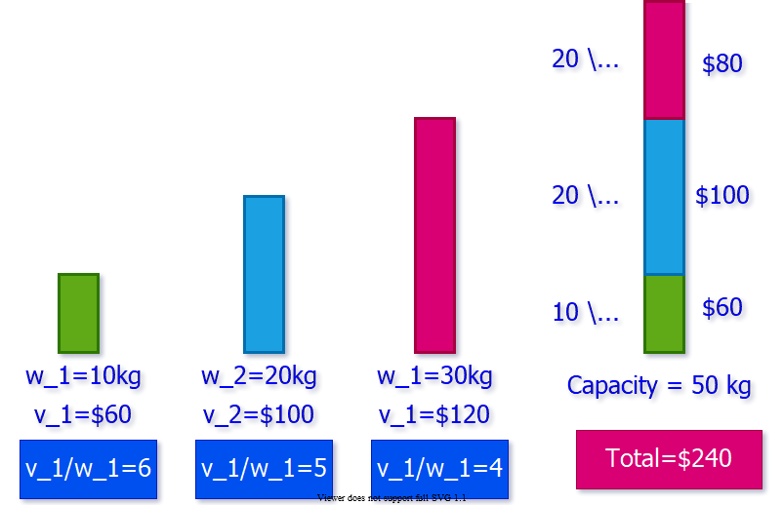
center h:450px

0-1 Knapsack Problem
- Can we use the same greedy algorithm?
  - Is there a better solution?
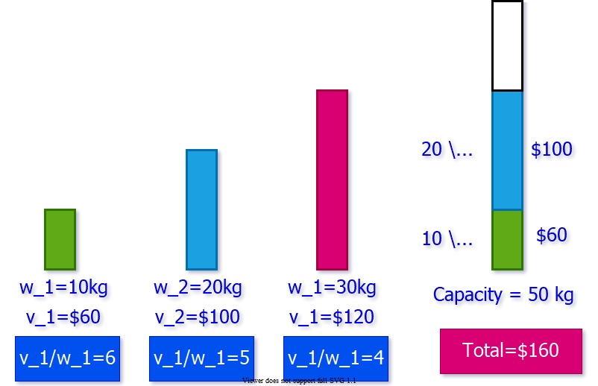
center h:450px

0-1 Knapsack Problem
- The optimal solution for this problem is:
  - This solution cannot be obtained using the greedy algorithm
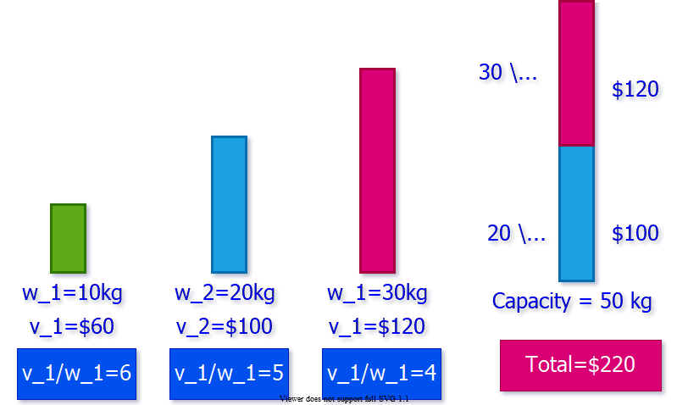
center h:450px

0-1 Knapsack Problem
- When we consider an item $I_{j}$ for inclusion we must compare the solutions to two subproblems
  - Subproblems in which $I_{j}$ is included and excluded
- The problem formulated in this way gives rise to many
  - overlapping subproblems (a key ingredient of DP)
    - In fact, dynamic programming can be used to solve the 0-1 Knapsack problem

0-1 Knapsack Problem
- A thief robbing a store containing $n$ articles
  - $\{a_{1},a_{2},…,a_{n}\}$
- The value of $i_{th}$ article is $v_{i}$ dollars ($v_{i}$ is integer)
- The weight of $i_{th}$ article is $w_{i}$ kg ($w_{i}$ is integer)
- Thief can carry at most $W$ kg in his knapsack
- Which articles should he take to maximize the value of his load?
- Let $K_{n,W}=\{a_{1},a_{2},…,a_{n}:W\}$ denote 0-1 knapsack problem
- Consider the solution as a sequence of $n$ decisions
  - i.e., $i_{th}$ decision: whether thief should pick $a_{i}$ for optimal load.

Optimal Substructure Property
- Notation: $K_{n,W}$:
  - The items to choose from: $\{a_{1},…,a_{n}\}$
  - The knapsack capacity: $W$
- Consider an optimal load $L$ for problem $K_{n,W}$
- Let’s consider two cases:
  - $a_{n}$ is in $L$
  - $a_{n}$ is not in $L$

Optimal Substructure Property
- Case 1: If $a_{n}∈L$
  - What can we say about the optimal substructure?
    - $L–\{a_{n}\}$ must be optimal for $K_{n−1,W−wn}$
    - $K_{n−1,W−wn}$:
      - The items to choose from $\{a_{1},…a_{n−1}\}$
      - The knapsack capacity: $W–wn$
- Case 2: If $a_{n}∉L$
  - What can we say about the optimal substructure?
    - $L$ must be optimal for $K_{n−1,W}$
      - $K_{n−1,W}$:
      - The items to choose from $\{a_{1},…a_{n−1}\}$
      - The knapsack capacity: $W$

Optimal Substructure Property
- In other words, optimal solution to $K_{n,W}$ contains an optimal solution to:
  - either: $K_{n−1,W−wn}$ (if $a_{n}$ is selected)
  - or: $K_{n−1,W}$ (if $a_{n}$ is not selected)

Recursive Formulation
$$c\left[i,w\right]=\left\{\begin{matrix}0 & \text{ if }i=0, \text{or} w=0 \\ c\left[i−1,w\right], & \text{ if }w_{i}>w \\ max\{v_{i}+c\left[i−1,w−w_{i}\right],c\left[i−1,w\right] & otherwise\end{matrix}\right.$$

0-1 Knapsack Problem
- Recursive definition for value of optimal soln:
  - This recurrence says that an optimal solution $S_{i,w}$ for $K_{i,w}$
    - either contains $a_{i}⇒c\left(S_{i},w\right)=v_{i}+c\left(S_{i−1,w−w_{i}}\right)$
    - or does not contain $a_{i}⇒c\left(Si,w\right)=c\left(S_{i−1},w\right)$
  - If thief decides to pick $a_{i}$
    - He takes $v_{i}$ value and he can choose from $\{a_{1},a_{2},…,a_{i−1}\}$ up to the weight limit $w−w_{i}$ to get $c\left[i−1,w−w_{i}\right]$
  - If he decides not to pick $a_{i}$
    - He can choose from $\{a_{1},a_{2},…,a_{i−1}\}$ up to the weight limit $w$ to get $c\left[i−1,w\right]$
  - The better of these two choices should be made

Bottom-up Computation
- Need to process:
  - $c\left[i,w\right]$
- after computing:
  - $c\left[i−1,w\right]$,
  - $c\left[i−1,w−w_{i}\right]$
    - for all $w_{i}<w$
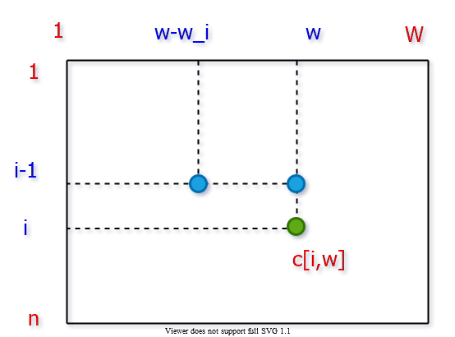
bg right:50% h:500px

Bottom-up Computation
$$\begin{matrix} & \text{for} i←1 \text{to} n \text{do} \\ & \text{for} w←1 \text{to} W \text{do} \\ & … \\ & c\left[i,w\right]←… \\ & …\end{matrix}$$
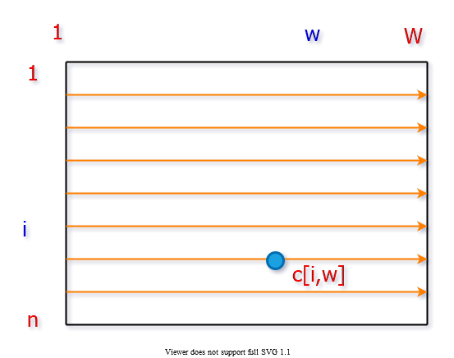
bg right:50% h:500px

DP Solution to 0-1 Knapsack
- $c$ is an $\left(n+1\right)×\left(W+1\right)$ array; $c\left[0…n:0…W\right]$
- Note : table is computed in row-major order
- Run time: $T\left(n\right)=Θ\left(nW\right)$

DP Solution to 0-1 Knapsack
$$\begin{matrix} & \text{KNAP0-1}\left(v,w,n,W\right) \\ & \text{for} ω←0 \text{to} W \text{do} \\ & c\left[0,ω\right]←0 \\ & \text{for} i←0 \text{to} m \text{do} \\ & c\left[i,0\right]←0 \\ & \text{for} i←0 \text{to} m \text{do} \\ & \text{for} ω←1 \text{to} W \text{do} \\ & \text{if} w_{i}≤ω \text{then} \\ & c\left[i,ω\right]←max\{v_{i}+c\left[i−1,ω−w_{i}\right],c\left[i−1,ω\right]\} \\ & \text{else} \\ & c\left[i,ω\right]←c\left[i−1,ω\right] \\ & return c\left[m,W\right]\end{matrix}$$

Constructing an Optimal Solution
- No extra data structure is maintained to keep track of the choices made to compute $c\left[i,w\right]$
  - i.e. The choice of whether choosing item i or not
- Possible to understand the choice done by comparing $c\left[i,w\right]$ with $c\left[i−1,w\right]$
  - If $c\left[i,w\right]=c\left[i−1,w\right]$ then it means item i was assumed to be not chosen for the best $c\left[i,w\right]$

Finding the Set S of Articles in an Optimal Load
$$\begin{matrix} & \text{SOLKNAP0-1}\left(a,v,w,n,W,c\right) \\ & i←n;ω←W \\ & S←∅ \\ & while i←0 do \\ & if c\left[i,ω\right]=c\left[i−1,ω\right] then \\ & i←i−1 \\ & else \\ & S←S∪\{a_{i}\} \\ & ω←ω−w_{i} \\ & i←i−1 \\ & return S\end{matrix}$$

References
- Introduction to Algorithms, Third Edition | The MIT Press
- Bilkent CS473 Course Notes (new)
- Bilkent CS473 Course Notes (old)

$−End−Of−Week−7−Course−Module−$

