CE100 Algorithms and Programming II
Dynamic Programming
Author: Asst. Prof. Dr. Uğur CORUH

CE100 Algorithms and Programming II

Week-5 (Dynamic Programming)

Spring Semester, 2021-2022
Download DOC-PDF, DOC-DOCX, SLIDE, PPTX

Quicksort Sort

Outline
- Convex Hull (Divide & Conquer)
- Dynamic Programming
  - Introduction
  - Divide-and-Conquer (DAC) vs Dynamic Programming (DP)

- Fibonacci Numbers
  - Recursive Solution
  - Bottom-Up Solution
- Optimization Problems
- Development of a DP Algorithms

- Matrix-Chain Multiplication
  - Matrix Multiplication and Row Columns Definitions
  - Cost of Multiplication Operations (pxqxr)
  - Counting the Number of Parenthesizations

- The Structure of Optimal Parenthesization
  - Characterize the structure of an optimal solution
  - A Recursive Solution
    - Direct Recursion Inefficiency.
  - Computing the optimal Cost of Matrix-Chain Multiplication
  - Bottom-up Computation

- Algorithm for Computing the Optimal Costs
  - MATRIX-CHAIN-ORDER
- Construction and Optimal Solution
  - MATRIX-CHAIN-MULTIPLY
- Summary

Dynamic Programming - Introduction
- An algorithm design paradigm like divide-and-conquer
- Programming: A tabular method (not writing computer code)
  - Older sense of planning or scheduling, typically by filling in a table
- Divide-and-Conquer (DAC): subproblems are independent
- Dynamic Programming (DP): subproblems are not independent
- Overlapping subproblems: subproblems share sub-subproblems
  - In solving problems with overlapping subproblems
    - A DAC algorithm does redundant work
      - Repeatedly solves common subproblems
    - A DP algorithm solves each problem just once
      - Saves its result in a table

Problem 1: Fibonacci Numbers Recursive Solution
- Reminder:
$$\begin{matrix} & F\left(0\right)=0\text{ and }F\left(1\right)=1 \\ & F\left(n\right)=F\left(n−1\right)+F\left(n−2\right) \\ & \text{REC-FIBO}\left(n\right)\{ \\ & \text{if} n<2 \\ & \text{return} n \\ & \text{else} \\ & \text{return} \text{REC-FIBO}\left(n−1\right)+\text{REC-FIBO}\left(n−2\right) \}\end{matrix}$$
- Overlapping subproblems in different recursive calls. Repeated work!
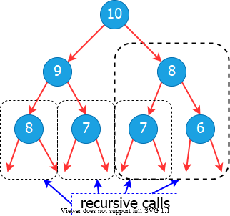
bg right:40% w:500px

Problem 1: Fibonacci Numbers Recursive Solution
- Recurrence:
  - exponential runtime
$$T\left(n\right)=T\left(n−1\right)+T\left(n−2\right)+1$$
- Recursive algorithm inefficient because it recomputes the same $F\left(i\right)$ repeatedly in different branches of the recursion tree.

Problem 1: Fibonacci Numbers Bottom-up Computation
- Reminder:
$$\begin{matrix} & F\left(0\right)=0\text{ and }F\left(1\right)=1 \\ & F\left(n\right)=F\left(n−1\right)+F\left(n−2\right)\end{matrix}$$
- Runtime $Θ\left(n\right)$
ITER-FIBO(n)
F[0] = 0
F[1] = 1
for i = 2 to n do
F[i] = F[i-1] + F[i-2]
return F[n]
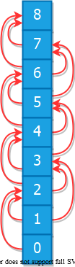
bg right:40% w:150px

Optimization Problems
- DP typically applied to optimization problems
- In an optimization problem
  - There are many possible solutions (feasible solutions)
  - Each solution has a value
  - Want to find an optimal solution to the problem
    - A solution with the optimal value (min or max value)
  - Wrong to say the optimal solution to the problem
    - There may be several solutions with the same optimal value

Development of a DP Algorithm
Step-1. Characterize the structure of an optimal solution Step-2. Recursively define the value of an optimal solution Step-3. Compute the value of an optimal solution in a bottom-up fashion Step-4. Construct an optimal solution from the information computed in Step 3

Problem 2: Matric Chain Multiplication
- Input: a sequence (chain) $⟨A_{1},A_{2},…,A_{n}⟩$ of $n$ matrices
- Aim: compute the product $A_{1}⋅A_{2}⋅…A_{n}$
- A product of matrices is fully parenthesized if
  - It is either a single matrix
  - Or, the product of two fully parenthesized matrix products surrounded by a pair of parentheses. $(A_{i}\left(A_{i+1}A_{i+2}…A_{j}\right))$ $(\left(A_{i}A_{i+1}A_{i+2}…A_{j−1}\right)A_{j})$ $(\left(A_{i}A_{i+1}A_{i+2}…A_{k}\right)\left(A_{k+1}A_{k+2}…A_{j}\right))$ for $i≤k<j$
- All parenthesizations yield the same product; matrix product is associative

Matrix-chain Multiplication: An Example Parenthesization
- Input: $⟨A_{1},A_{2},A_{3},A_{4}⟩$ ($5$ distinct ways of full parenthesization)
$$\begin{matrix} & (A_{1}(A_{2}\left(A_{3}A_{4}\right))) \\ & (A_{1}(\left(A_{2}A_{3}\right)A_{4})) \\ & (\left(A_{1}A_{2}\right)\left(A_{3}A_{4}\right)) \\ & ((A_{1}\left(A_{2}A_{3}\right)A_{4})) \\ & ((\left(A_{1}A_{2}\right)A_{3})A_{4})\end{matrix}$$
- The way we parenthesize a chain of matrices can have a dramatic effect on the cost of computing the product

Matrix-chain Multiplication: Reminder
MATRIX-MULTIPLY(A, B)
if cols[A]!=rows[B] then
error(“incompatible dimensions”)
for i=1 to rows[A] do
for j=1 to cols[B] do
C[i,j]=0
for k=1 to cols[A] do
C[i,j]=C[i,j]+A[i,k]·B[k,j]
return C
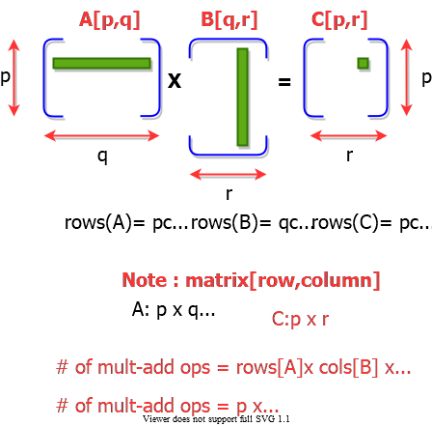
bg right:50% w:500px

Matrix Chain Multiplication: Example
- $A1:10\text{x}100$, $A2:100\text{x}5$, $A3:5\text{x}50$
  - Which paranthesization is better? $\left(A1A2\right)A3$ or $A1\left(A2A3\right)$?
- 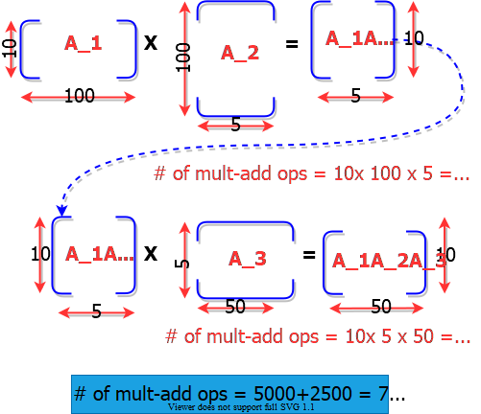
- bg right:50% w:650px

Matrix Chain Multiplication: Example
- $A1:10×100$, $A2:100×5$, $A3:5×50$
  - Which paranthesization is better? $\left(A1A2\right)A3$ or $A1\left(A2A3\right)$?
- 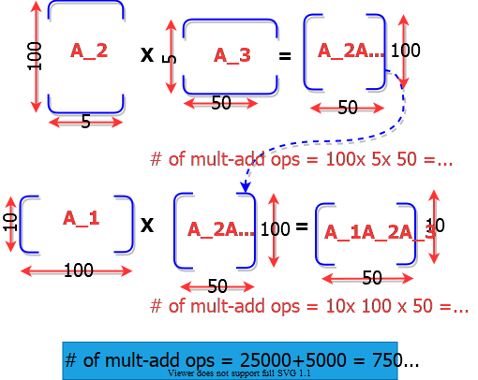
- bg right:50% w:650px

Matrix Chain Multiplication: Example
- $A1:10×100$, $A2:100×5$, $A3:5×50$
  - Which paranthesization is better? $\left(A1A2\right)A3$ or $A1\left(A2A3\right)$?
In summary:
- $\left(A1A2\right)A3$ = $\#$ of multiply-add ops: $7500$
- $A1\left(A2A3\right)$ = $\#$ of multiple-add ops: $75000$
First parenthesization yields 10x faster computation

Matrix-chain Multiplication Problem
- Input: A chain $⟨A_{1},A_{2},…,A_{n}⟩$ of $n$ matrices,
  - where $A_{i}$ is a $p_{i−1}×p_{i}$ matrix
- Objective: Fully parenthesize the product
  - $A_{1}⋅A_{2}…A_{n}$
    - such that the number of scalar mult-adds is minimized.

Counting the Number of Parenthesizations
- Brute force approach: exhaustively check all parenthesizations
- $P\left(n\right)$: $\#$ of parenthesizations of a sequence of n matrices
- We can split sequence between $k^{th}$ and ${\left(k+1\right)}^{st}$ matrices for any $k=1,2,…,n−1$ , then parenthesize the two resulting sequences independently, i.e.,
$$\left(A_{1}A_{2}A_{3}…A_{k}\overset{break−point}{\overbrace{)(}}A_{k+1}A_{k+2}…A_{n}\right)$$
- We obtain the recurrence
$$P\left(1\right)=1\text{ and }P\left(n\right)=\sum_{k=1}^{n−1}{P}\left(k\right)P\left(n−k\right)$$

Number of Parenthesizations:
- $P\left(1\right)=1$ and $P\left(n\right)=\sum_{k=1}^{n−1}{P}\left(k\right)P\left(n−k\right)$
- The recurrence generates the sequence of Catalan Numbers Solution is $P\left(n\right)=C\left(n−1\right)$ where
$$C\left(n\right)=\frac{1}{n+1}\left({2n \atop n}\right)=Ω\left(4^{n}/n^{3/2}\right)$$
- The number of solutions is exponential in $n$
- Therefore, brute force approach is a poor strategy

The Structure of Optimal Parenthesization
- Notation: $A_{i..j}$: The matrix that results from evaluation of the product: $A_{i}A_{i+1}A_{i+2}…A_{j}$
- Observation: Consider the last multiplication operation in any parenthesization: $\left(A_{1}A_{2}…A_{k}\right)⋅\left(A_{k+1}A_{k+2}…A_{n}\right)$
  - There is a $k$ value $\left(1≤k<n\right)$ such that:
    - First, the product $A_{1}…k$ is computed
    - Then, the product $A_{k+1…n}$ is computed
    - Finally, the matrices $A_{1…k}$ and $A_{k+1…n}$ are multiplied

Step 1: Characterize the Structure of an Optimal Solution
- An optimal parenthesization of product $A_{1}A_{2}…A_{n}$ will be: $\left(A_{1}A_{2}…A_{k}\right)⋅\left(A_{k+1}A_{k+2}…A_{n}\right)$ for some $k$ value
- The cost of this optimal parenthesization will be: $=$ Cost of computing $A_{1…k}$ $+$ Cost of computing $A_{k+1…n}$ $+$ Cost of multiplying $A_{1…k}⋅A_{k+1…n}$

Step 1: Characterize the Structure of an Optimal Solution
- Key observation: Given optimal parenthesization
  - $\left(A_{1}A_{2}A_{3}…A_{k}\right)⋅\left(A_{k+1}A_{k+2}…A_{n}\right)$
- Parenthesization of the subchain $A_{1}A_{2}A_{3}…A_{k}$
- Parenthesization of the subchain $A_{k+1}A_{k+2}…A_{n}$
should both be optimal
- Thus, optimal solution to an instance of the problem contains optimal solutions to subproblem instances
  - i.e., optimal substructure within an optimal solution exists.

Step 2: A Recursive Solution
- Step 2: Define the value of an optimal solution recursively in terms of optimal solutions to the subproblems
- Assume we are trying to determine the min cost of computing $A_{i…j}$
- $m_{i,j}$: min $\#$ of scalar multiply-add opns needed to compute $A_{i…j}$
  - Note: The optimal cost of the original problem: $m_{1,n}$
- How to compute $m_{i,j}$ recursively?

Step 2: A Recursive Solution
- Base case: $m_{i,i}=0$ (single matrix, no multiplication)
- Let the size of matrix $A_{i}$ be $\left(p_{i−1}×p_{i}\right)$
- Consider an optimal parenthesization of chain
  - $A_{i}…A_{j}:\left(A_{i}…A_{k}\right)⋅\left(A_{k+1}…A_{j}\right)$
- The optimal cost: $m_{i,j}=m_{i,k}+m_{k+1,j}+p_{i−1}×p_{k}×p_{j}$
- where:
  - $m_{i,k}$: Optimal cost of computing $A_{i…k}$
  - $m_{k+1,j}$: Optimal cost of computing $A_{k+1…j}$
  - $p_{i−1}×p_{k}×p_{j}$ : Cost of multiplying $A_{i…k}$ and $A_{k+1…j}$

Step 2: A Recursive Solution
- In an optimal parenthesization: $k$ must be chosen to minimize $m_{ij}$
- The recursive formulation for $m_{ij}$:
$$\begin{matrix}m_{ij}=\left\{\begin{matrix}0 & if & i=j \\ \underset{i≤k<j}{MIN}\{m_{ik}+m_{k+1,j}+p_{i−1}p_{k}p_{j}\} & if & i<j\end{matrix}\right.\end{matrix}$$

Step 2: A Recursive Solution
- The $m_{ij}$ values give the costs of optimal solutions to subproblems
- In order to keep track of how to construct an optimal solution
  - Define $s_{ij}$ to be the value of $k$ which yields the optimal split of the subchain $A_{i…j}$
    - That is, $s_{ij}=k$ such that
      - $m_{ij}=m_{ik}+m_{k+1,j}+p_{i−1}p_{k}p_{j}$ holds

Direct Recursion: Inefficient!
- Recursive Matrix-Chain (RMC) Order
RMC(p,i,j)
if (i == j) then
return 0
m[i, j] = INF
for k=i to j-1 do
q = RMC(p, i, k) + RMC(p, k+1, j) + p_{i-1} p_k p_j
if q < m[i, j] then
m[i, j] = q
endfor
return m[i, j]

Direct Recursion: Inefficient!
- Recursion tree for $RMC\left(p,1,4\right)$
- Nodes are labeled with $i$ and $j$ values
- 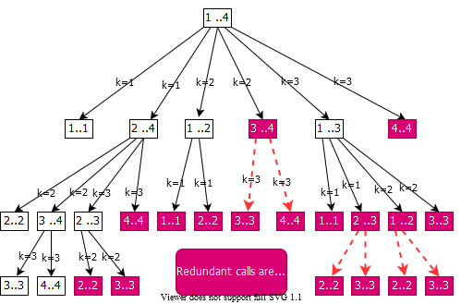
- bg right:60% w:650px

Computing the Optimal Cost (Matrix-Chain Multiplication)
An important observation: - We have relatively few subproblems - one problem for each choice of $i$ and $j$ satisfying $1≤i≤j≤n$ - total $n+\left(n−1\right)+…+2+1=\frac{1}{2}n\left(n+1\right)=Θ\left(n2\right)$ subproblems - We can write a recursive algorithm based on recurrence. - However, a recursive algorithm may encounter each subproblem many times in different branches of the recursion tree - This property, overlapping subproblems, is the second important feature for applicability of dynamic programming

Computing the Optimal Cost (Matrix-Chain Multiplication)
- Compute the value of an optimal solution in a bottom-up fashion
  - matrix $A_{i}$ has dimensions $p_{i−1}×p_{i}$ for $i=1,2,…,n$
  - the input is a sequence $⟨p_{0},p_{1},…,p_{n}⟩$ where $length\left[p\right]=n+1$
- Procedure uses the following auxiliary tables:
  - $m\left[1…n,1…n\right]$: for storing the $m\left[i,j\right]$ costs
  - $s\left[1…n,1…n\right]$: records which index of $k$ achieved the optimal cost in computing $m\left[i,j\right]$

Bottom-Up Computation
- How to choose the order in which we process $m_{ij}$ values?
- Before computing $m_{ij}$, we have to make sure that the values for $m_{ik}$ and $m_{k+1,j}$ have been computed for all $k$.
$$m_{ij}=\underset{i≤k<j}{MIN}\{m_{ik}+m_{k+1,j}+p_{i−1}p_{k}p_{j}\}$$

Bottom-Up Computation
$$m_{ij}=\underset{i≤k<j}{MIN}\{m_{ik}+m_{k+1,j}+p_{i−1}p_{k}p_{j}\}$$
- $m_{ij}$ must be processed after $m_{ik}$ and $m_{j,k+1}$
- Reminder: $m_{ij}$ computed only for $j>i$
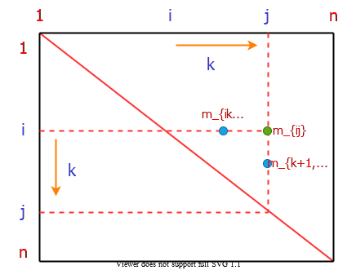
bg right:50% h:500px

Bottom-Up Computation
$$m_{ij}=\underset{i≤k<j}{MIN}\{m_{ik}+m_{k+1,j}+p_{i−1}p_{k}p_{j}\}$$
- $m_{ij}$ must be processed after $m_{ik}$ and $m_{j,k+1}$
- How to set up the iterations over $i$ and $j$ to compute $m_{ij}$?
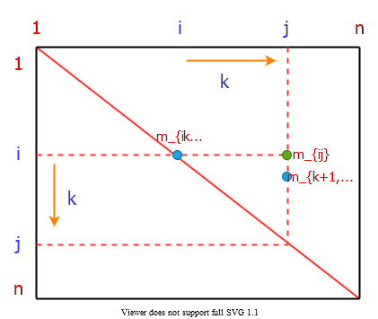
bg right:50% h:500px

Bottom-Up Computation
$$m_{ij}=\underset{i≤k<j}{MIN}\{m_{ik}+m_{k+1,j}+p_{i−1}p_{k}p_{j}\}$$
- If the entries $m_{ij}$ are computed in the shown order, then $m_{ik}$ and $m_{k+1,j}$ values are guaranteed to be computed before $m_{ij}$.
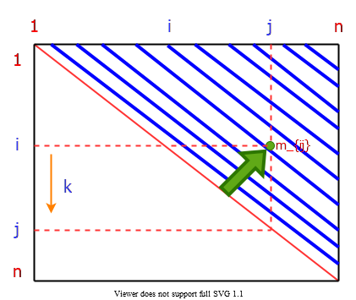
bg right:50% h:500px

Bottom-Up Computation
$$m_{ij}=\underset{i≤k<j}{MIN}\{m_{ik}+m_{k+1,j}+p_{i−1}p_{k}p_{j}\}$$
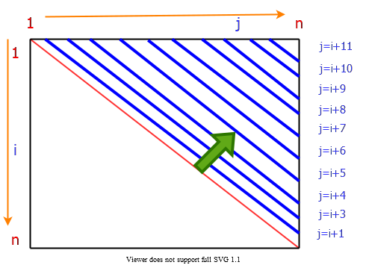
bg right:50% h:450px

Bottom-Up Computation
$$m_{ij}=\underset{i≤k<j}{MIN}\{m_{ik}+m_{k+1,j}+p_{i−1}p_{k}p_{j}\}$$
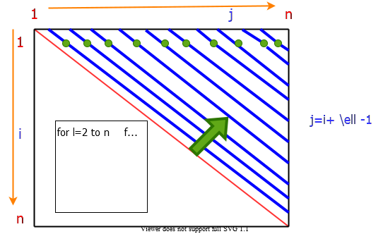
bg right:65% h:500px

Algorithm for Computing the Optimal Costs
- Note: l $=ℓ$ and p_{i-1} p_k p_j $=p_{i−1}p_{k}p_{j}$
MATRIX-CHAIN-ORDER(p)
n = length[p]-1
for i=1 to n do
m[i, i]=0
endfor
for l=2 to n do
for i=1 to n n-l+1 do
j=i+l-1
m[i, j]=INF
for k=i to j-1 do
q=m[i,k]+m[k+1, j]+p_{i-1} p_k p_j
if q < m[i,j] then
m[i,j]=q
s[i,j]=k
endfor
endfor
endfor
return m and s

Algorithm for Computing the Optimal Costs
- The algorithm first computes
  - $m\left[i,i\right]←0$ for $i=1,2,…,n$ min costs for all chains of length 1
- Then, for $ℓ=2,3,…,n$ computes
  - $m\left[i,i+ℓ−1\right]$ for $i=1,…,n−ℓ+1$ min costs for all chains of length $ℓ$
- For each value of $ℓ=2,3,…,n$,
  - $m\left[i,i+ℓ−1\right]$ depends only on table entries $m\left[i,k\right]\&m\left[k+1,i+ℓ−1\right]$ for $i≤k<i+ℓ−1$, which are already computed

Algorithm for Computing the Optimal Costs
$$\begin{matrix}\begin{matrix}\text{compute }m\left[i,i+1\right] \\ \underset{\left(n−1\right)\text{ values}}{\underset{⏟}{\{m\left[1,2\right],m\left[2,3\right],…,m\left[n−1,n\right]\}}}\end{matrix} & \left\{\begin{matrix} & ℓ=2 \\ & \text{for }i=1\text{ to }n−1\text{ do } \\ & m\left[i,i+1\right]=∞ \\ & \text{for }k=i\text{ to }i\text{ do } \\ & ⋮\end{matrix}\right. \\ \begin{matrix}\text{compute }m\left[i,i+2\right] \\ \underset{\left(n−2\right)\text{ values}}{\underset{⏟}{\{m\left[1,3\right],m\left[2,4\right],…,m\left[n−2,n\right]\}}}\end{matrix} & \left\{\begin{matrix} & ℓ=3 \\ & \text{for }i=1\text{ to }n−2\text{ do } \\ & m\left[i,i+2\right]=∞ \\ & \text{for }k=i\text{ to }i+1\text{ do } \\ & ⋮\end{matrix}\right. \\ \begin{matrix}\text{compute }m\left[i,i+3\right] \\ \underset{\left(n−3\right)\text{ values}}{\underset{⏟}{\{m\left[1,4\right],m\left[2,5\right],…,m\left[n−3,n\right]\}}}\end{matrix} & \left\{\begin{matrix} & ℓ=4 \\ & \text{for }i=1\text{ to }n−3\text{ do } \\ & m\left[i,i+3\right]=∞ \\ & \text{for }k=i\text{ to }i+2\text{ do } \\ & ⋮\end{matrix}\right.\end{matrix}$$

Table access pattern in computing $m\left[i,j\right]$s for $ℓ=j−i+1$
$$\begin{matrix} & \text{for} k←i \text{to} j−1 \text{do} \\ & q←m\left[i,k\right]+m\left[k+1,j\right]+p_{i−1}p_{k}p_{j}\end{matrix}$$
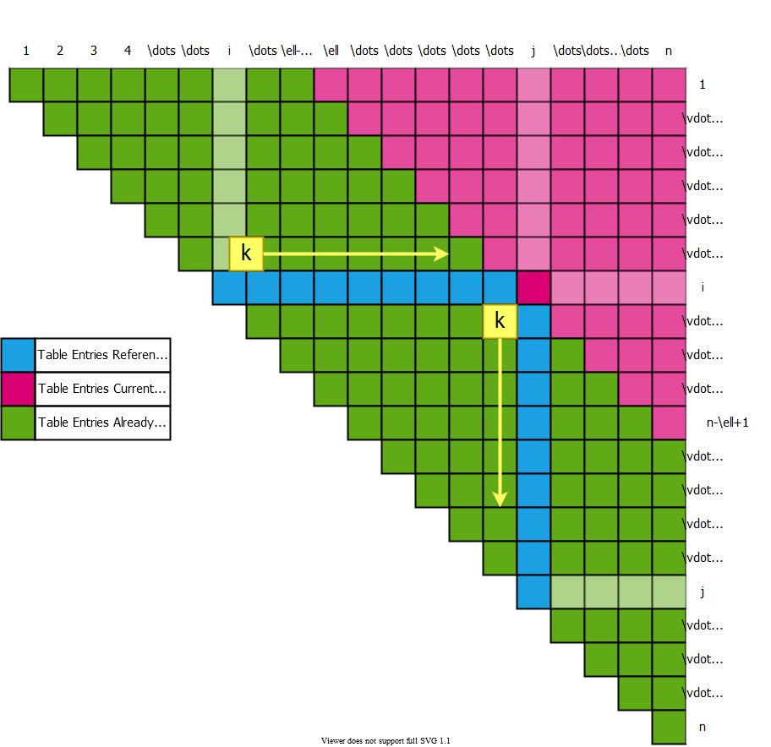
bg right:50% h:600px

Table access pattern in computing $m\left[i,j\right]$s for $ℓ=j−i+1$
$$\begin{matrix} & (\left(A_{i}\right)\overset{mult.}{⋮}\left(A_{i+1}A_{i+2}…A_{j}\right))\end{matrix}$$
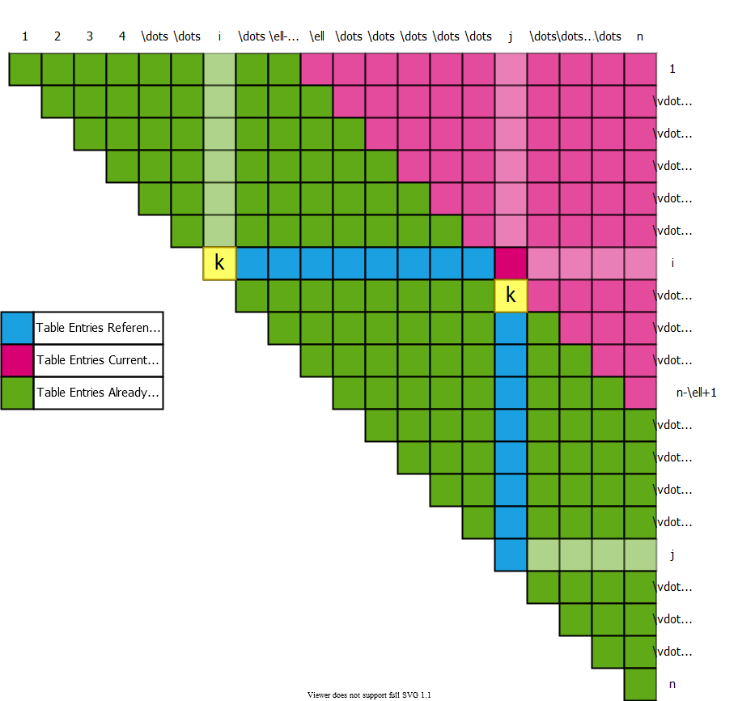
bg right:50% h:600px

Table access pattern in computing $m\left[i,j\right]$s for $ℓ=j−i+1$
$$\begin{matrix}(\left(A_{i}A_{i+1}\right)\overset{mult.}{⋮}\left(A_{i+2}…A_{j}\right))\end{matrix}$$
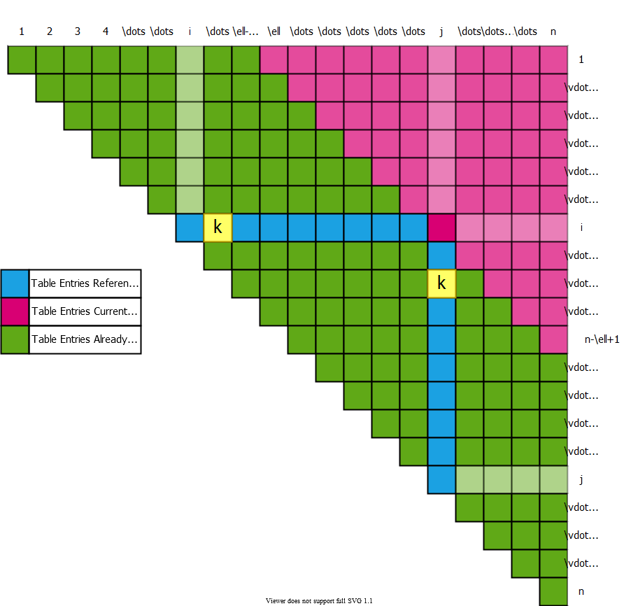
bg right:50% h:600px

Table access pattern in computing $m\left[i,j\right]$s for $ℓ=j−i+1$
$$\begin{matrix}(\left(A_{i}A_{i+1}A_{i+2}\right)\overset{mult.}{⋮}\left(A_{i+3}…A_{j}\right))\end{matrix}$$
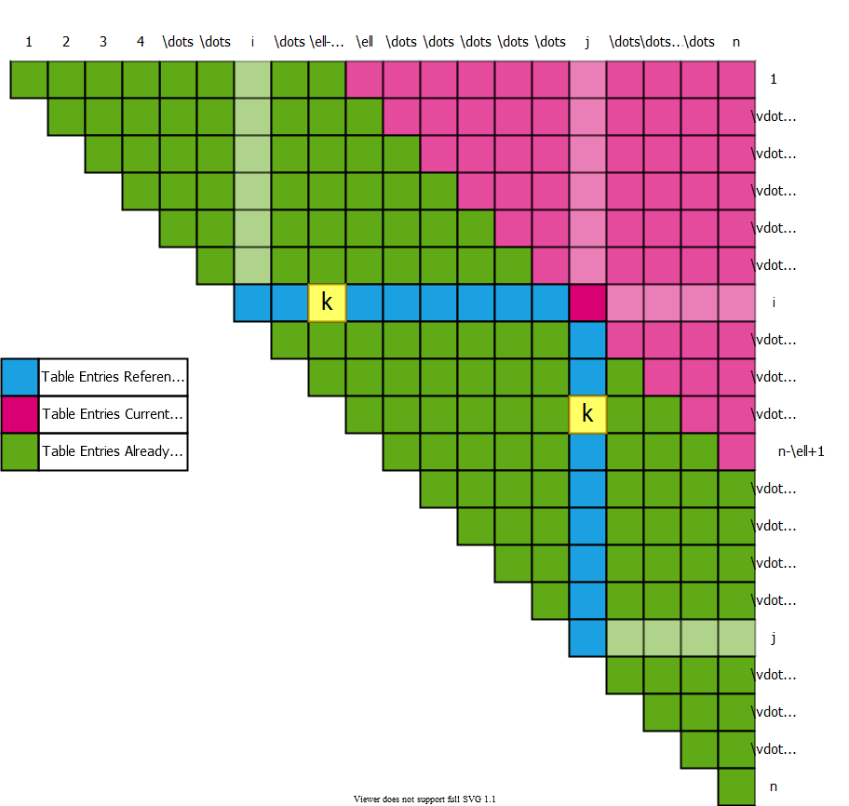
bg right:50% h:600px

Table access pattern in computing $m\left[i,j\right]$s for $ℓ=j−i+1$
$$\begin{matrix}(\left(A_{i}A_{i+1}…A_{j−1}\right)\overset{mult.}{⋮}\left(A_{j}\right))\end{matrix}$$
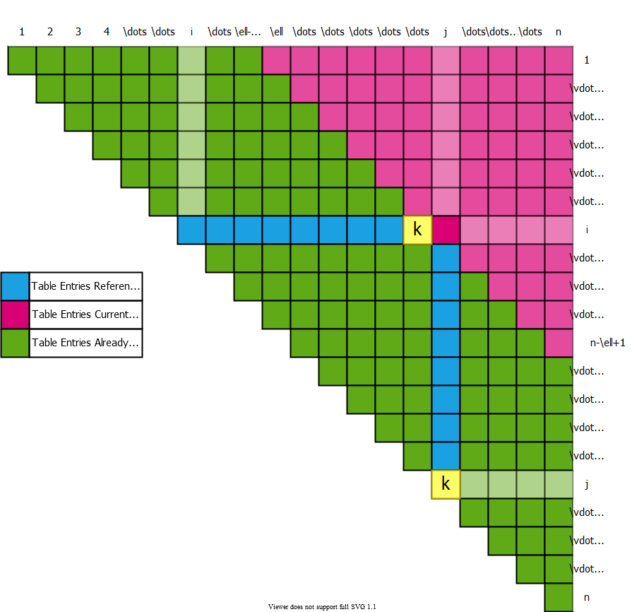
bg right:50% h:600px

Table access pattern Example
- Compute $m_{25}$
- Choose the $k$ value that leads to min cost
$$
m_{ij}=\underset{i \leq k < j}{MIN} \{ m_{ik} + m_{k+1,j} + p_{i-1} p_k p_j \} \\[10pt]
\begin{align*}
\begin{aligned}
A_1 &: (30 \times 35) \\
A_2 &: (35 \times 15) \\
A_3 &: (15 \times 5) \\
A_4 &: (5 \times 10) \\
A_5 &: (10 \times 20) \\
A_6 &: (20 \times 25)
\end{aligned}
\begin{aligned}
& ((A_2) \overbrace{\vdots}^{ (k=2) } (A_3 A_4 A_5)) \\[10 pt]
\quad cost &= m_{22} + m_{35} + p_1p_2p_5 \\
&= 0 + 2500 + 35 \times 15 \times 20 \\
&= 13000
\end{aligned}
\end{align*}
$$
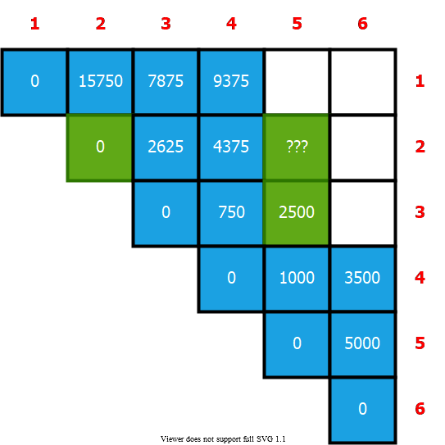
bg right:40% h:500px

Table access pattern Example
- Compute $m_{25}$
- Choose the $k$ value that leads to min cost
$$
m_{ij}=\underset{i \leq k < j}{MIN} \{ m_{ik} + m_{k+1,j} + p_{i-1} p_k p_j \} \\[10pt]
\begin{align*}
\begin{aligned}
A_1 &: (30 \times 35) \\
A_2 &: (35 \times 15) \\
A_3 &: (15 \times 5) \\
A_4 &: (5 \times 10) \\
A_5 &: (10 \times 20) \\
A_6 &: (20 \times 25)
\end{aligned}
\begin{aligned}
& ((A_2 A_3) \overbrace{\vdots}^{ (k=3) } (A_4 A_5)) \\[10 pt]
\quad cost &= m_{23} + m_{45} + p_1p_3p_5 \\
&= 2625 + 1000 + 35 \times 5 \times 20 \\
&= 7125
\end{aligned}
\end{align*}
$$
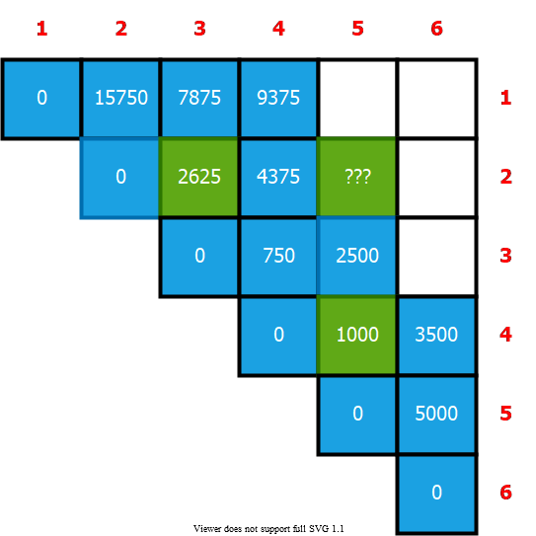
bg right:40% h:500px

Table access pattern Example
- Compute $m_{25}$
- Choose the $k$ value that leads to min cost
$$
m_{ij}=\underset{i \leq k < j}{MIN} \{ m_{ik} + m_{k+1,j} + p_{i-1} p_k p_j \} \\[10pt]
\begin{align*}
\begin{aligned}
A_1 &: (30 \times 35) \\
A_2 &: (35 \times 15) \\
A_3 &: (15 \times 5) \\
A_4 &: (5 \times 10) \\
A_5 &: (10 \times 20) \\
A_6 &: (20 \times 25)
\end{aligned}
\begin{aligned}
& ((A_2 A_3 A_4)\overbrace{\vdots}^{ (k=4) }(A_5)) \\[10 pt]
\quad cost &= m_{24} + m_{55} + p_1p_4p_5 \\
&= 4375 + 0 + 35 \times 10 \times 20 \\
&= 11375
\end{aligned}
\end{align*}
$$
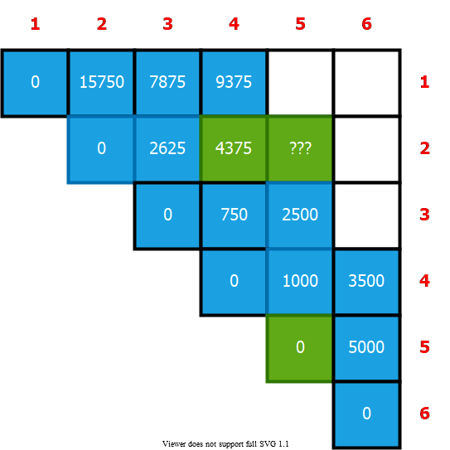
bg right:40% h:500px

Table access pattern Example
- Compute $m_{25}$
- Choose the $k$ value that leads to min cost
$$
m_{ij}=\underset{i \leq k < j}{MIN} \{ m_{ik} + m_{k+1,j} + p_{i-1} p_k p_j \} \\[10pt]
\begin{align*}
\begin{aligned}
A_1 &: (30 \times 35) \\
A_2 &: (35 \times 15) \\
A_3 &: (15 \times 5) \\
A_4 &: (5 \times 10) \\
A_5 &: (10 \times 20) \\
A_6 &: (20 \times 25)
\end{aligned} \quad
\begin{aligned}
& ((A_2)\overbrace{\vdots}^{ (k=2) } (A_3 A_4 A_5)) \rightarrow m_{22} + m_{35} + p_1p_2p_5 = 13000 \\
& ((A_2 A_3) \overbrace{\vdots}^{ (k=3) } (A_4 A_5)) \rightarrow m_{23} + m_{45} + p_1p_3p_5 = \overbrace{ \boldsymbol{7125}}^{selected} \Leftarrow \text{min} \\
& ((A_2 A_3 A_4)\overbrace{\vdots}^{ (k=4) }(A_5)) \rightarrow m_{24} + m_{55} + p_1p_4p_5 = 11375 \\[20 pt]
& m_{25} = 7125 \\
& s_{25} = 3
\end{aligned}
\end{align*}
$$
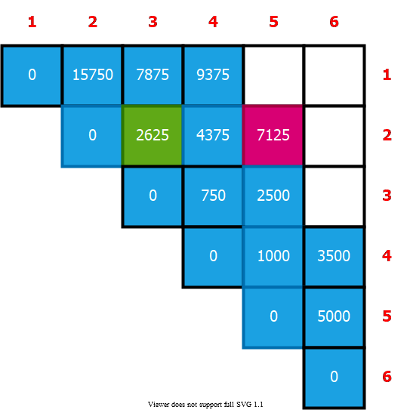
bg right:40% h:500px

Constructing an Optimal Solution
- MATRIX-CHAIN-ORDER determines the optimal $\#$ of scalar mults/adds
  - needed to compute a matrix-chain product
  - it does not directly show how to multiply the matrices
- That is,
  - it determines the cost of the optimal solution(s)
  - it does not show how to obtain an optimal solution
- Each entry $s\left[i,j\right]$ records the value of $k$ such that optimal parenthesization of $A_{i}…A_{j}$ splits the product between $A_{k}$ & $A_{k+1}$
- We know that the final matrix multiplication in computing $A_{1…n}$ optimally is $A_{1…s\left[1,n\right]}×A_{s\left[1,n\right]+1,n}$

Example: Constructing an Optimal Solution
- Reminder: $s_{ij}$ is the optimal top-level split of $A_{i}…A_{j}$
- What is the optimal top-level split for:
  - $A_{1}A_{2}A_{3}A_{4}A_{5}A_{6}$
  - $s_{16}=3$
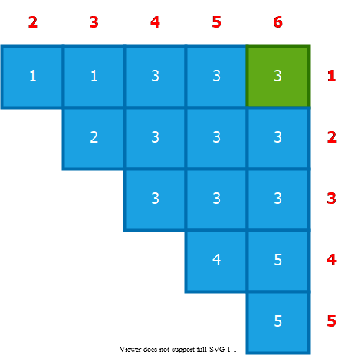
bg right:30% h:400px

Example: Constructing an Optimal Solution
- Reminder: $s_{ij}$ is the optimal top-level split of $A_{i}…A_{j}$
- $\left(A_{1}A_{2}A_{3}\right)\overset{\left(k=4\right)}{\overbrace{⋮}}\left(A_{4}A_{5}A_{6}\right)$
  - What is the optimal split for $A_{1}…A_{3}$ ? ( $s_{13}=1$ )
  - What is the optimal split for $A_{4}…A_{6}$ ? ( $s_{46}=5$ )
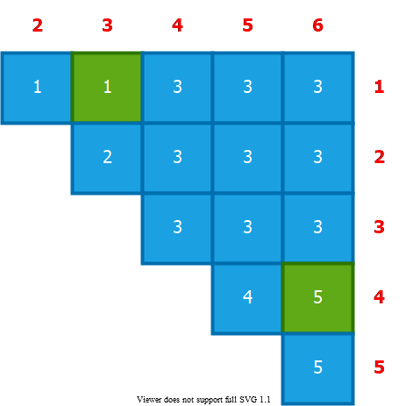
bg right:30% h:400px

Example: Constructing an Optimal Solution
- Reminder: $s_{ij}$ is the optimal top-level split of $A_{i}…A_{j}$
- $(\left(A_{1}\right)\overset{\left(k=1\right)}{\overbrace{⋮}}\left(A_{2}A_{3}\right))(\left(A_{4}A_{5}\right)\overset{\left(k=5\right)}{\overbrace{⋮}}\left(A_{6}\right))$
  - What is the optimal split for $A_{1}…A_{3}$ ? ( $s_{13}=1$ )
  - What is the optimal split for $A_{4}…A_{6}$ ? ( $s_{46}=5$ )
bg right:30% h:400px

Example: Constructing an Optimal Solution
- Reminder: $s_{ij}$ is the optimal top-level split of $A_{i}…A_{j}$
- $(\left(A_{1}\right)\left(A_{2}A_{3}\right))(\left(A_{4}A_{5}\right)\left(A_{6}\right))$
  - What is the optimal split for $A_{2}A_{3}$ ? ( $s_{23}=2$ )
  - What is the optimal split for $A_{4}A_{5}$ ? ( $s_{45}=4$ )
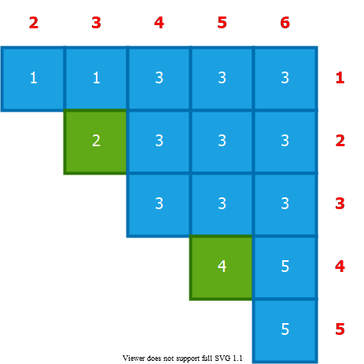
bg right:30% h:400px

Example: Constructing an Optimal Solution
- Reminder: $s_{ij}$ is the optimal top-level split of $A_{i}…A_{j}$
- $((A_{1})(\left(A_{2}\right)\overset{\left(k=2\right)}{\overbrace{⋮}}\left(A_{3}\right)))((\left(A_{4}\right)\overset{\left(k=4\right)}{\overbrace{⋮}}\left(A_{5}\right))(A_{6}))$
  - What is the optimal split for $A_{2}A_{3}$ ? ( $s_{23}=2$ )
  - What is the optimal split for $A_{4}A_{5}$ ? ( $s_{45}=4$ )
bg right:30% h:390px

Constructing an Optimal Solution
- Earlier optimal matrix multiplications can be computed recursively
- Given:
  - the chain of matrices $A=⟨A_{1},A_{2},…A_{n}⟩$ the s table computed by $\text{MATRIX-CHAIN-ORDER}$
  - The following recursive procedure computes the matrix-chain product $A_{i…j}$
$$\begin{matrix} & \text{MATRIX-CHAIN-MULTIPLY}\left(A,s,i,j\right) \\ & \text{if} j>i \text{then} \\ & X←\text{MATRIX-CHAIN-MULTIPLY}\left(A,s,i,s\left[i,j\right]\right) \\ & Y←\text{MATRIX-CHAIN-MULTIPLY}\left(A,s,s\left[i,j\right]+1,j\right) \\ & \text{return} \text{MATRIX-MULTIPLY}\left(X,Y\right) \\ & \text{else} \\ & returnA_{i}\end{matrix}$$
- Invocation: $\text{MATRIX-CHAIN-MULTIPLY}\left(A,s,1,n\right)$

Example: Recursive Construction of an Optimal Solution
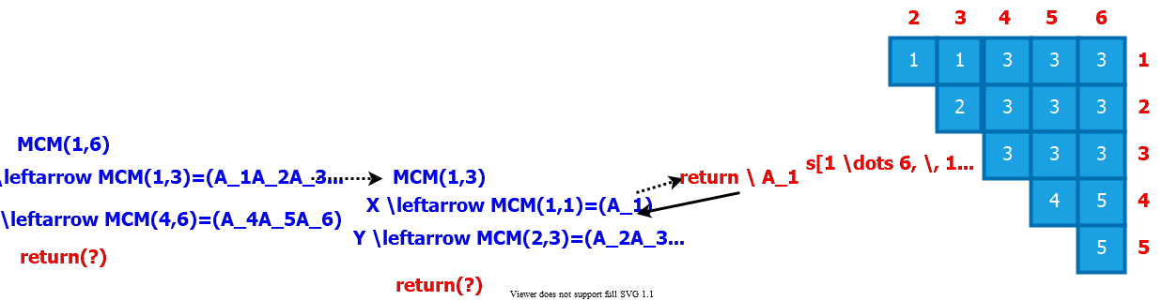
center

Example: Recursive Construction of an Optimal Solution
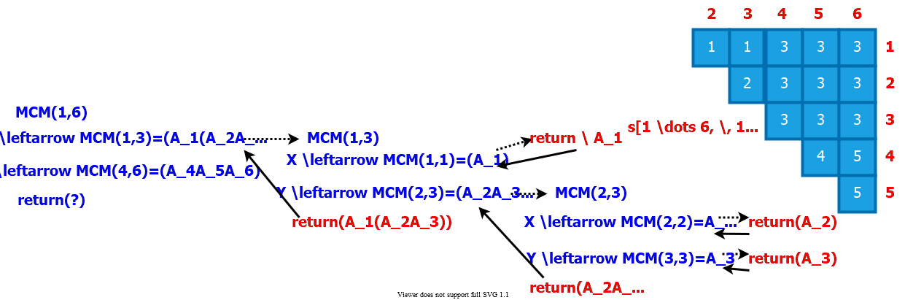
center

Example: Recursive Construction of an Optimal Solution
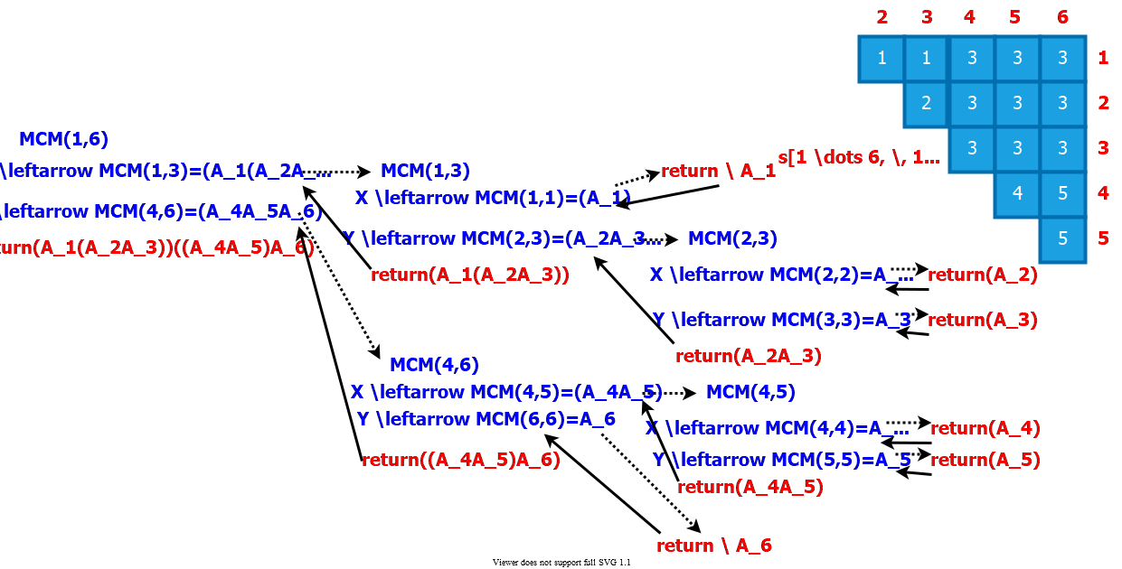
center

Table reference pattern for $m\left[i,j\right]$ $\left(1≤i≤j≤n\right)$
- $m\left[i,j\right]$ is referenced for the computation of
  - $m\left[i,r\right] \text{for} j<r≤n \left(n−j\right)$ times
  - $m\left[r,j\right] \text{for} 1≤r<i \left(i−1\right)$ times
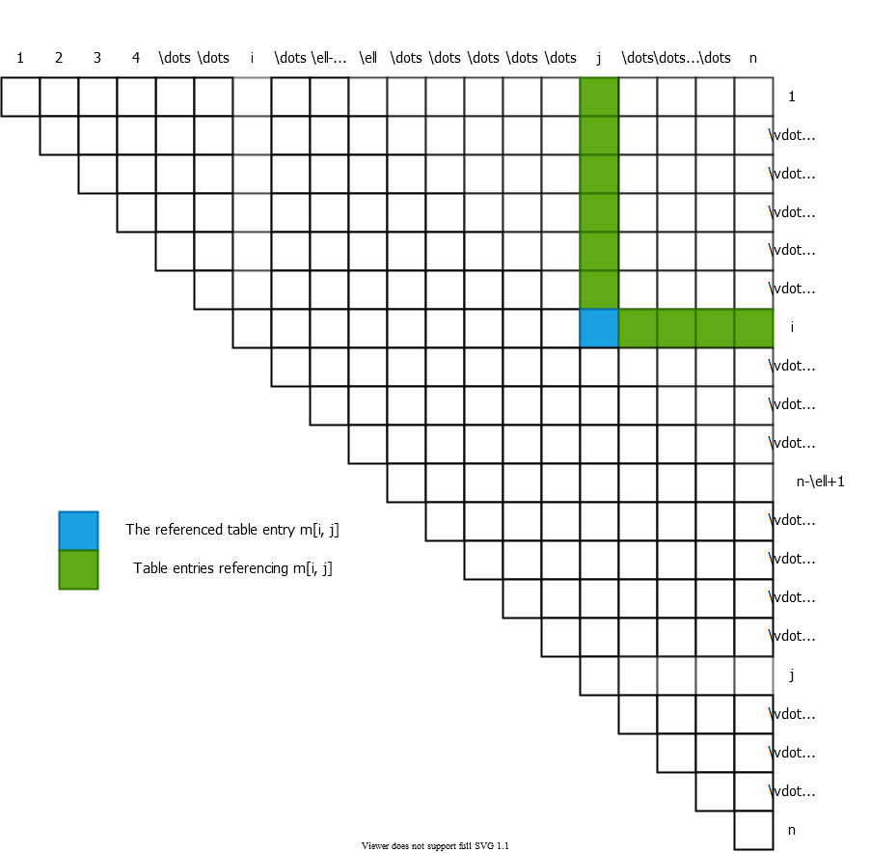
bg right:60% h:700px

Table reference pattern for $m\left[i,j\right]$ $\left(1≤i≤j≤n\right)$
- $R\left(i,j\right)$ = $\#$ of times that $m\left[i,j\right]$ is referenced in computing other entries
$$\begin{matrix}R\left(i,j\right) & =\left(n−j\right)+\left(i−1\right) \\ & =\left(n−1\right)−\left(j−i\right)\end{matrix}$$
- The total $\#$ of references for the entire table is: $\sum_{i=1}^{n}{\sum_{j=i}^{n}{R}}\left(i,j\right)=\frac{n^{3}−n}{3}$
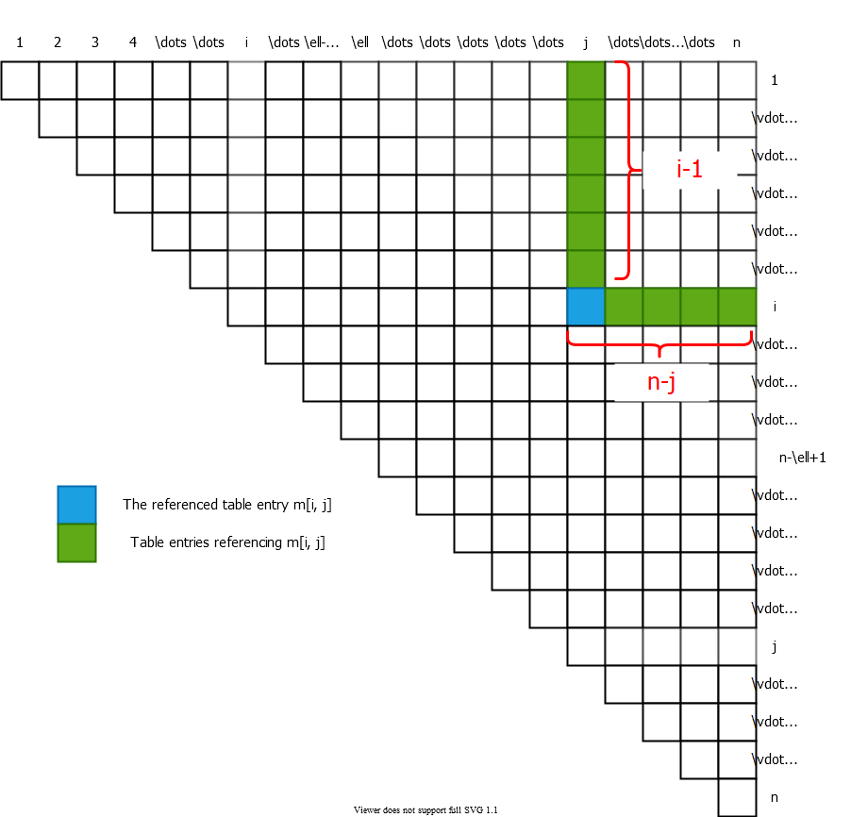
bg right:40% h:490px

Summary
- Identification of the optimal substructure property
- Recursive formulation to compute the cost of the optimal solution
- Bottom-up computation of the table entries
- Constructing the optimal solution by backtracing the table entries

References
- Introduction to Algorithms, Third Edition | The MIT Press
- Bilkent CS473 Course Notes (new)
- Bilkent CS473 Course Notes (old)

$−End−Of−Week−5−Course−Module−$

