CE100 Algorithms and Programming II
Heap/Heap Sort
Author: Asst. Prof. Dr. Uğur CORUH

CE100 Algorithms and Programming II

Week-4 (Heap/Heap Sort)

Spring Semester, 2021-2022
Download DOC, SLIDE, PPTX

Heap/Heap Sort

Outline (1)
- Heaps
  - Max / Min Heap
- Heap Data Structure
  - Heapify
    - Iterative
    - Recursive

Outline (2)
- Extract-Max
- Build Heap

Outline (3)
- Heap Sort
- Priority Queues
- Linked Lists
- Radix Sort
- Counting Sort

Heapsort
- Worst-case runtime: $O\left(nlgn\right)$
- Sorts in-place
- Uses a special data structure (heap) to manage information during execution of the algorithm
  - Another design paradigm

Heap Data Structure (1)
- Nearly complete binary tree
  - Completely filled on all levels except possibly the lowest level
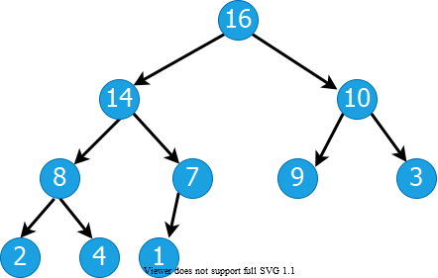
alt:“alt” height:350px center

Heap Data Structure (2)
- Height of node i: Length of the longest simple downward path from i to a leaf
- Height of the tree: height of the root
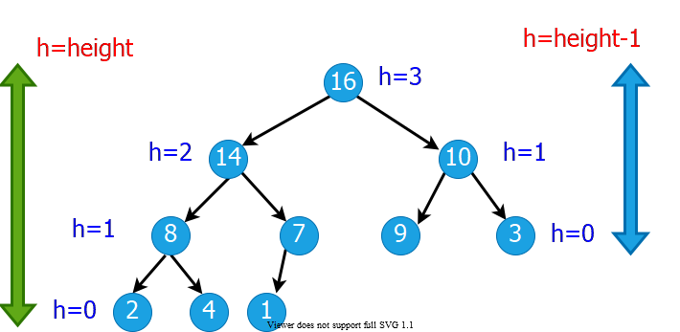
alt:“alt” height:400px center

Heap Data Structures (3)
- Depth of node i: Length of the simple downward path from the root to node i
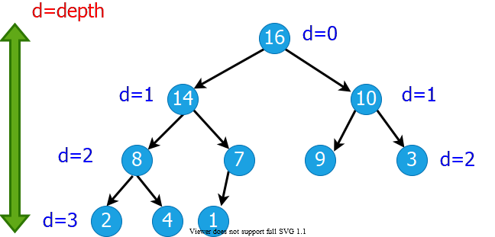
alt:“alt” height:350px center

Heap Property: Min-Heap
- The smallest element in any subtree is the root element in a min-heap
- Min heap: For every node i other than root, $A\left[parent\left(i\right)\right]≤A\left[i\right]$
  - Parent node is always smaller than the child nodes
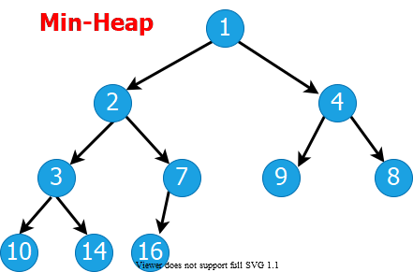
bg right:40% w:480

Heap Property: Max-Heap
- The largest element in any subtree is the root element in a max-heap
  - We will focus on max-heaps
- Max heap: For every node i other than root, $A\left[parent\left(i\right)\right]≥A\left[i\right]$
  - Parent node is always larger than the child nodes
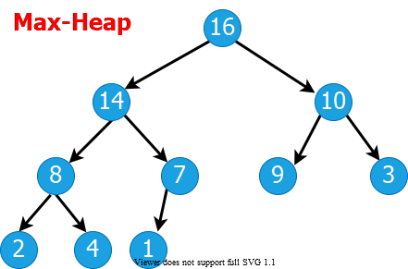
bg right:40% w:480

Heap Data Structures (4)
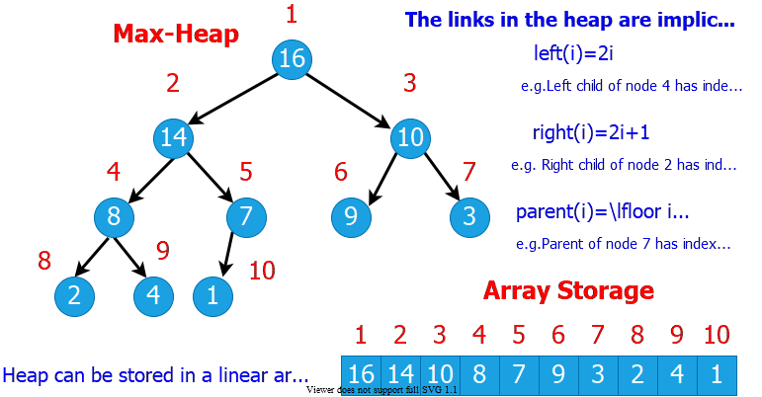
alt:“alt” height:500px center

Heap Data Structures (5)
- Computing left child, right child, and parent indices very fast
  - left(i) = 2i $⇒$ binary left shift
  - right(i) = 2i+1 $⇒$ binary left shift, then set the lowest bit to 1
  - parent(i) = floor(i/2) $⇒$ right shift in binary
- $A\left[1\right]$ is always the root element
- Array $A$ has two attributes:
  - length(A): The number of elements in $A$
  - n = heap-size(A): The number elements in $heap$
    - $n≤length\left(A\right)$

Heap Operations : EXTRACT-MAX (1)
EXTRACT-MAX(A, n)
max = A[1]
A[1] = A[n]
n = n - 1
HEAPIFY(A, 1,n)
return max

Heap Operations : EXTRACT-MAX (2)
- Return the max element,and reorganize the heap to maintain heap property
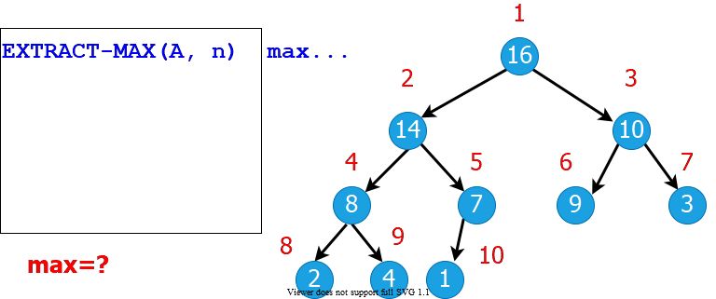
alt:“alt” height:400px center

Heap Operations: HEAPIFY (1)
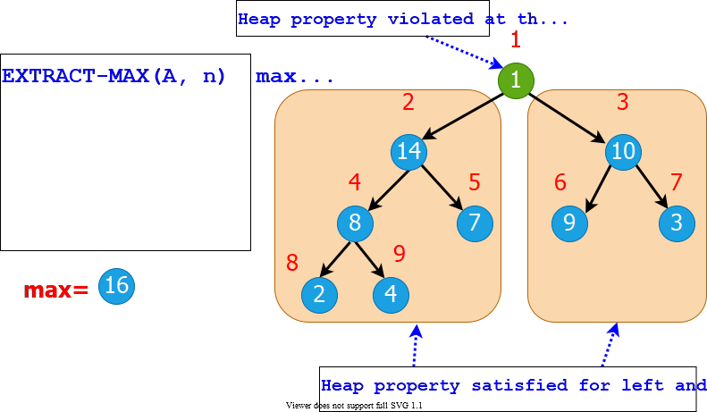
alt:“alt” height:500px center

Heap Operations: HEAPIFY (2)
- Maintaining heap property:
  - Subtrees rooted at $left\left[i\right]$ and $right\left[i\right]$ are already heaps.
  - But, $A\left[i\right]$ may violate the heap property (i.e., may be smaller than its children)
- Idea: Float down the value at $A\left[i\right]$ in the heap so that subtree rooted at $i$ becomes a heap.

Heap Operations: HEAPIFY (2)
HEAPIFY(A, i, n)
largest = i
if 2i <= n and A[2i] > A[i] then
largest = 2i;
endif
if 2i+1 <= n and A[2i+1] > A[largest] then
largest = 2i+1;
endif
if largest != i then
exchange A[i] with A[largest];
HEAPIFY(A, largest, n);
endif

Heap Operations: HEAPIFY (3)
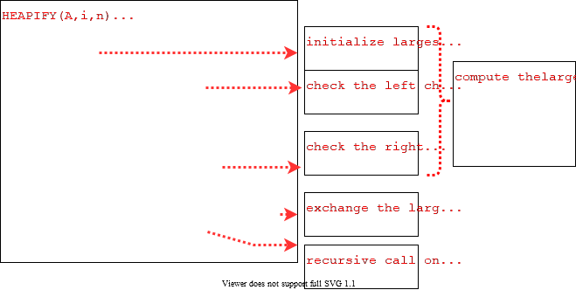
alt:“alt” height:500px center

Heap Operations: HEAPIFY (4)
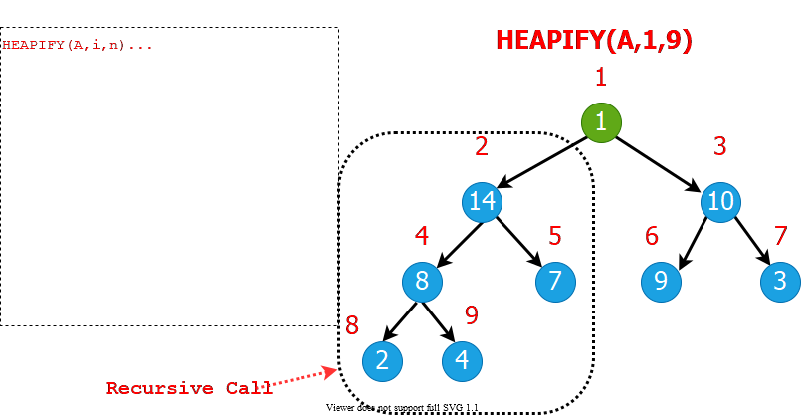
alt:“alt” height:500px center

Heap Operations: HEAPIFY (5)
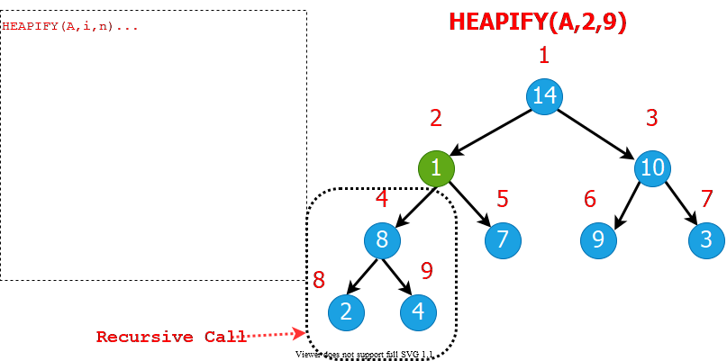
alt:“alt” height:500px center

Heap Operations: HEAPIFY (6)
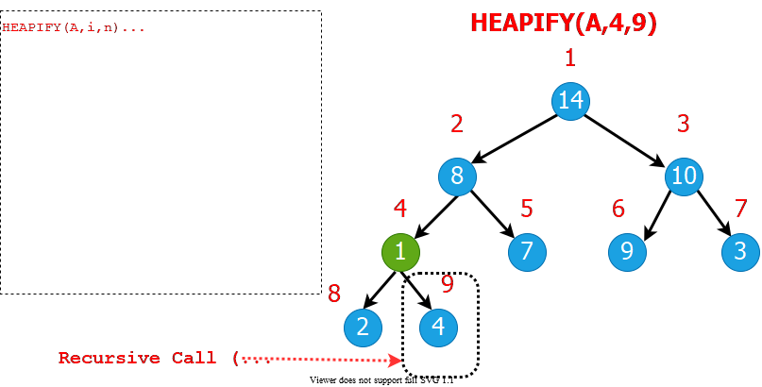
alt:“alt” height:500px center

Heap Operations: HEAPIFY (7)
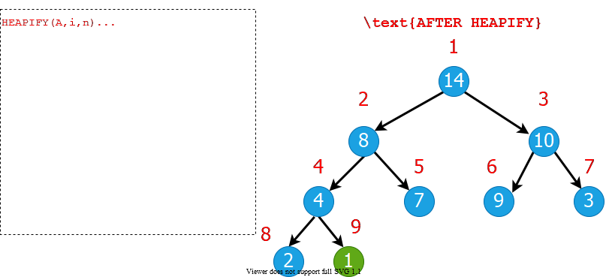
alt:“alt” height:500px center

Heap Operations: HEAPIFY (8)
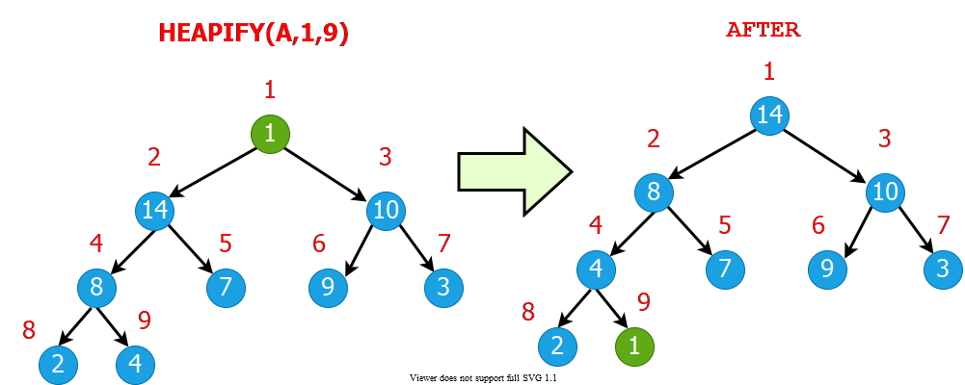
alt:“alt” height:500px center

Intuitive Analysis of HEAPIFY
- Consider $HEAPIFY\left(A,i,n\right)$
  - let $h\left(i\right)$ be the height of node $i$
  - at most $h\left(i\right)$ recursion levels
    - Constant work at each level: $Θ\left(1\right)$
  - Therefore $T\left(i\right)=O\left(h\left(i\right)\right)$
- Heap is almost-complete binary tree
  - $h\left(n\right)=O\left(lgn\right)$
- Thus $T\left(n\right)=O\left(lgn\right)$

Formal Analysis of HEAPIFY
- What is the recurrence?
  - Depends on the size of the subtree on which recursive call is made
    - In the next, we try to compute an upper bound for this subtree.

Reminder: Binary trees
- For a complete binary tree:
  - $\#$ of nodes at depth $d$: $2^{d}$
  - $\#$ of nodes with depths less than $d$: $2^{d}−1$
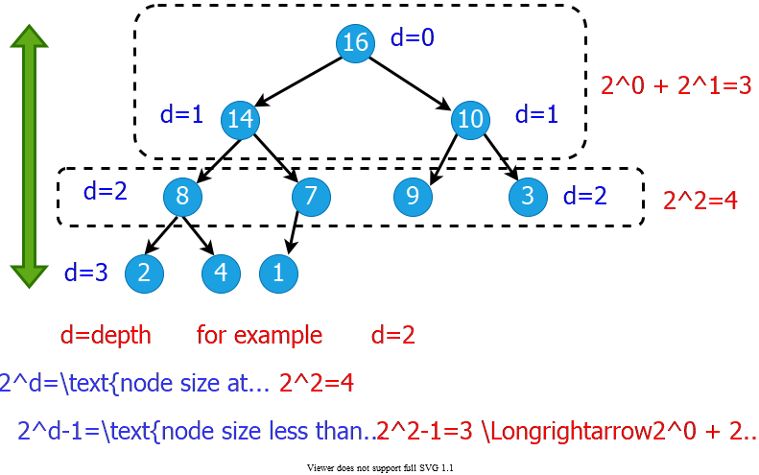
alt:“alt” height:450px center

Formal Analysis of HEAPIFY (1)
- Worst case occurs when last row of the subtree $S_{i}$ rooted at node $i$ is half full
- $T\left(n\right)≤T\left(\left|S_{L\left(i\right)}\right|\right)+Θ\left(1\right)$
- $S_{L\left(i\right)}$ and $S_{R\left(i\right)}$ are complete binary trees of heights $h\left(i\right)−1$ and $h\left(i\right)−2$, respectively
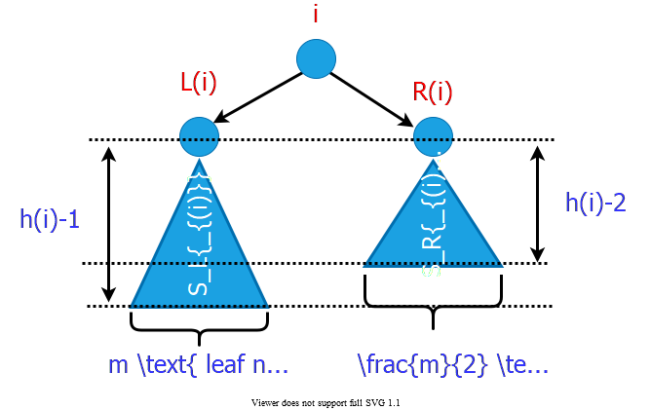
bg right:50% w:600

Formal Analysis of HEAPIFY (2)
- Let $m$ be the number of leaf nodes in $S_{L\left(i\right)}$
  - $\left|S_{L\left(i\right)}\right|=\overset{ext.}{\overbrace{m}}+\overset{int.}{\overbrace{\left(m–1\right)}}=2m–1$
  - $\left|S_{R\left(i\right)}\right|=\overset{ext.}{\overbrace{\frac{m}{2}}}+\overset{int.}{\overbrace{\left(\frac{m}{2}–1\right)}}=m–1$
  - $\left|S_{L\left(i\right)}\right|+\left|S_{R\left(i\right)}\right|+1=n$

Formal Analysis of HEAPIFY (2)
$$\begin{matrix}\left(2m–1\right)+\left(m–1\right)+1 & =n \\ m & =\left(n+1\right)/3 \\ \left|S_{L\left(i\right)}\right| & =2m–1 \\ & =2\left(n+1\right)/3–1 \\ & =\left(2n/3+2/3\right)–1 \\ & =\frac{2n}{3}−\frac{1}{3}≤\frac{2n}{3} \\ T\left(n\right) & ≤T\left(2n/3\right)+Θ\left(1\right) \\ T\left(n\right) & =O\left(lgn\right)\end{matrix}$$
- By CASE-2 of Master Theorem $⇒$ $T\left(n\right)=Θ\left(n^{log_{b}^{a}}lgn\right)$

Formal Analysis of HEAPIFY (2)
- Recurrence: $T\left(n\right)=aT\left(n/b\right)+f\left(n\right)$
- Case 2: $\frac{f\left(n\right)}{n^{log_{b}^{a}}}=Θ\left(1\right)$
- i.e., $f\left(n\right)$ and $n^{log_{b}^{a}}$ grow at similar rates
- Solution: $T\left(n\right)=Θ\left(n^{log_{b}^{a}}lgn\right)$
  - $T\left(n\right)≤T\left(2n/3\right)+Θ\left(1\right)$ (drop constants.)
  - $T\left(n\right)≤Θ\left(n^{log_{3}^{1}}lgn\right)$
  - $T\left(n\right)≤Θ\left(n^{0}lgn\right)$
  - $T\left(n\right)=O\left(lgn\right)$

HEAPIFY: Efficiency Issues
- Recursion vs Iteration:
  - In the absence of tail recursion, iterative version is in general more efficient because of the pop/push operations to/from stack at each level of recursion.

Heap Operations: HEAPIFY (1)
Recursive
HEAPIFY(A, i, n)
largest = i
if 2i <= n and A[2i] > A[i] then
largest = 2i
if 2i+1 <= n and A[2i+1] > A[largest] then
largest = 2i+1
if largest != i then
exchange A[i] with A[largest]
HEAPIFY(A, largest, n)

Heap Operations: HEAPIFY (2)
Iterative
HEAPIFY(A, i, n)
j = i
while(true) do
largest = j
if 2j <= n and A[2j] > A[j] then
largest = 2j
if 2j+1 <= n and A[2j+1] > A[largest] then
largest = 2j+1
if largest != j then
exchange A[j] with A[largest]
j = largest
else return

Heap Operations: HEAPIFY (3)
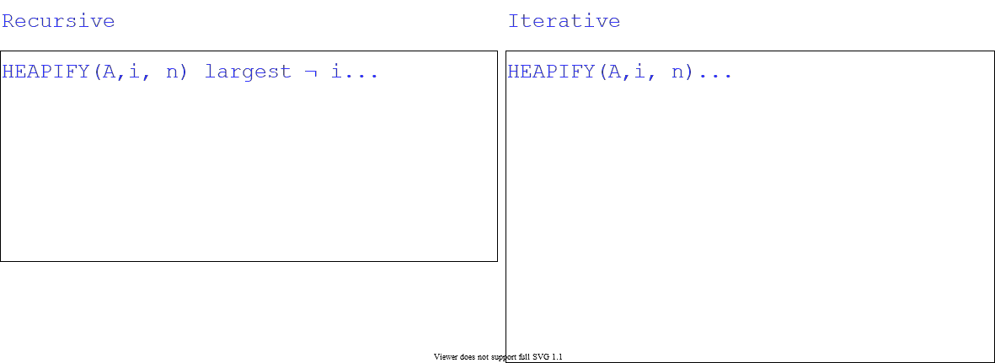
alt:“alt” height:500px center

Heap Operations: Building Heap
- Given an arbitrary array, how to build a heap from scratch?
- Basic idea: Call $HEAPIFY$ on each node bottom up
  - Start from the leaves (which trivially satisfy the heap property)
  - Process nodes in bottom up order.
  - When $HEAPIFY$ is called on node $i$, the subtrees connected to the $left$ and $right$ subtrees already satisfy the heap property.
- 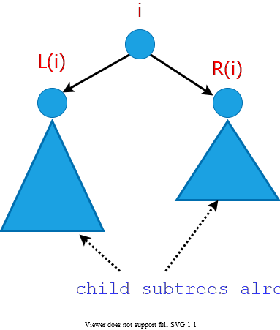
- bg right:25% w:300px

Storage of the leaves (Lemma)
- Lemma: The last $⌈\frac{n}{2}⌉$ nodes of a heap are all leaves.
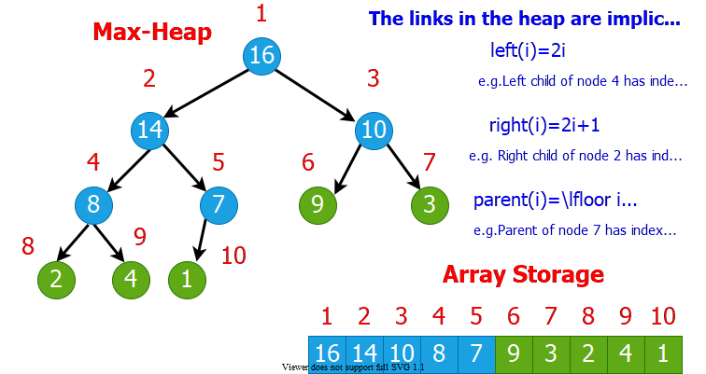
bg right:70% w:800

Storage of the leaves (Proof of Lemma) (1)
- Lemma: last $⌈n/2⌉$ nodes of a heap are all leaves
- Proof :
  - $m=2^{d−1}$: $\#$ nodes at level $d−1$
  - $f$: $\#$ nodes at level $d$ (last level)
- $\#$ of nodes with depth $d−1$ : $m$
- $\#$ of nodes with depth $<d−1$ : $m−1$
- $\#$ of nodes with depth $d$ : $f$
- Total $\#$ of nodes :$n=f+2m−1$
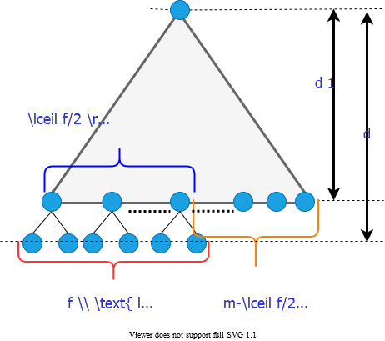
bg right:40% w:480

Storage of the leaves (Proof of Lemma) (2)
- Total $\#$ of nodes : $f=n−2m+1$
$$\begin{matrix}\text{\#of leaves: } & =f+m−⌈f/2⌉ \\ & =m+⌊f/2⌋ \\ & =m+⌊\left(n−2m+1\right)/2⌋ \\ & =⌊\left(n+1\right)/2⌋ \\ & =⌈n/2⌉\end{matrix}$$
Proof is Completed
bg right:40% w:480

Heap Operations: Building Heap
BUILD-HEAP (A, n)
for i = ceil(n/2) downto 1 do
HEAPIFY(A, i, n)
- Reminder: The last $⌈n/2⌉$ nodes of a heap are all leaves, which trivially satisfy the heap property

Build-Heap Example (Step-1)
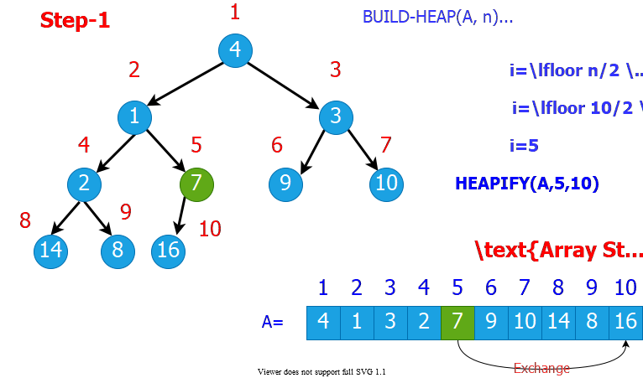
bg right:70% w:800px

Build-Heap Example (Step-2)
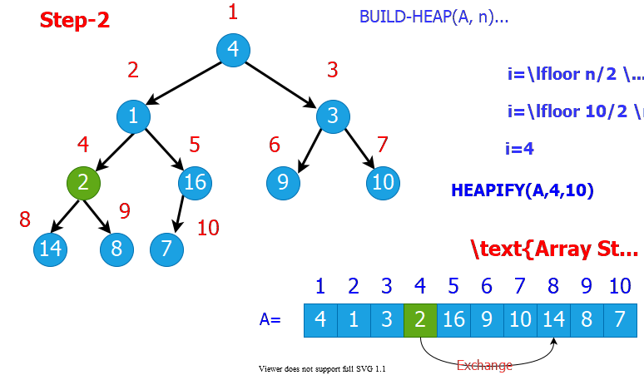
bg right:70% w:800px

Build-Heap Example (Step-3)
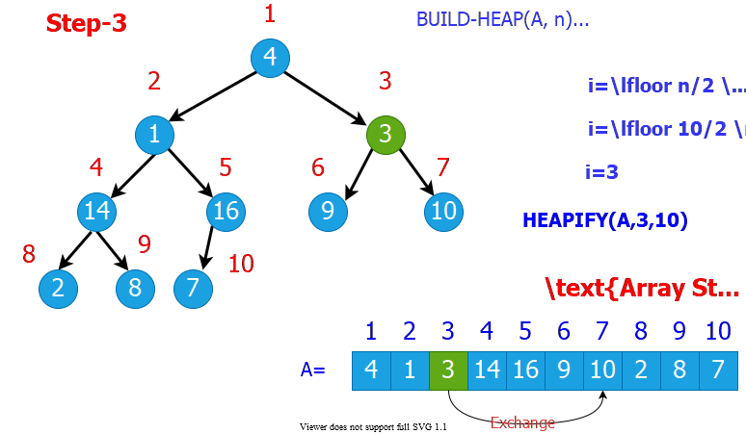
bg right:70% w:800px

Build-Heap Example (Step-4)
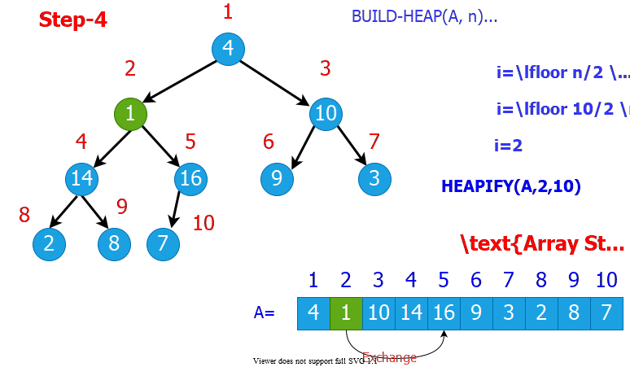
bg right:70% w:800px

Build-Heap Example (Step-5)
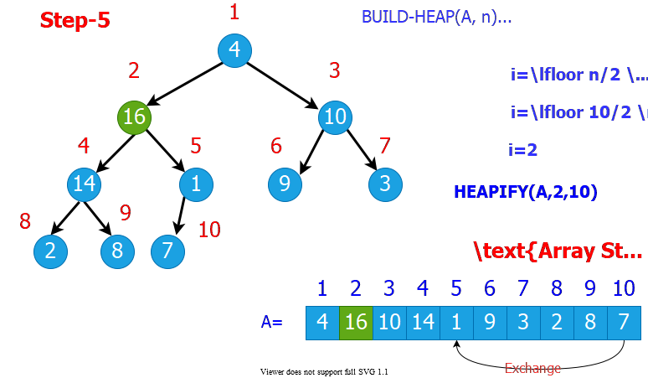
bg right:70% w:800px

Build-Heap Example (Step-6)
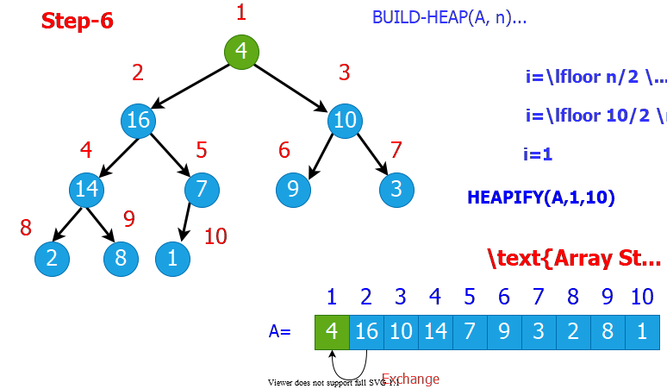
bg right:70% w:800px

Build-Heap Example (Step-7)
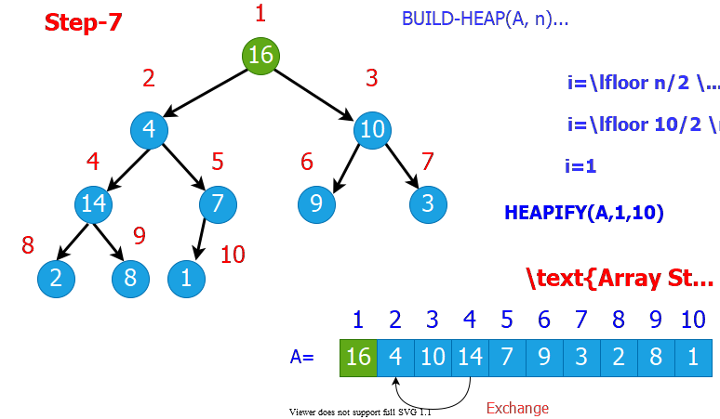
bg right:70% w:800px

Build-Heap Example (Step-8)
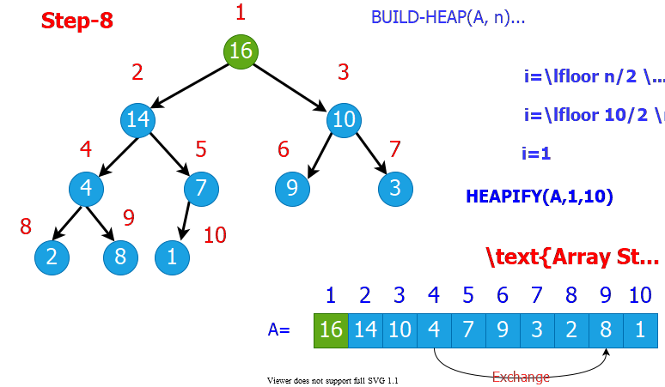
bg right:70% w:800px

Build-Heap Example (Step-9)
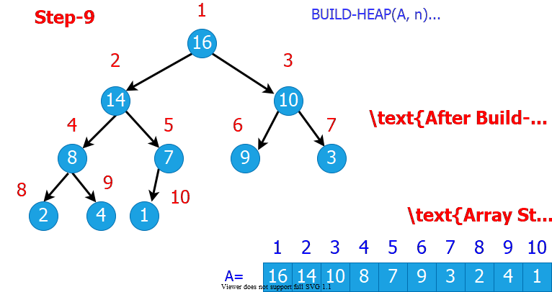
bg right:70% w:800px

Build-Heap: Runtime Analysis
- Simple analysis:
  - $O\left(n\right)$ calls to $HEAPIFY$, each of which takes $O\left(lgn\right)$ time
  - $O\left(nlgn\right)$ $⇒$ loose bound
- In general, a good approach:
  - Start by proving an easy bound
  - Then, try to tighten it
- Is there a tighter bound?

Build-Heap: Tighter Running Time Analysis
- If the heap is complete binary tree then $h_{ℓ}=d–ℓ$
- Otherwise, nodes at a given level do not all have the same height, But we have $d–ℓ–1≤h_{ℓ}≤d–ℓ$
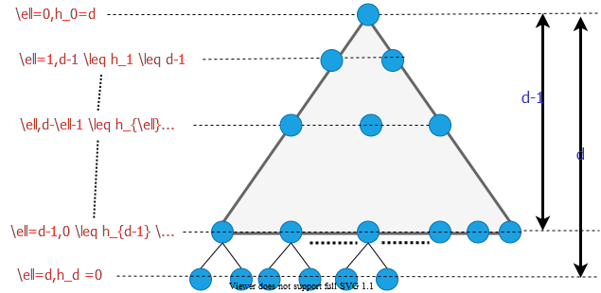
alt:“alt” height:420px center

Build-Heap: Tighter Running Time Analysis
- Assume that all nodes at level $ℓ=d–1$ are processed
$$\begin{matrix}T\left(n\right) & =\sum_{ℓ=0}^{d−1}{n_{ℓ}}O\left(h_{ℓ}\right)=O\left(\sum_{ℓ=0}^{d−1}{n_{ℓ}}h_{ℓ}\right)\left\{\begin{matrix}n_{ℓ}=2^{ℓ}=\#\text{ of nodes at level }ℓ \\ h_{ℓ}=\text{height of nodes at level }ℓ\end{matrix}\right. \\ ∴T\left(n\right) & =O(\sum_{ℓ=0}^{d−1}{2^{ℓ}}\left(d−ℓ\right)) \\ \text{Let } & h=d−ℓ⇒ℓ=d−h\text{ change of variables} \\ T\left(n\right) & =O(\sum_{h=1}^{d}{h}2^{d−h})=O(\sum_{h=1}^{d}{h}\frac{2^{d}}{2^{h}})=O(2^{d}\sum_{h=1}^{d}{h}{\left(1/2\right)}^{h}) \\ \text{ but } & 2^{d}=Θ\left(n\right)⇒O(n\sum_{h=1}^{d}{h}{\left(1/2\right)}^{h})\end{matrix}$$

Build-Heap: Tighter Running Time Analysis
$$\sum_{h=1}^{d}{h}{\left(1/2\right)}^{h}≤\sum_{h=0}^{d}{h}{\left(1/2\right)}^{h}≤\sum_{h=0}^{∞}{h}{\left(1/2\right)}^{h}$$
- recall infinite decreasing geometric series
$$\sum_{k=0}^{∞}{x^{k}}=\frac{1}{1−x}\text{ where }\left|x\right|<1$$
- differentiate both sides
$$\sum_{k=0}^{∞}{k}x^{k−1}=\frac{1}{{\left(1−x\right)}^{2}}$$

Build-Heap: Tighter Running Time Analysis
$$\sum_{k=0}^{∞}{k}x^{k−1}=\frac{1}{{\left(1−x\right)}^{2}}$$
- then, multiply both sides by $x$
$$\sum_{k=0}^{∞}{k}x^{k}=\frac{x}{{\left(1−x\right)}^{2}}$$
- in our case: $x=1/2$ and $k=h$
$$
\therefore \sum \limits_{h=0}^{\infty}h(1/2)^h = \frac{1/2}{(1-(1/2))^2}=2=O(1) \\
\therefore T(n)=O(n\sum \limits_{h=1}^{d}h(1/2)^h)=O(n)
$$

Heapsort Algorithm Steps
- (1) Build a heap on array $A\left[1…n\right]$ by calling $BUILD−HEAP\left(A,n\right)$
- (2) The largest element is stored at the root $A\left[1\right]$
  - Put it into its correct final position $A\left[n\right]$ by $A\left[1\right]↔A\left[n\right]$
- (3) Discard node $n$ from the heap
- (4) Subtrees $\left(S2\&S3\right)$ rooted at children of root remain as heaps, but the new root element may violate the heap property.
  - Make $A\left[1…n−1\right]$ a heap by calling $HEAPIFY\left(A,1,n−1\right)$
- (5) $n←n−1$
- (6) Repeat steps (2-4) until $n=2$

Heapsort Algorithm Example (Step-1)
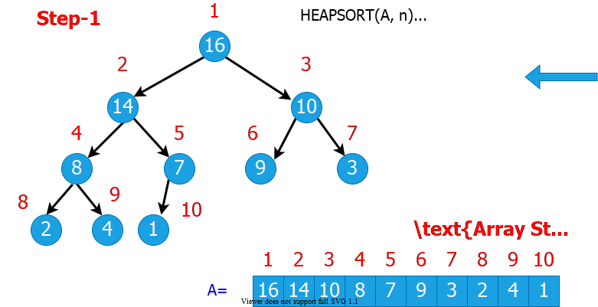
bg right:70% w:800px

Heapsort Algorithm Example (Step-2)
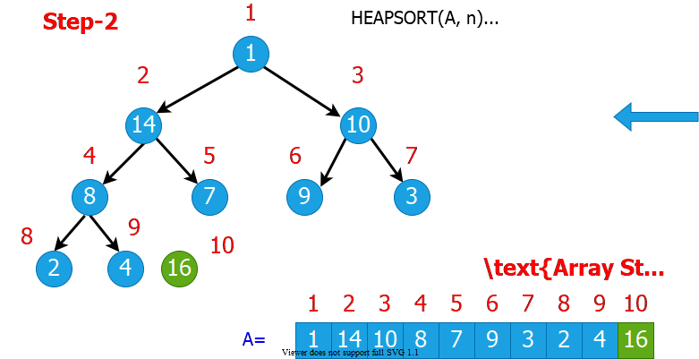
bg right:70% w:800px

Heapsort Algorithm Example (Step-3)
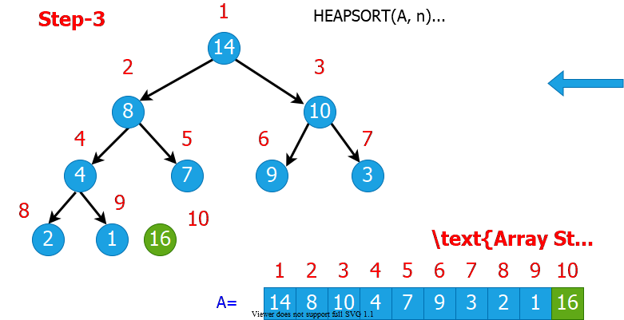
bg right:70% w:800px

Heapsort Algorithm Example (Step-4)
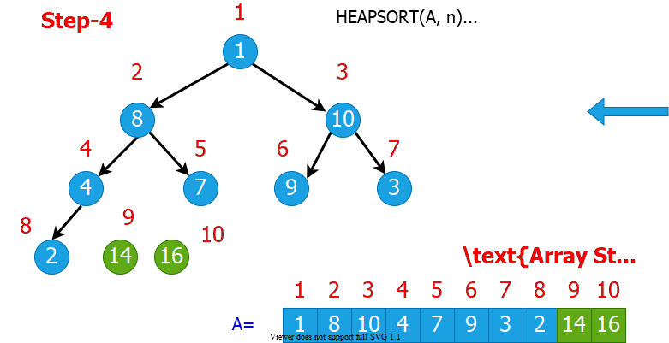
bg right:70% w:800px

Heapsort Algorithm Example (Step-5)
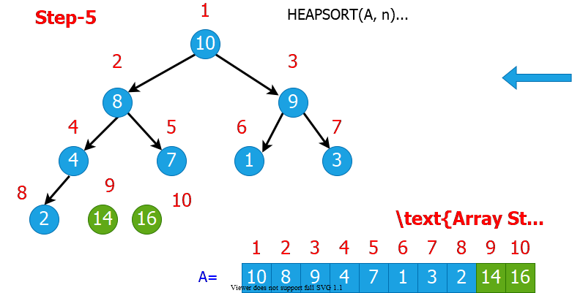
bg right:70% w:800px

Heapsort Algorithm Example (Step-6)
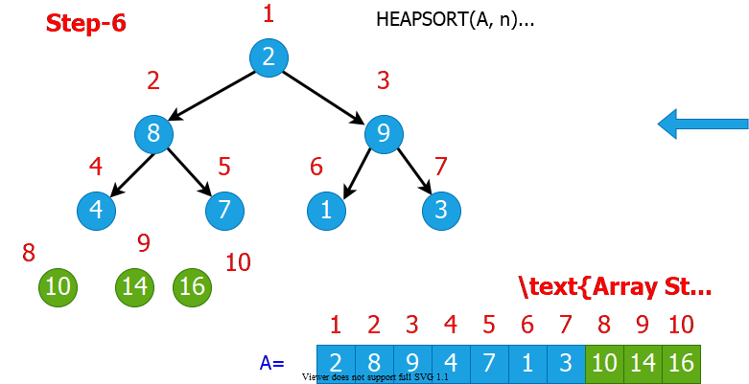
bg right:70% w:800px

Heapsort Algorithm Example (Step-7)
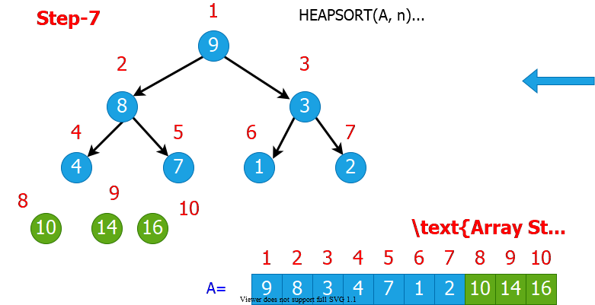
bg right:70% w:800px

Heapsort Algorithm Example (Step-8)
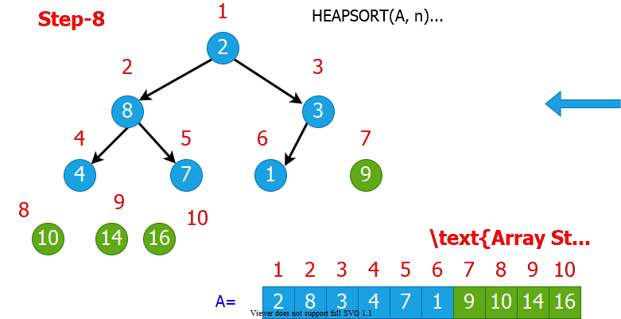
bg right:70% w:800px

Heapsort Algorithm Example (Step-9)
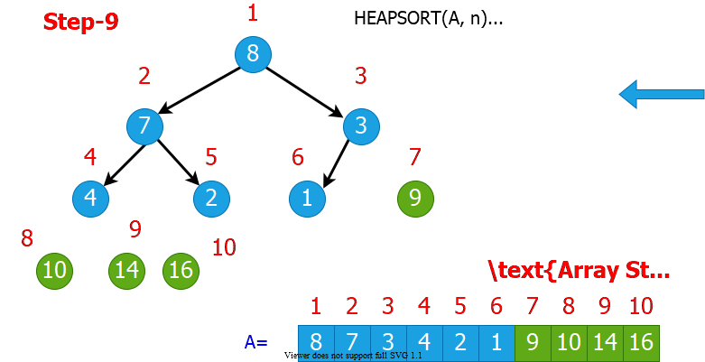
bg right:70% w:800px

Heapsort Algorithm Example (Step-10)
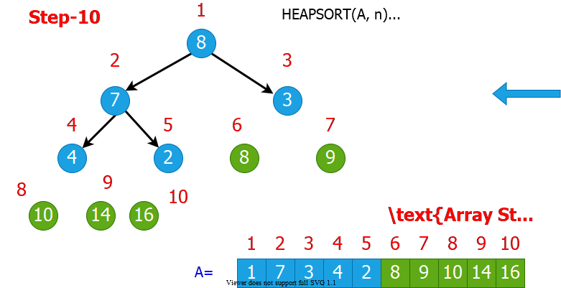
bg right:70% w:800px

Heapsort Algorithm Example (Step-11)
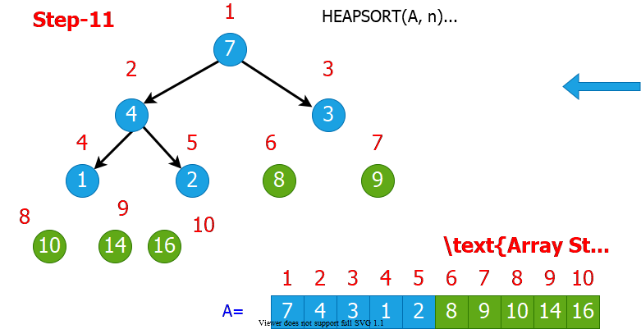
bg right:70% w:800px

Heapsort Algorithm Example (Step-12)
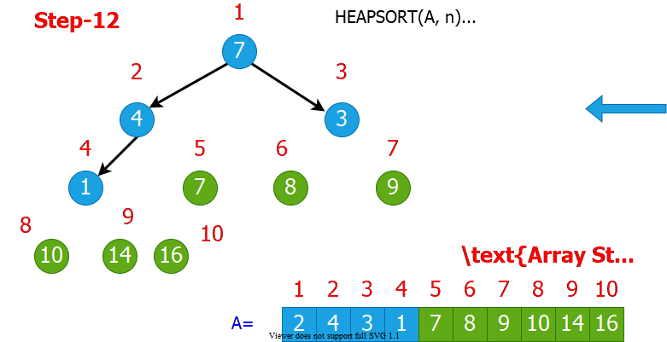
bg right:70% w:800px

Heapsort Algorithm Example (Step-13)
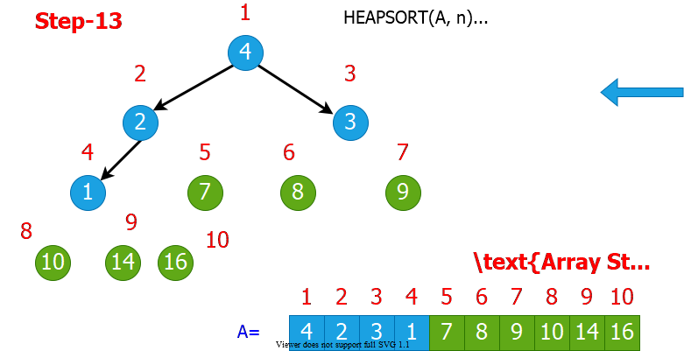
bg right:70% w:800px

Heapsort Algorithm Example (Step-14)
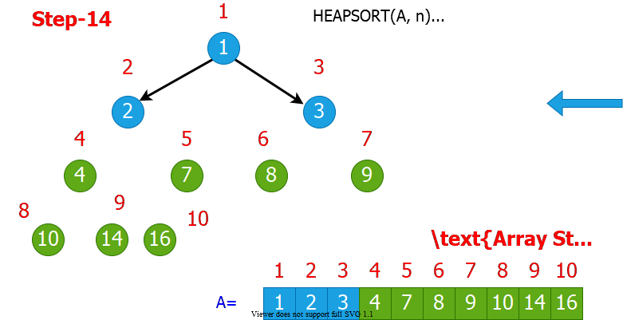
bg right:70% w:800px

Heapsort Algorithm Example (Step-15)
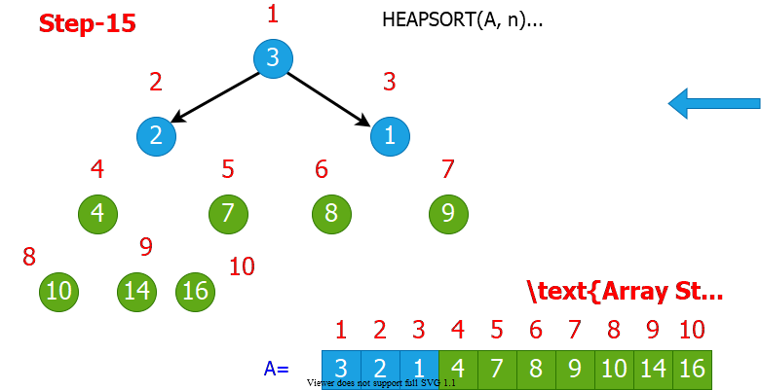
bg right:70% w:800px

Heapsort Algorithm Example (Step-16)
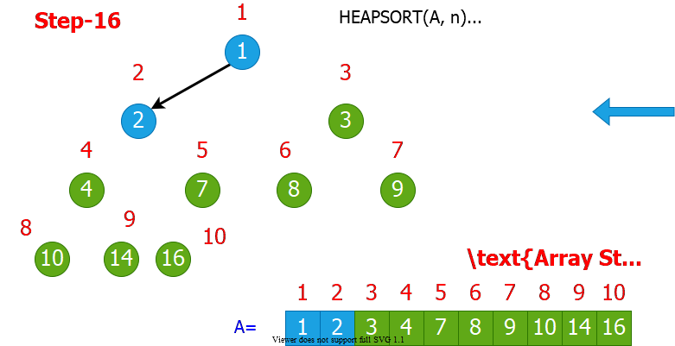
bg right:70% w:800px

Heapsort Algorithm Example (Step-17)
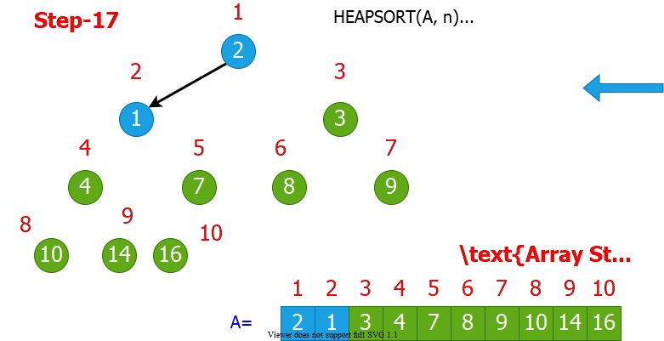
bg right:70% w:800px

Heapsort Algorithm Example (Step-18)
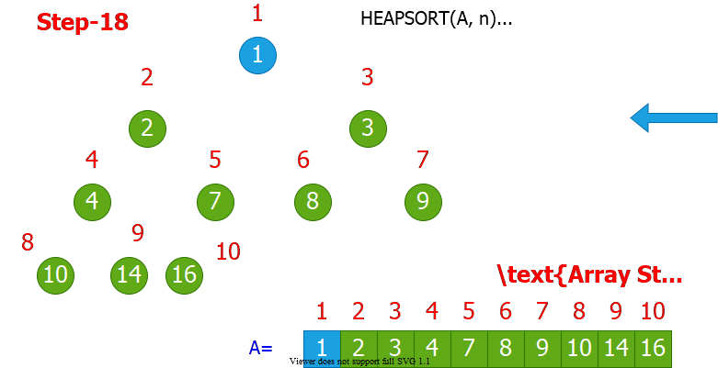
bg right:70% w:800px

Heapsort Algorithm Example (Step-19)
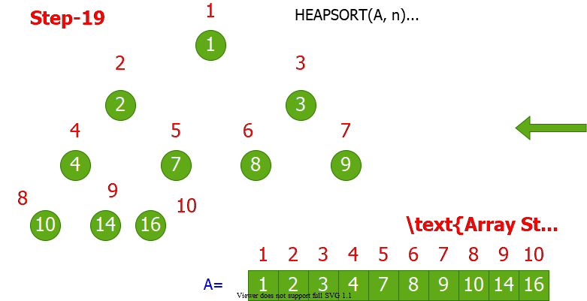
bg right:70% w:800px

Heapsort Algorithm: Runtime Analysis
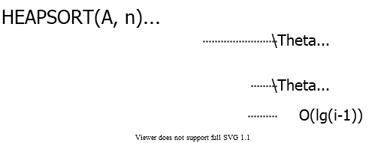
center height:250px
$$\begin{matrix}T\left(n\right) & =Θ\left(n\right)+\sum_{i=2}^{n}{O}\left(lgi\right) \\ & =Θ\left(n\right)+O(\sum_{i=2}^{n}{O}\left(lgn\right)) \\ & =O\left(nlgn\right)\end{matrix}$$

Heapsort - Notes
- Heapsort is a very good algorithm but, a good implementation of quicksort always beats heapsort in practice
- However, heap data structure has many popular applications, and it can be efficiently used for implementing priority queues

Data structures for Dynamic Sets
- Consider sets of records having key and satellite data
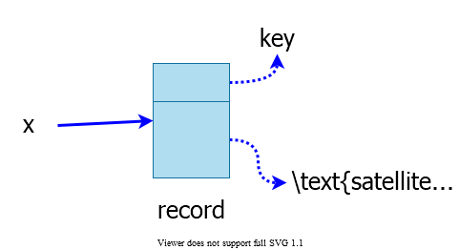
center height:300px

Operations on Dynamic Sets
- Queries: Simply return info;
  - $MAX\left(S\right)/MIN\left(S\right):$ (Query) return $x∈S$ with the largest/smallest $key$
  - $SEARCH\left(S,k\right):$ (Query) return $x∈S$ with $key\left[x\right]=k$
  - $SUCCESSOR\left(S,x\right)/PREDECESSOR\left(S,x\right):$ (Query) return $y∈S$ which is the next larger/smaller element after $x$
- Modifying operations: Change the set
  - $INSERT\left(S,x\right):$ (Modifying) $S←S∪\{x\}$
  - $DELETE\left(S,x\right):$ (Modifying) $S←S−\{x\}$
  - $\text{EXTRACT-MAX}\left(S\right)/\text{EXTRACT-MIN}\left(S\right):$ (Modifying) return and delete $x∈S$ with the largest/smallest $key$
- Different data structures support/optimize different operations

Priority Queues (PQ)
- Supports
  - $INSERT$
  - $MAX/MIN$
  - $\text{EXTRACT-MAX}/\text{EXTRACT-MIN}$

Priority Queues (PQ)
- One application: Schedule jobs on a shared resource
  - PQ keeps track of jobs and their relative priorities
  - When a job is finished or interrupted, highest priority job is selected from those pending using $\text{EXTRACT-MAX}$
  - A new job can be added at any time using $INSERT$

Priority Queues (PQ)
- Another application: Event-driven simulation
  - Events to be simulated are the items in the PQ
  - Each event is associated with a time of occurrence which serves as a $key$
  - Simulation of an event can cause other events to be simulated in the future
  - Use $\text{EXTRACT-MIN}$ at each step to choose the next event to simulate
  - As new events are produced insert them into the PQ using $INSERT$

Implementation of Priority Queue
- Sorted linked list: Simplest implementation
  - $INSERT$
    - $O\left(n\right)$ time
    - Scan the list to find place and splice in the new item
  - $\text{EXTRACT-MAX}$
    - $O\left(1\right)$ time
    - Take the first element
  - Fast extraction but slow insertion.

Implementation of Priority Queue
- Unsorted linked list: Simplest implementation
  - $INSERT$
    - $O\left(1\right)$ time
    - Put the new item at front
  - $\text{EXTRACT-MAX}$
    - $O\left(n\right)$ time
    - Scan the whole list
  - Fast insertion but slow extraction.
- Sorted linked list is better on the average
  - Sorted list: on the average, scans $n/2$ element per insertion
  - Unsorted list: always scans $n$ element at each extraction

Heap Implementation of PQ
- $INSERT$ and $\text{EXTRACT-MAX}$ are both $O\left(lgn\right)$
  - good compromise between fast insertion but slow extraction and vice versa
- $\text{EXTRACT-MAX}$: already discussed $\text{HEAP-EXTRACT-MAX}$
- $INSERT$: Insertion is like that of Insertion-Sort.
HEAP-INSERT(A, key, n)
n = n+1
i=n
while i>1 and A[floor(i/2)] < key do
A[i]=A[floor(i/2)]
i= floor(i/2)
A[i]=key

Heap Implementation of PQ
- Traverses $O\left(lgn\right)$ nodes, as $HEAPIFY$ does but makes fewer comparisons and assignments
  - $HEAPIFY$: compares parent with both children
  - $HEAP−INSERT$: with only one

HEAP-INSERT Example (Step-1)
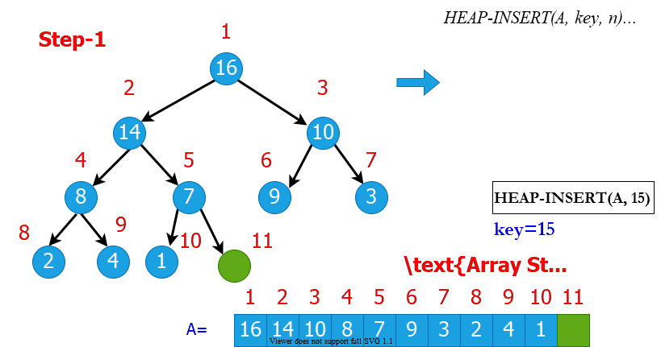
bg right:70% w:800px

HEAP-INSERT Example (Step-2)
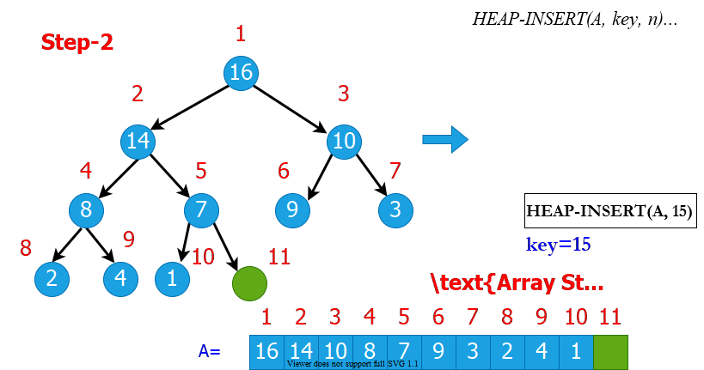
bg right:70% w:800px

HEAP-INSERT Example (Step-3)
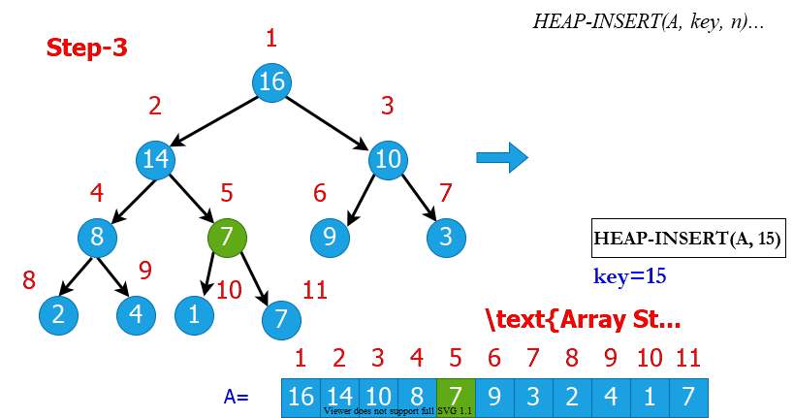
bg right:70% w:800px

HEAP-INSERT Example (Step-4)
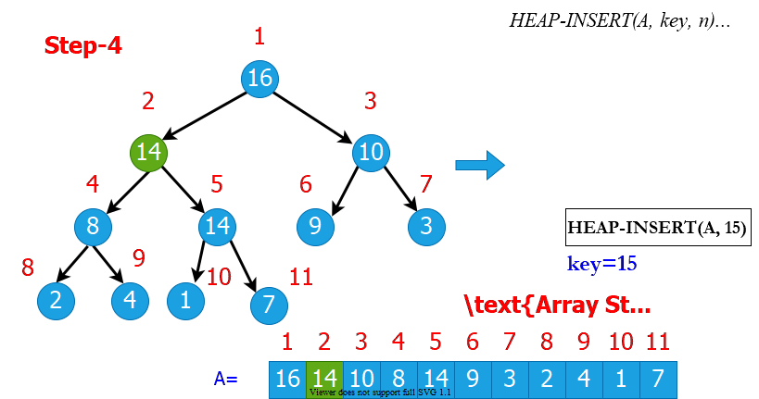
bg right:70% w:800px

HEAP-INSERT Example (Step-5)
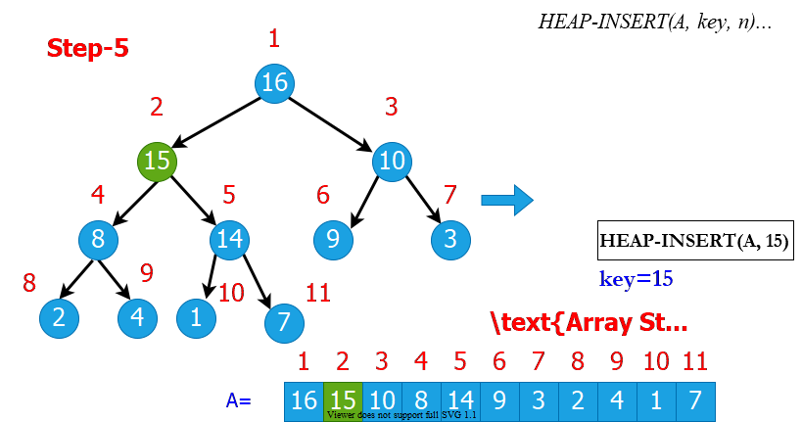
bg right:70% w:800px

Heap Increase Key
- Key value of $i^{th}$ element of heap is increased from $A\left[i\right]$ to $key$
HEAP-INCREASE-KEY(A, i, key)
if key < A[i] then
return error
while i > 1 and A[floor(i/2)] < key do
A[i] = A[floor(i/2)]
i = floor(i/2)
A[i] = key

HEAP-INCREASE-KEY Example (Step-1)
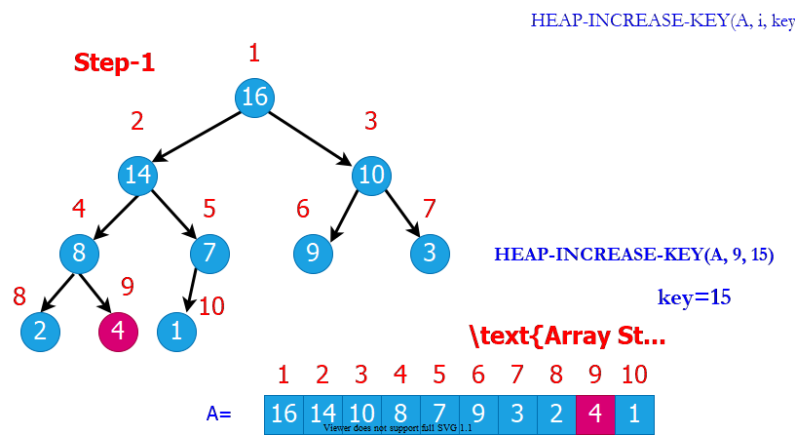
bg right:70% w:800px

HEAP-INCREASE-KEY Example (Step-2)
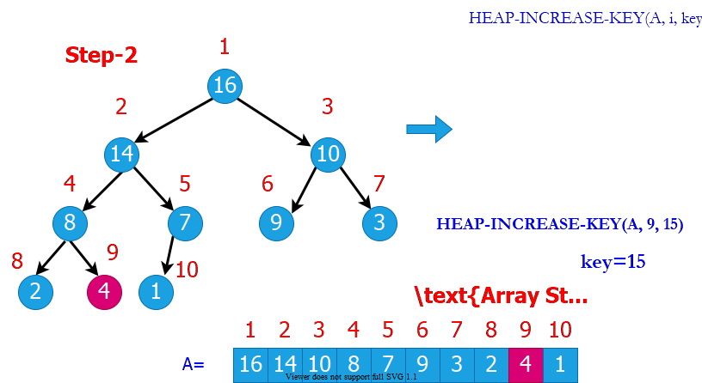
bg right:70% w:800px

HEAP-INCREASE-KEY Example (Step-3)
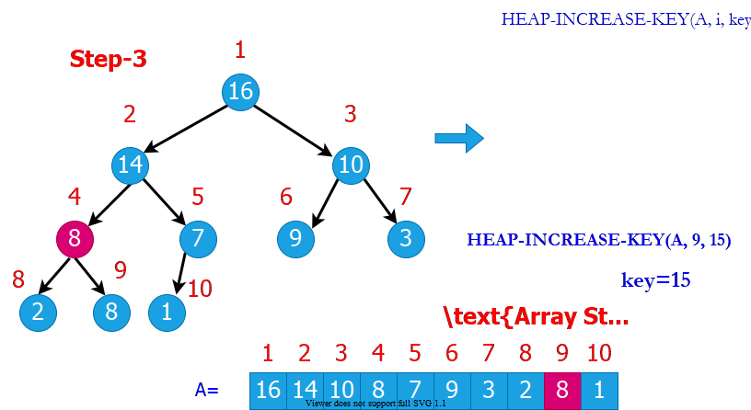
bg right:70% w:800px

HEAP-INCREASE-KEY Example (Step-4)
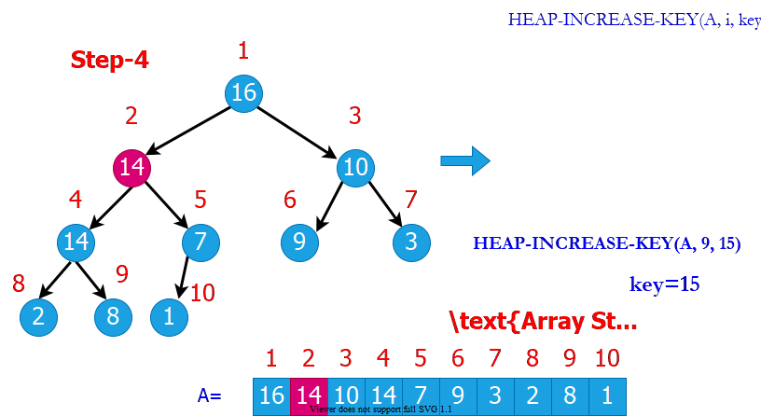
bg right:70% w:800px

HEAP-INCREASE-KEY Example (Step-5)
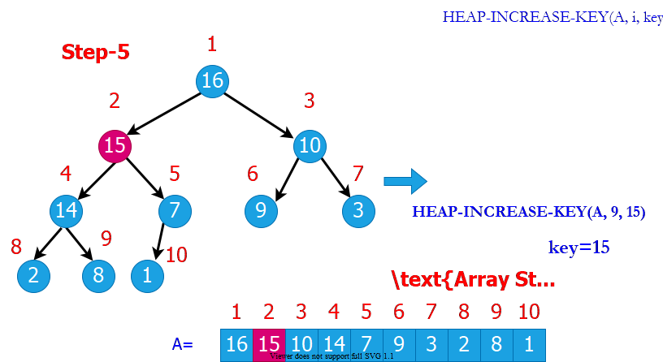
bg right:70% w:800px

Heap Implementation of Priority Queue (PQ)
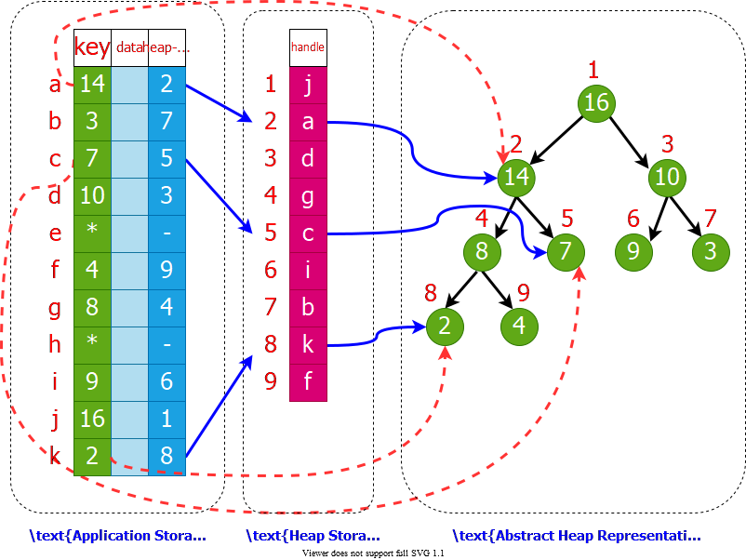
bg right:70% w:800px

Summary: Max Heap
- Heapify(A, i)
  - Works when both child subtrees of node i are heaps
  - “Floats down” node i to satisfy the heap property
  - Runtime: $O\left(lgn\right)$
- Max(A, n)
  - Returns the max element of the heap (no modification)
  - Runtime: $O\left(1\right)$
- Extract-Max(A, n)
  - Returns and removes the max element of the heap
  - Fills the gap in $A\left[1\right]$ with $A\left[n\right]$, then calls Heapify(A,1)
  - Runtime: $O\left(lgn\right)$

Summary: Max Heap
- Build-Heap(A, n)
  - Given an arbitrary array, builds a heap from scratch
  - Runtime: $O\left(n\right)$
- Min(A, n)
  - How to return the min element in a max-heap?
  - Worst case runtime: $O\left(n\right)$
    - because ~half of the heap elements are leaf nodes
  - Instead, use a min-heap for efficient min operations
- Search(A, x)
  - For an arbitrary $x$ value, the worst-case runtime: $O\left(n\right)$
  - Use a sorted array instead for efficient search operations

Summary: Max Heap
- Increase-Key(A, i, x)
  - Increase the key of node $i$ (from $A\left[i\right]$ to $x$)
  - “Float up” $x$ until heap property is satisfied
  - Runtime: $O\left(lgn\right)$
- Decrease-Key(A, i, x)
  - Decrease the key of node $i$ (from $A\left[i\right]$ to $x$)
  - Call Heapify(A, i)
  - Runtime: $O\left(lgn\right)$

Phone Operator Problem
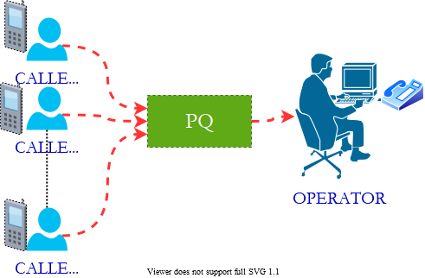
bg right:40% w:500px
- A phone operator answering $n$ phones
- Each phone $i$ has $x_{i}$ people waiting in line for their calls to be answered.
- Phone operator needs to answer the phone with the largest number of people waiting in line.
- New calls come continuously, and some people hang up after waiting.

Phone Operator Solution
- Step 1: Define the following array:
- $A\left[i\right]$: the ith element in heap
- $A\left[i\right].id$: the index of the corresponding phone
- $A\left[i\right].key$: $\#$ of people waiting in line for phone with index $A\left[i\right].id$
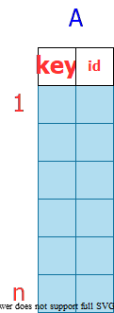
bg right:30% w:200px

Phone Operator Solution
- Step 2: $\text{Build-Max-Heap}\left(A,n\right)$
  - Execution:
    - When the operator wants to answer a phone:
      - $id=A\left[1\right].id$
        - $\text{Decrease-Key}\left(A,1,A\left[1\right].key−1\right)$
        - answer phone with index $id$
      - When a new call comes in to phone i:
        - $\text{Increase-Key}\left(A,i,A\left[i\right].key+1\right)$
      - When a call drops from phone i:
        - $\text{Decrease-Key}\left(A,i,A\left[i\right].key−1\right)$

Linked Lists
- Like arrays, Linked List is a linear data structure.
- Unlike arrays, linked list elements are not stored at a contiguous location; the elements are linked using pointers.
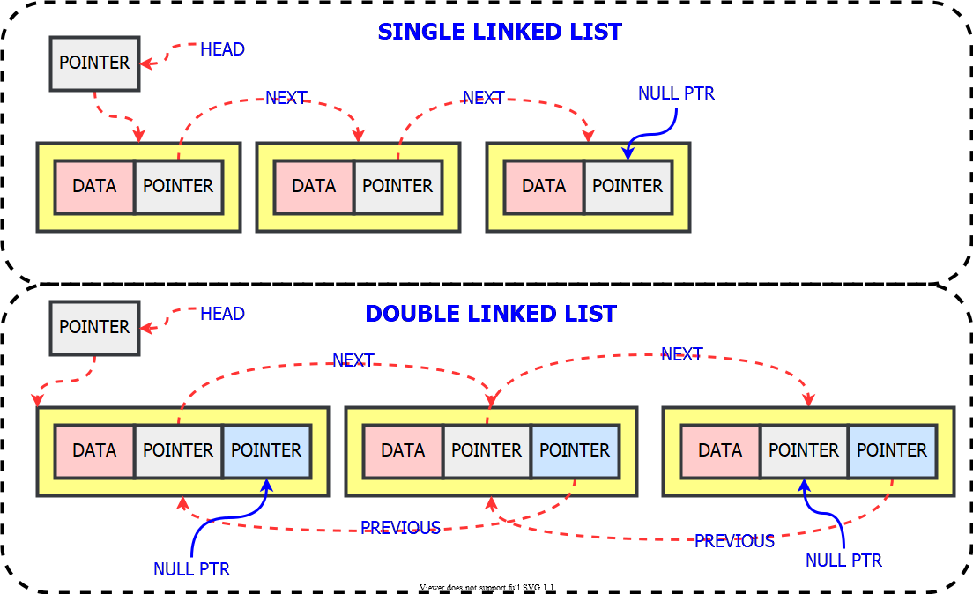
bg right:60% w:730px

Linked Lists - C Definition
- C
- // A linked list node
struct Node {
int data;
struct Node* next;
};

Linked Lists - Cpp Definition
- Cpp
- class Node {
public:
int data;
Node* next;
};

Linked Lists - Java Definition
- Java
- class LinkedList {
Node head; // head of the list
/* Linked list Node*/
class Node {
int data;
Node next;
// Constructor to create a new node
// Next is by default initialized
// as null
Node(int d) { data = d; }
}
}

Linked Lists - Csharp Definition
- Csharp
- class LinkedList {
// The first node(head) of the linked list
// Will be an object of type Node (null by default)
Node head;
class Node {
int data;
Node next;
// Constructor to create a new node
Node(int d) { data = d; }
}
}

Priority Queue using Linked List Methods
- Implement Priority Queue using Linked Lists.
  - push(): This function is used to insert a new data into the queue.
  - pop(): This function removes the element with the highest priority from the queue.
  - peek()/top(): This function is used to get the highest priority element in the queue without removing it from the queue.

Priority Queue using Linked List Algorithm
PUSH(HEAD, DATA, PRIORITY)
Create NEW.Data = DATA & NEW.Priority = PRIORITY
If HEAD.priority < NEW.Priority
NEW -> NEXT = HEAD
HEAD = NEW
Else
Set TEMP to head of the list
Endif
WHILE TEMP -> NEXT != NULL and TEMP -> NEXT ->PRIORITY > PRIORITY THEN
TEMP = TEMP -> NEXT
ENDWHILE
NEW -> NEXT = TEMP -> NEXT
TEMP -> NEXT = NEW

Priority Queue using Linked List Algorithm
POP(HEAD)
//Set the head of the list to the next node in the list.
HEAD = HEAD -> NEXT.
Free the node at the head of the list
PEEK(HEAD):
Return HEAD -> DATA

Priority Queue using Linked List Notes
- LinkedList is already sorted.
- Time Complexities and Comparison with Binary Heap
 | peek() | push() | pop()
Linked List | $O\left(1\right)$ | $O\left(n\right)$ | $O\left(1\right)$
Binary Heap | $O\left(1\right)$ | $O\left(lgn\right)$ | $O\left(lgn\right)$

Sorting in Linear Time

How Fast Can We Sort?
- The algorithms we have seen so far:
  - Based on comparison of elements
  - We only care about the relative ordering between the elements (not the actual values)
  - The smallest worst-case runtime we have seen so far: $O\left(nlgn\right)$
  - Is $O\left(nlgn\right)$ the best we can do?
- Comparison sorts: Only use comparisons to determine the relative order of elements.

Decision Trees for Comparison Sorts
- Represent a sorting algorithm abstractly in terms of a decision tree
  - A binary tree that represents the comparisons between elements in the sorting algorithm
  - Control, data movement, and other aspects are ignored
- One decision tree corresponds to one sorting algorithm and one value of $n$ (input size)

Reminder: Insertion Sort Step-By-Step Description (1)
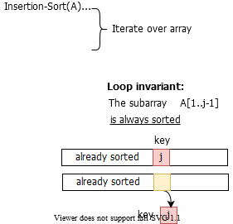
bg right:60% w:700px

Reminder: Insertion Sort Step-By-Step Description (2)
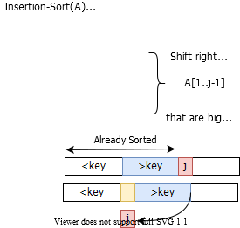
bg right:60% w:700px

Reminder: Insertion Sort Step-By-Step Description (3)
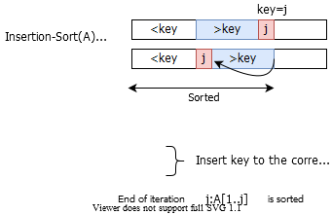
bg right:60% w:700px

Different Outcomes for Insertion Sort and n=3
- Input : $<a_{1},a_{2},a_{3}>$
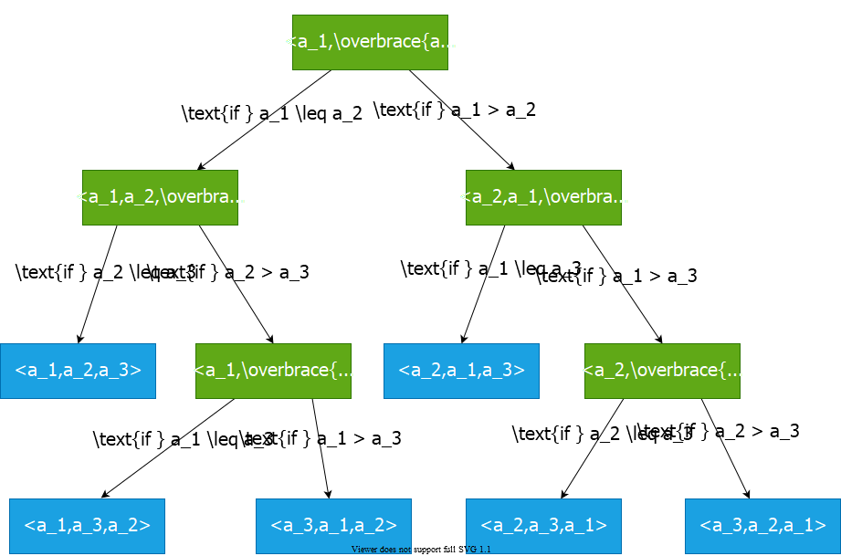
bg right:65% w:760px

Decision Tree for Insertion Sort and n=3
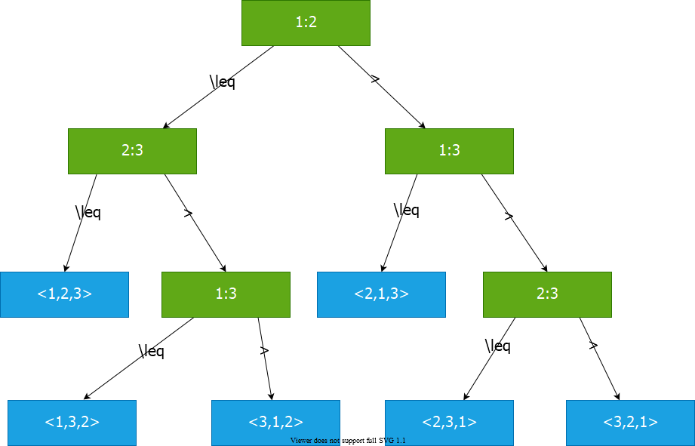
bg right:70% w:850px

Decision Tree Model for Comparison Sorts
- Internal node $\left(i:j\right)$: Comparison between elements $a_{i}$ and $a_{j}$
- Leaf node: An output of the sorting algorithm
- Path from root to a leaf: The execution of the sorting algorithm for a given input
- All possible executions are captured by the decision tree
- All possible outcomes (permutations) are in the leaf nodes

Decision Tree for Insertion Sort and n=3
- Input: $<9,4,6>$
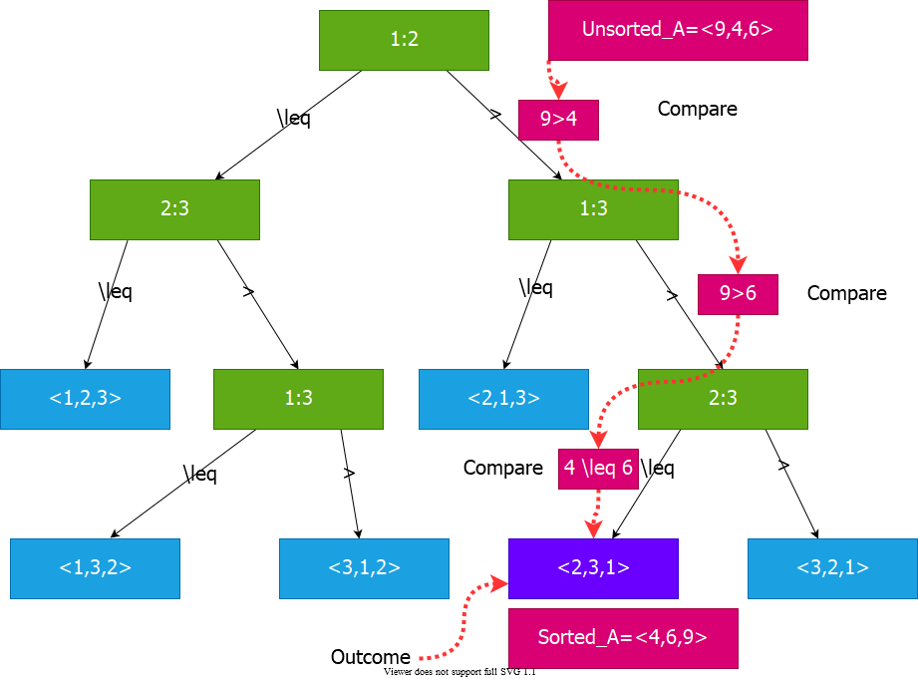
bg right:70% w:850px

Decision Tree Model
- A decision tree can model the execution of any comparison sort:
  - One tree for each input size $n$
  - View the algorithm as splitting whenever it compares two elements
  - The tree contains the comparisons along all possible instruction traces
- The running time of the algorithm $=$ the length of the path taken
- Worst case running time $=$ height of the tree

Counting Sort

Lower Bound for Comparison Sorts
- Let $n$ be the number of elements in the input array.
- What is the $min$ number of leaves in the decision tree?
  - $n!$ (because there are n! permutations of the input array, and all possible outputs must be captured in the leaves)
- What is the max number of leaves in a binary tree of height $h$? $⇒$ $2^{h}$
- So, we must have:
$$2^{h}≥n!$$

Lower Bound for Decision Tree Sorting
- Theorem: Any comparison sort algorithm requires $Ω\left(nlgn\right)$ comparisons in the worst case.
- Proof: We’ll prove that any decision tree corresponding to a comparison sort algorithm must have height $Ω\left(nlgn\right)$
$$\begin{matrix}2^{h} & ≥n! \\ h & ≥lg\left(n!\right) \\ & ≥lg\left({\left(n/e\right)}^{n}\right)\left(StirlingApproximation\right) \\ & =nlgn−nlge \\ & =Ω\left(nlgn\right)\end{matrix}$$

Lower Bound for Decision Tree Sorting
Corollary: Heapsort and merge sort are asymptotically optimal comparison sorts.
Proof: The $O\left(nlgn\right)$ upper bounds on the runtimes for heapsort and merge sort match the $Ω\left(nlgn\right)$ worst-case lower bound from the previous theorem.

Sorting in Linear Time
- Counting sort: No comparisons between elements
  - Input: $A\left[1…n\right]$, where $A\left[j\right]∈\{1,2,…,k\}$
  - Output: $B\left[1…n\right]$, sorted
  - Auxiliary storage: $C\left[1…k\right]$

Counting Sort-1
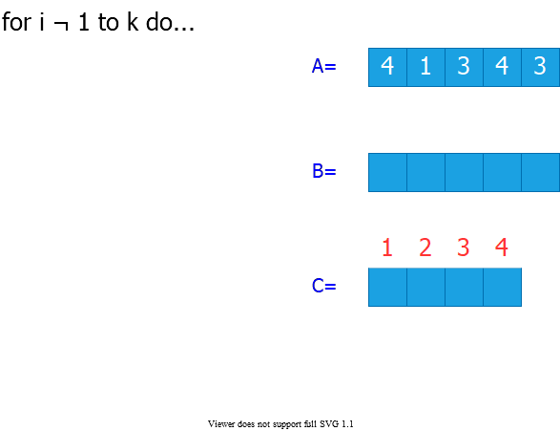
bg right:60% w:750px

Counting Sort-2
- Step 1: Initialize all counts to 0
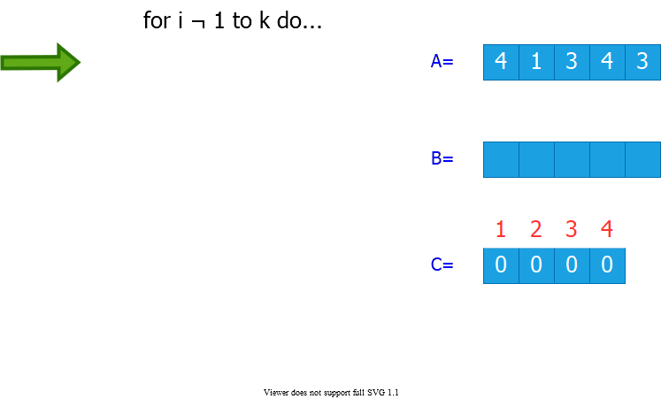
bg right:60% w:750px

Counting Sort-3
- Step 2: Count the number of occurrences of each value in the input array
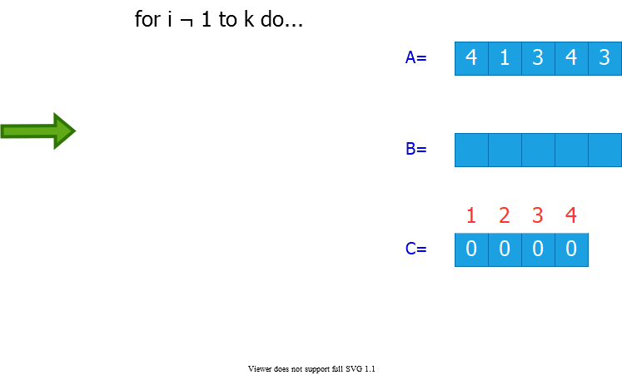
bg right:60% w:750px

Counting Sort-4
- Step 3: Compute the number of elements less than or equal to each value
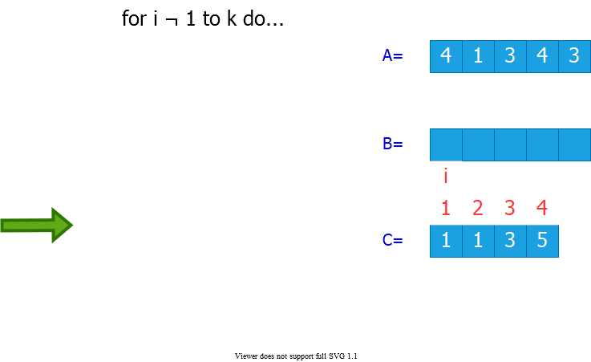
bg right:60% w:750px

Counting Sort-5
- Step 4: Populate the output array
  - There are $C\left[3\right]=3$ elements that are $≤3$
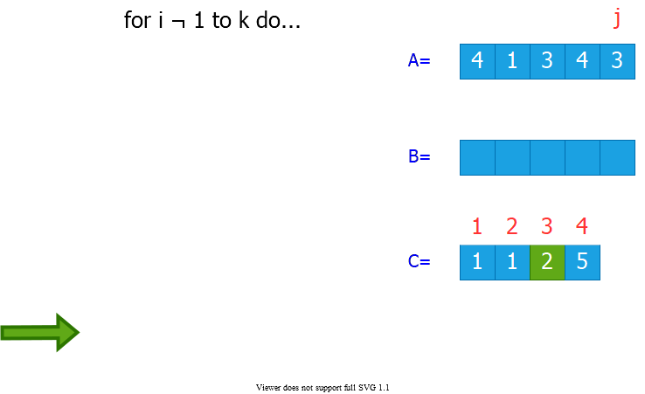
bg right:60% w:750px

Counting Sort-6
- Step 4: Populate the output array
  - There are $C\left[4\right]=5$ elements that are $≤4$
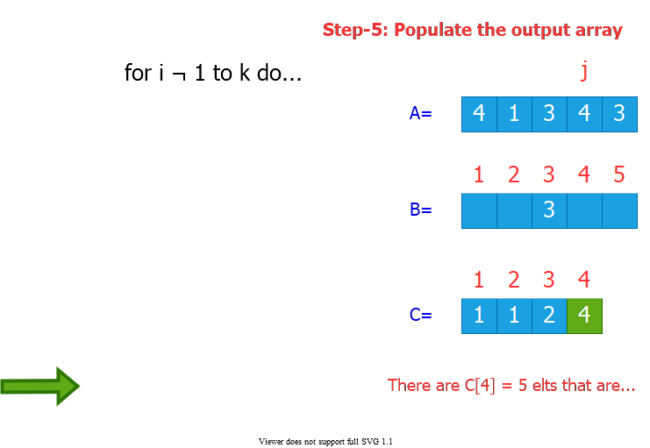
bg right:60% w:750px

Counting Sort-7
- Step 4: Populate the output array
  - There are $C\left[3\right]=2$ elements that are $≤3$
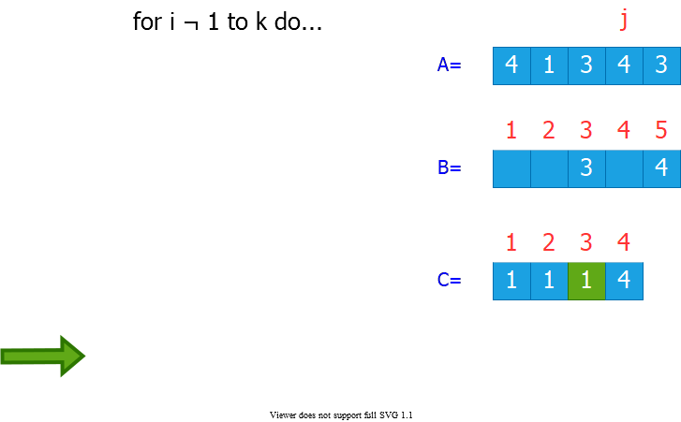
bg right:60% w:750px

Counting Sort-8
- Step 4: Populate the output array
  - There are $C\left[1\right]=1$ elements that are $≤1$
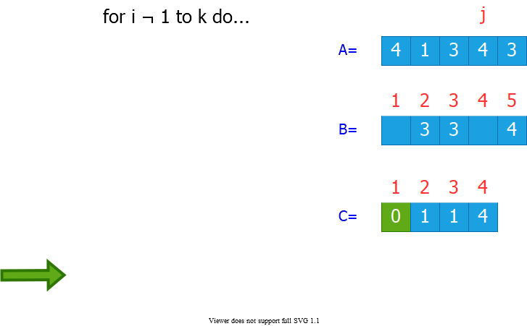
bg right:60% w:750px

Counting Sort-9
- Step 4: Populate the output array
  - There are $C\left[4\right]=4$ elements that are $≤4$
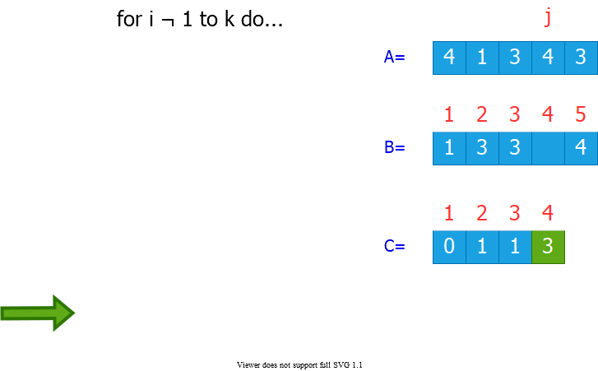
bg right:60% w:750px

Counting Sort: Runtime Analysis
- Total Runtime: $Θ\left(n+k\right)$
  - $n$ : size of the input array
  - $k$ : the range of input values
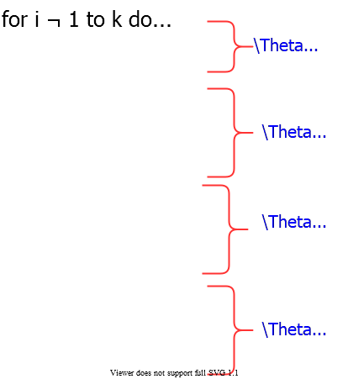
bg right:60% w:550px

Counting Sort: Runtime
- Runtime is $Θ\left(n+k\right)$
  - If $k=O\left(n\right)$, then counting sort takes $Θ\left(n\right)$
- Question: We proved a lower bound of $Θ\left(nlgn\right)$ before! Where is the fallacy?
- Answer:
  - $Θ\left(nlgn\right)$ lower bound is for comparison-based sorting
  - Counting sort is not a comparison sort
  - In fact, not a single comparison between elements occurs!

Stable Sorting
- Counting sort is a stable sort: It preserves the input order among equal elements.
  - i.e. The numbers with the same value appear in the output array in the same order as they do in the input array.
- Note: Which other sorting algorithms have this property?
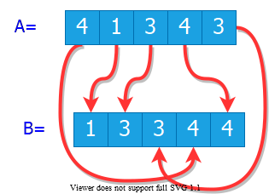
center h:300px

Radix Sort
- Origin: Herman Hollerith’s card-sorting machine for the 1890 US Census.
- Basic idea: Digit-by-digit sorting
- Two variations:
  - Sort from MSD to LSD (bad idea)
  - Sort from LSD to MSD (good idea)
(LSD/MSD: Least/most significant digit)

Herman Hollerith (1860-1929)
- The 1880 U.S. Census took almost 10 years to process.
- While a lecturer at MIT, Hollerith prototyped punched-card technology.
- His machines, including a card sorter, allowed the 1890 census total to be reported in 6 weeks.
- He founded the Tabulating Machine Company in 1911, which merged with other companies in 1924 to form International Business Machines(IBM).
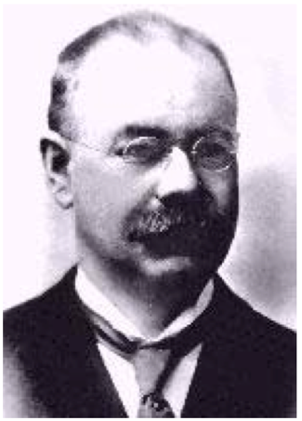
center h:250px

Hollerith Punched Card
- Punched card: A piece of stiff paper that contains digital information represented by the presence or absence of holes.
  - 12 rows and 24 columns
  - coded for age, state of residency, gender, etc.
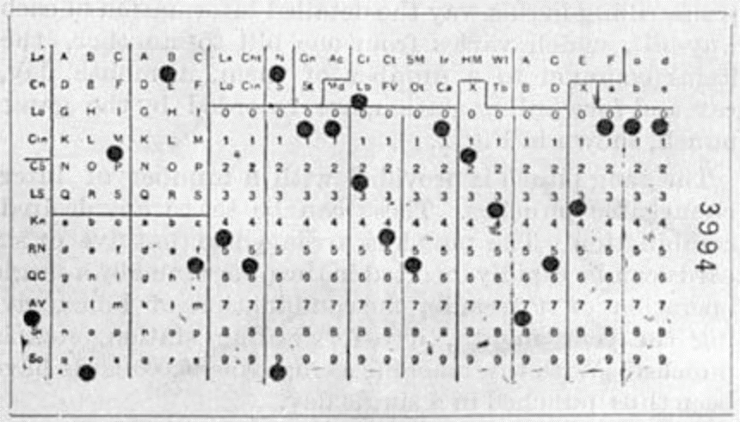
center h:300px

Modern IBM card
- One character per column
  - So, that’s why text windows have 80 columns!
- 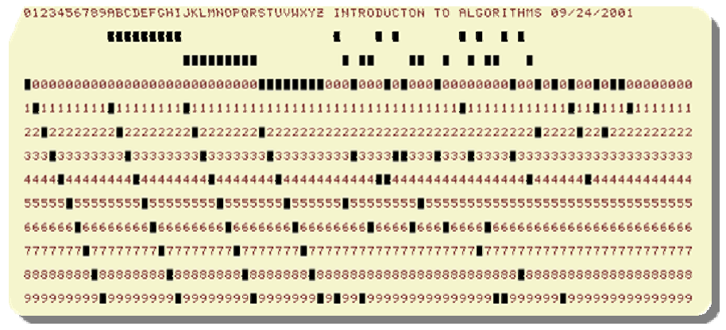
- center h:350px
- for more samples visit https://en.wikipedia.org/wiki/Punched_card

Hollerith Tabulating Machine and Sorter
- Mechanically sorts the cards based on the hole locations.
- Sorting performed for one column at a time
- Human operator needed to load/retrieve/move cards at each stage
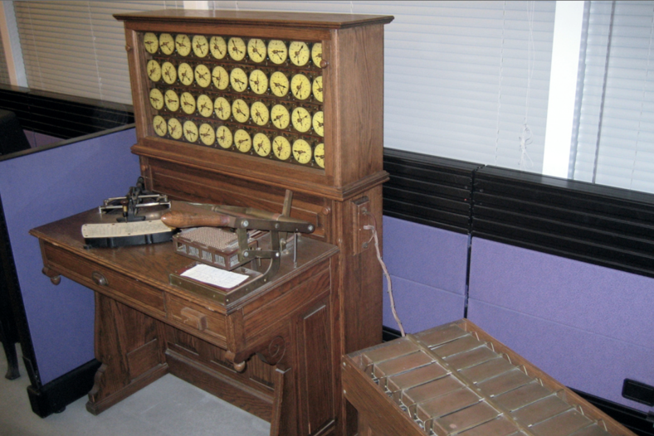
center h:350px

Hollerith’s MSD-First Radix Sort
- Sort starting from the most significant digit (MSD)
- Then, sort each of the resulting bins recursively
- At the end, combine the decks in order
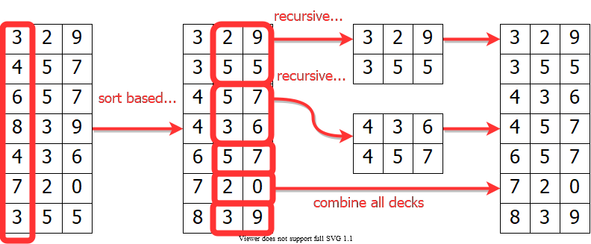
center h:350px

Hollerith’s MSD-First Radix Sort
- To sort a subset of cards recursively:
  - All the other cards need to be removed from the machine, because the machine can handle only one sorting problem at a time.
  - The human operator needs to keep track of the intermediate card piles
- 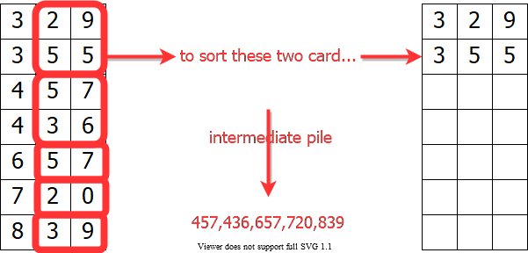
- center h:300px

Hollerith’s MSD-First Radix Sort
- MSD-first sorting may require:
  - very large number of sorting passes
  - very large number of intermediate card piles to maintain
- S(d):
  - $\#$ of passes needed to sort d-digit numbers (worst-case)
- Recurrence:
  - $S\left(d\right)=10S\left(d−1\right)+1$ with $S\left(1\right)=1$
    - Reminder: Recursive call made to each subset with the same most significant digit(MSD)

Hollerith’s MSD-First Radix Sort
- Recurrence: $S\left(d\right)=10S\left(d−1\right)+1$
$$\begin{matrix}S\left(d\right) & =10S\left(d−1\right)+1 \\ & =10(10S\left(d−2\right)+1)+1 \\ & =10(10(10S\left(d−3\right)+1)+1)+1 \\ & =10iS\left(d−i\right)+10i−1+10i−2+…+101+100 \\ & =\sum_{i=0}^{d−1}{{10}^{i}}\end{matrix}$$
- Iteration terminates when $i=d−1$ with $S\left(d−\left(d−1\right)\right)=S\left(1\right)=1$

Hollerith’s MSD-First Radix Sort
- Recurrence: $S\left(d\right)=10S\left(d−1\right)+1$
$$\begin{matrix}S\left(d\right) & =\sum_{i=0}^{d−1}{{10}^{i}} \\ & =\frac{{10}^{d}−1}{10−1} \\ & =\frac{1}{9}\left({10}^{d}−1\right) \\ & ⇓ \\ S\left(d\right) & =\frac{1}{9}\left({10}^{d}−1\right)\end{matrix}$$

Hollerith’s MSD-First Radix Sort
- $P\left(d\right)$: $\#$ of intermediate card piles maintained (worst-case)
- Reminder: Each routing pass generates 9 intermediate piles except the sorting passes on least significant digits (LSDs)
  - There are ${10}^{d−1}$ sorting calls to LSDs
$$\begin{matrix}P\left(d\right) & =9\left(S\left(d\right)–{10}^{d−1}\right) \\ & =9\frac{\left({10}^{d–1}\right)}{9–{10}^{d−1}} \\ & =\left({10}^{d–1}–9*{10}^{d−1}\right) \\ & ={10}^{d−1}−1\end{matrix}$$

Hollerith’s MSD-First Radix Sort
$$\begin{matrix}P\left(d\right) & ={10}^{d−1}−1\end{matrix}$$
Alternative solution: Solve the recurrence
$$\begin{matrix}P\left(d\right) & =10P\left(d−1\right)+9 \\ P\left(1\right) & =0\end{matrix}$$

Hollerith’s MSD-First Radix Sort
- Example: To sort $3$ digit numbers, in the worst case:
  - $S\left(d\right)=\left(1/9\right)\left(103−1\right)=111$ sorting passes needed
  - $P\left(d\right)=10d−1−1=99$ intermediate card piles generated
- MSD-first approach has more recursive calls and intermediate storage requirement
  - Expensive for a tabulating machine to sort punched cards
  - Overhead of recursive calls in a modern computer

LSD-First Radix Sort
- Least significant digit (LSD)-first radix sort seems to be a folk invention originated by machine operators.
- It is the counter-intuitive, but the better algorithm.
- Basic Algorithm:
- Sort numbers on their LSD first (Stable Sorting Needed)
Combine the cards into a single deck in order
Continue this sorting process for the other digits
from the LSD to MSD
- Requires only $d$ sorting passes
- No intermediate card pile generated

LSD-first Radix Sort Example
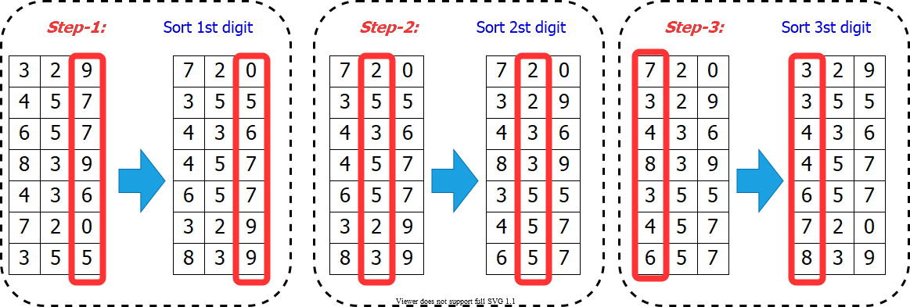
center h:500px

Correctness of Radix Sort (LSD-first)
- Proof by induction:
  - Base case: $d=1$ is correct (trivial)
  - Inductive hyp: Assume the first $d−1$ digits are sorted correctly
- Prove that all $d$ digits are sorted correctly after sorting digit $d$
- Two numbers that differ in digit $d$ are correctly sorted (e.g. 355 and 657)
- Two numbers equal in digit d are put in the same order as the input
  - (correct order)
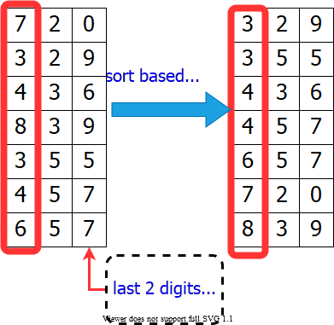
bg right:39% h:450px

Radix Sort Runtime
- Use counting-sort to sort each digit
- Reminder: Counting sort complexity: $Θ\left(n+k\right)$
  - $n$: size of input array
  - $k$: the range of the values
- Radix sort runtime: $Θ\left(d\left(n+k\right)\right)$
  - $d$: $\#$ of digits
How to choose the $d$ and $k$?

Radix Sort: Runtime – Example 1
- We have flexibility in choosing $d$ and $k$
- Assume we are trying to sort 32-bit words
  - We can define each digit to be 4 bits
  - Then, the range for each digit $k=2^{4}=16$
    - So, counting sort will take $Θ\left(n+16\right)$
  - The number of digits $d=32/4=8$
  - Radix sort runtime: $Θ\left(8\left(n+16\right)\right)=Θ\left(n\right)$
- $\overset{\text{32-bits}}{\overbrace{\left[4bits\left|4bits\right|4bits\left|4bits\right|4bits\left|4bits\right|4bits|4bits\right]}}$

Radix Sort: Runtime – Example 2
- We have flexibility in choosing $d$ and $k$
- Assume we are trying to sort 32-bit words
  - Or, we can define each digit to be 8 bits
  - Then, the range for each digit $k=2^{8}=256$
    - So, counting sort will take $Θ\left(n+256\right)$
  - The number of digits $d=32/8=4$
  - Radix sort runtime: $Θ\left(4\left(n+256\right)\right)=Θ\left(n\right)$
- $\overset{\text{32-bits}}{\overbrace{\left[8bits\left|8bits\right|8bits|8bits\right]}}$

Radix Sort: Runtime
- Assume we are trying to sort $b$-bit words
  - Define each digit to be $r$ bits
  - Then, the range for each digit $k=2^{r}$
    - So, counting sort will take $Θ\left(n+2^{r}\right)$
  - The number of digits $d=b/r$
    - Radix sort runtime:
$$\begin{matrix}T\left(n,b\right) & =Θ(\frac{b}{r}\left(n+2^{r}\right))\end{matrix}$$
- $\overset{b/r\text{ bits}}{\overbrace{\left[rbits\left|rbits\right|rbits|rbits\right]}}$

Radix Sort: Runtime Analysis
$$\begin{matrix}T\left(n,b\right) & =Θ(\frac{b}{r}\left(n+2^{r}\right))\end{matrix}$$
- Minimize $T\left(n,b\right)$ by differentiating and setting to $0$
- Or, intuitively:
  - We want to balance the terms $\left(b/r\right)$ and $\left(n+2^{r}\right)$
  - Choose $r≈lgn$
    - If we choose $r<<lgn⇒\left(n+2^{r}\right)$ term doesn’t improve
    - If we choose $r>>lgn⇒\left(n+2^{r}\right)$ increases exponentially

Radix Sort: Runtime Analysis
$$\begin{matrix}T\left(n,b\right) & =Θ(\frac{b}{r}\left(n+2^{r}\right))\end{matrix}$$
$$\begin{matrix}\text{Choose }r=lgn⇒T\left(n,b\right)=Θ\left(bn/lgn\right)\end{matrix}$$
- For numbers in the range from $0$ to $n^{d}–1$, we have:
  - The number of bits $b=lg\left(nd\right)=dlgn$
    - Radix sort runs in $Θ\left(dn\right)$

Radix Sort: Conclusions
$$\begin{matrix}\text{Choose }r=lgn⇒T\left(n,b\right)=Θ\left(bn/lgn\right)\end{matrix}$$
- Example: Compare radix sort with merge sort/heapsort
  - $1$ million ($2^{20}$), $32$-bit numbers $\left(n=2^{20},b=32\right)$
    - Radix sort: $⌊32/20⌋=2$ passes
    - Merge sort/heap sort: $lgn=20$ passes
- Downsides:
  - Radix sort has little locality of reference (more cache misses)
  - The version that uses counting sort is not in-place
- On modern processors, a well-tuned quicksort implementation typically runs faster.

References
- Introduction to Algorithms, Third Edition | The MIT Press
- Bilkent CS473 Course Notes (new)
- Bilkent CS473 Course Notes (old)
- Insertion Sort - GeeksforGeeks
- Priority Queue Using Linked List - GeeksforGeeks
- Priority Queue Using Linked List - JavatPoint
- NIST Dictionary of Algorithms and Data Structures
- NIST - Dictionary of Algorithms and Data Structures

$−End−Of−Week−4−Course−Module−$

